**Project Title: Manage and Monitor the Docker Containers with Dry Tool**

**Note: This is a solution document on how to execute Dry to monitor Docker containers. A documentation should be created referring it as a project proposal where all the following steps are added.**

Run multiple containers in an interactive and detached mode.

docker pull busybox

docker pull hello-world

docker run -t -d busybox

docker run -t -d hello-world

Confirm if the containers are up and running:

docker ps

You can check the exited containers:

docker ps -a

Download the latest version of Dry :

wget <https://github.com/moncho/dry/releases/download/v0.9-beta.3/dry-linux-amd64>

Move the file to /usr/local/bin/dry

sudo mv dry-linux-amd64 /usr/local/bin/dry

Provide the access permissions.

sudo chmod 755 /usr/local/bin/dry

Check the version of Dry:

dry -v

Now, run Dry. Type **dry** in the command and hit [enter]. You should get the similar output where your containers are running.

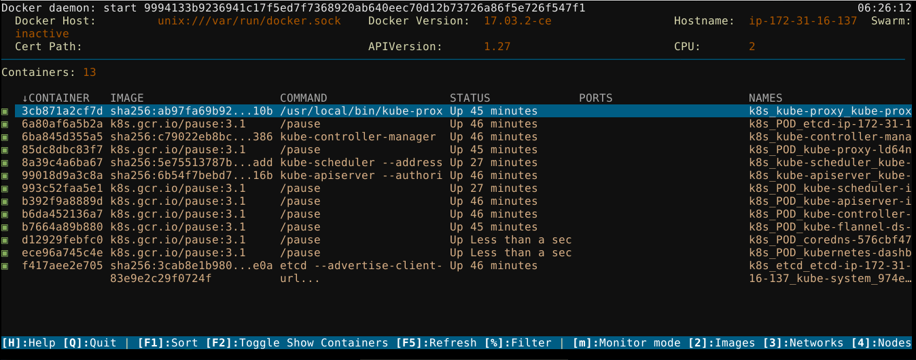

**Interacting with Docker Containers:**

Use the navigation keys mentioned below to interact with the terminal.

[H]:Help [Q]:Quit | [F1]:Sort [F2]:Toggle Show Containers [F5]:Refresh [%]:Filter |

[m]:Monitor mode [2]:Images [3]:Networks [4]:Nodes [5]:Services | [Enter]:Commands

Select any container from the list and hit [enter] to open the options:

Fetch logs

Inspect container

Kill container

Remove container

Restart

Show image history

Stats + Top

Stop

The reference screenshot is available.

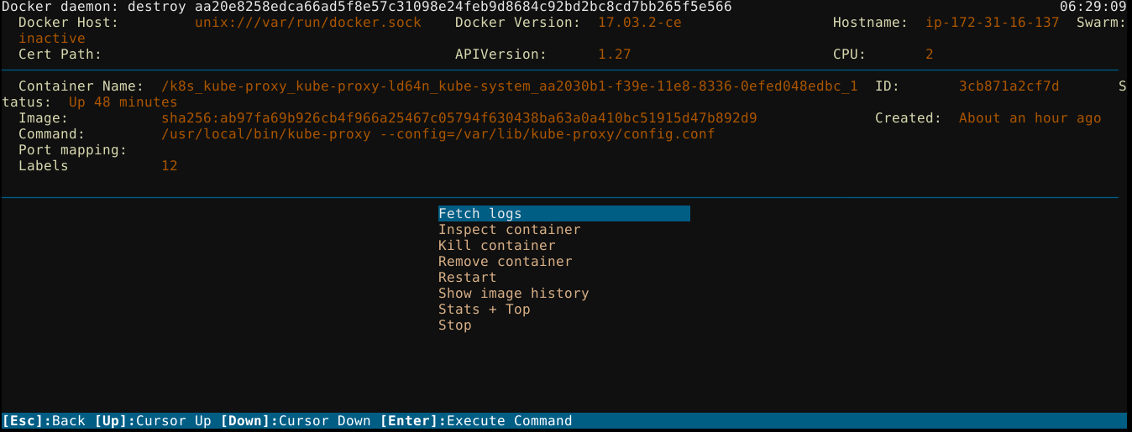

**Interacting with Docker images:**

Press [2] to switch to Docker images. It will show a list of your Docker images.

Select any image from the list and hit [enter] to show the details of the selected image.

You can use the shortcuts in Dry:

“Ctrl + D” to remove dangling. It is equivalent to docker volume rm with the flag **dangling=true**

“Ctrl + E” to remove image. It is equivalent to **docker rmi**

“CTRL + F” to force remove. It is equivalent to **docker rmi --force**

**Interacting with Docker Networks:**

Press [3] to switch to Docker networks. It will show a list of your active Docker networks.

Select any network from the list and hit [enter] to fetch and show the details of the selected network. The output will look similar to the below:

