Lesson 5 Demo 2: Cucumber Installation

This section will guide you to:

* Install cucumber, and run with JavaScript
* Use visual studio code (the popular text editor for web-based projects)
* Confirm the cucumber installation via npm

**Step 1:** Install Node.js and npm from the official site

* Install the node.js in your system by running the command below in the terminal:

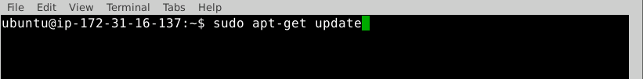



* Once the installation is complete, open your command prompt and type the command mentioned below to check the versions of node and npm:

**node --version**

**npm --version**

* If you’re unable to find the latest version in the Ubuntu labs, continue with the instructions given below; otherwise, skip this step and continue with step 2.

**Alternate 1:**

If you find the oldest version of the node, execute the commands below in the terminal:

sudo npm cache clean -f

sudo npm install -g n

sudo n stable

To upgrade to the latest version, run the command below:

sudo n latest

**Alternate 2:**

Run the command given below to install the Node.js v10.x version:

curl -sL https://deb.nodesource.com/setup_10.x | sudo -E bash -

sudo apt-get install -y nodejs

**Step 2:** Download visual studio code from the official site <https://code.visualstudio.com/download> and click on **.deb** button to download the software.

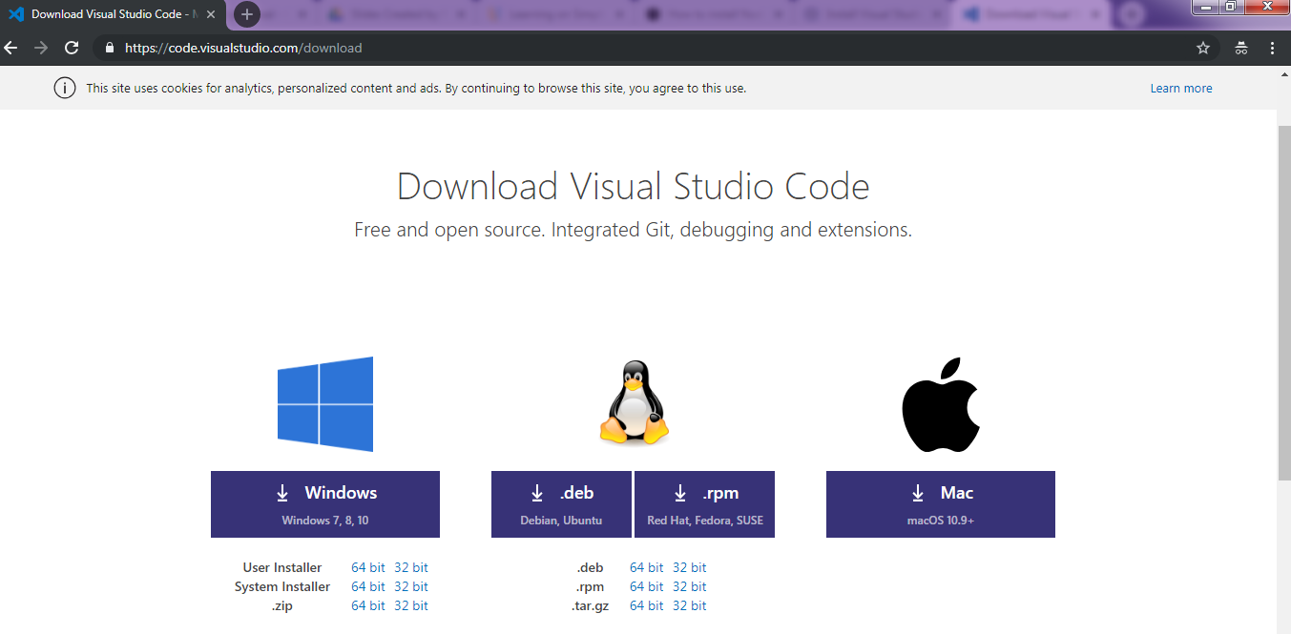

* Open the terminal, and run the command given below to install the visual studio code:

**cd < path to the downloads folder>**

**right click and select "Open Terminal Here"**

**run the command given below to install VSCode**

**sudo dpkg-i <Your Downloaded File Name>**

* To open the visual studio code editor, click on the  button available on the top-left side in the lab, select **Development**,and click on **Visual Studio Code**.

**Step 3:** Create a separate folder via terminal and navigate inside the folder. An example folder name with commands is mentioned below:

**mkdir DevOps**

**cd DevOps**

* Go to the visual studio code editor, and open the newly created folder performing the following steps in the editor:

**File** → **Open Folder…[Ctrl+K+Ctrl+O]** and navigate to the newly created folder.

* Type **Ctrl+`** or navigate to **View → Terminal.**
* Type the following commands (without ‘#’) in the visual studio code’s terminal to install cucumber:

**npm init -yes**

**npm install --save-dev @cucumber/cucumber**

* Create a folder and a subfolder with the names, features, and steps as shown below inside the root folder:

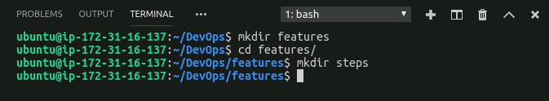

* Create a file named **cucumber.js** inside the project folder with the following code.

module.exports = {

default: `--format-options '{"snippetInterface": "synchronous"}'`

}

* The project directory should be:

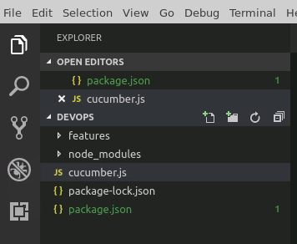

* Create a file as **stepdef.js** inside the **features/step/** directory and add the following code:

const assert = require('assert');

const { Given, When, Then } = require('cucumber');

* The project directory should be:

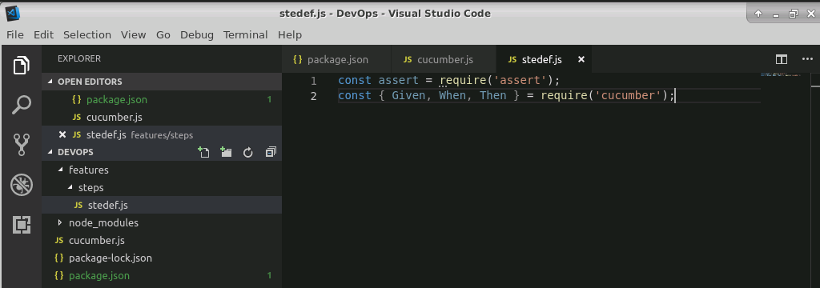

* Click on **package.json** file, and edit the code of test:

From: “test”: “echo \”Error: no test specified\ “”

To: “test” : “cucumber-js” and

From “@cucumber/cucumber”

To: “cucumber” and save the file

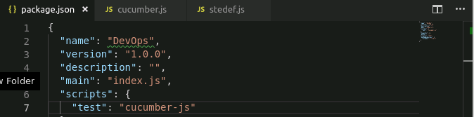

* Run **npm test** in the terminal of visual studio code to confirm that cucumber is installed