Lesson 2 Demo 2: Create a Github Repository

This section will guide you to:

* Create a github repository

This lab has three subsections, namely:

1. Creating a new github repository
2. Editing the README file
3. Uploading a file to the repository

**Please Note**: As you have already done the DevOps Certification Training, you might already have a GitHub account and a repository. If not please refer to the GitHub demo in the DevOps Certification Training to create a GitHub account and follow the steps below to create a repository.

**Step 1:** Creating a new github repository

* Open the browser in your lab, go to **github.com** and login to your account
* Click on the **+** icon from the upper-right corner of the page and select **New repository** from the drop-down menu

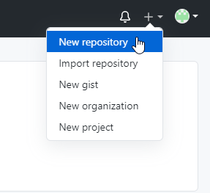

* Enter *sample repository* the **Repository name.** Entering **Description** is optional.
* Choose **Public** for the repository type
* Select **Initialize this repository with a README** to include a *README* file for the repository
* Click on the **Create Repository** button

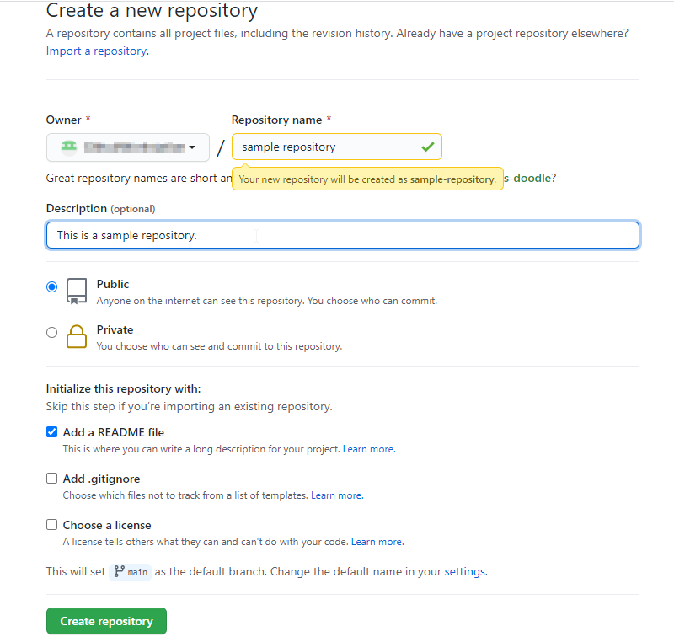

**Step 2:** Editing the *README* file

* Click on the **Edit** button to edit the *README* file

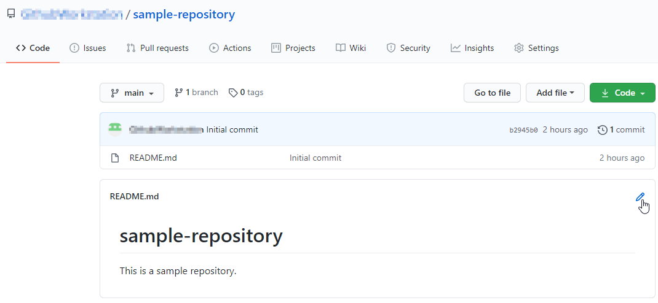

* Add some text in the README file (Example: *We have edited the README file.*)

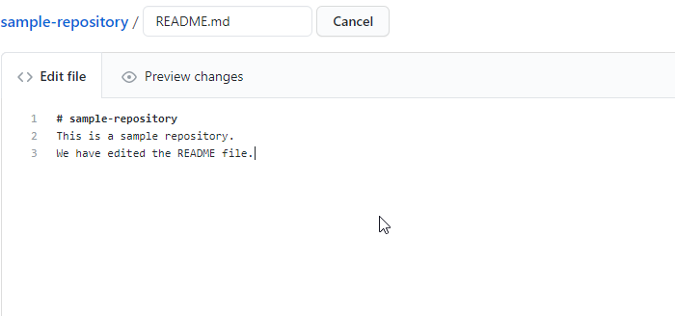

* Type a commit message to describe the changes made in the file (**Example**: *First commit: README file update*)

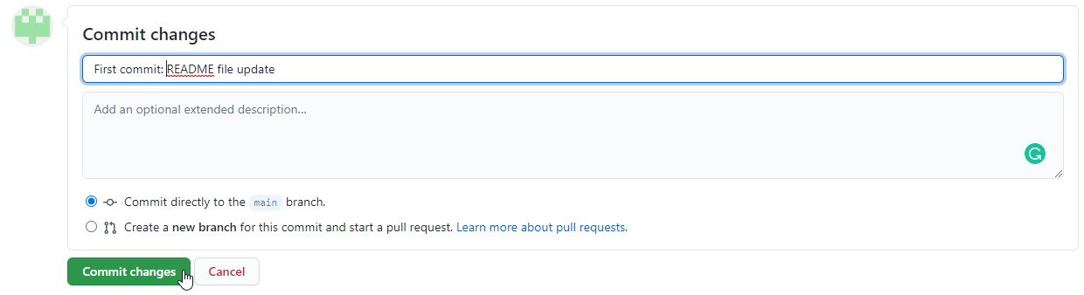

**Step 3:** Adding a file to the repository

* Go to your Github repository and to add a file to the repository, click on **Add file**, and then select **Create New File**

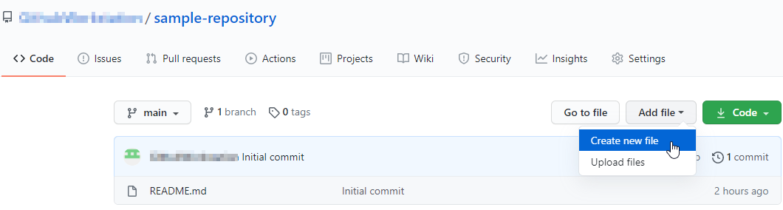

* Enter the filename as **SampleFile.txt** and add the following text in the **Edit new file** tab

*This is a sample file.*

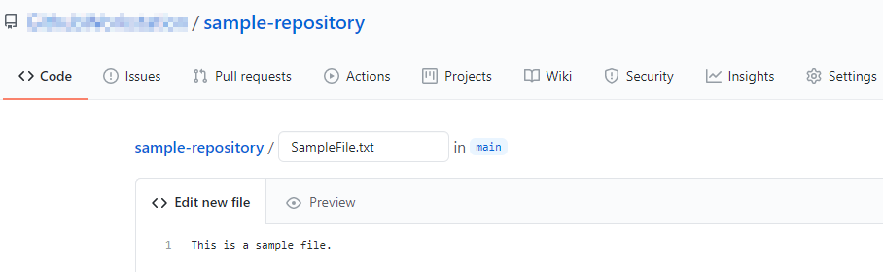

* Next, scroll down to the **Commit New File** section. Write a Commit Message (**Example:** *Create SampleFile.txt*) and click on the **Commit New File** button

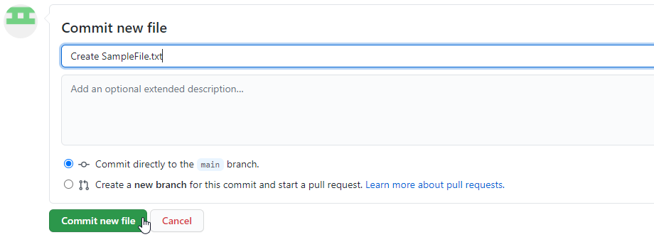

* Check the newly added file with the commit message

