Lesson 3 Demo 3: Rolling Back to Previous Commits

This section will guide you to:

* Rollback to a previous commit using the reset command
* Rollback to a previous commit using the revert command

This lab has two subsections, namely:

1. Rolling back to a previous commit using the **reset** command
2. Rolling back to a previous commit using the **revert** command

**Please Note**: Make sure you have successfully completed the second demo from the third lesson before you begin this demo.

**Step 1:** Rolling back to a previous commit using the **reset** command

* In the terminal, use the **git log --oneline** command to check the log of recent commits  
    
  **Note:** Ensure that you are in the repository directory that you have cloned. Make sure to type **cd <your_repository_name>** before you begin this step.

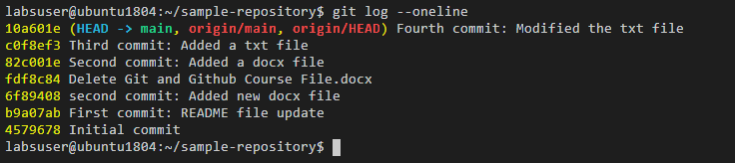

* Use the following command to rollback to a particular commit:

**git reset COMMIT_VALUE**

where **COMMIT_VALUE** is the number shown in front of each commit

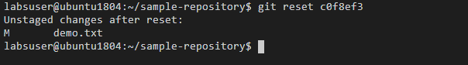

* Use the **git log** **--oneline** command to check the log of recent commits

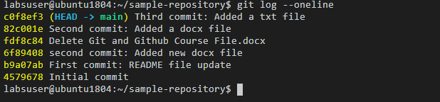

**Note:** Notice that the fourth commit is deleted, and the last commit that the log shows is actually the third commit.

**Step 2:** Rolling back to a previous commit using the **revert** command

* Use the following command to rollback to a particular commit:

**git revert COMMIT_VALUE**

where **COMMIT_VALUE** is the number shown in front of each commit

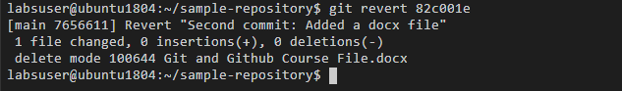

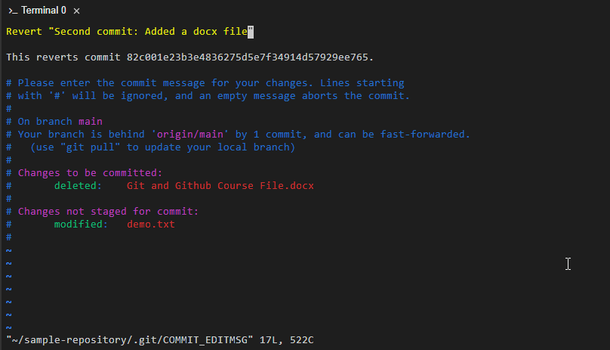

* Use the **git log --oneline** command to check the log of recent commits

