Lesson 3 Demo 5: Adding Changes to the Last Commit

This section will guide you to:

* Add changes to the last commit

This lab has six subsections, namely:

1. Checking the log of the recent commits
2. Opening the file in the **vi editor** to implement necessary changes
3. Executing **git status** to check the status of the repository.
4. Using the **git add .** command to add the files to the staging area
5. Executing **git commit --amend** to modify the most recent commit
6. Executing **git log --oneline** to check the recent commit with the modified message

**Please note**: Make sure you have successfully completed the fourth demo from the third lesson.

**Step 1:** Checking the log of the recent commits

* Execute **git log --oneline** to know the latest commit

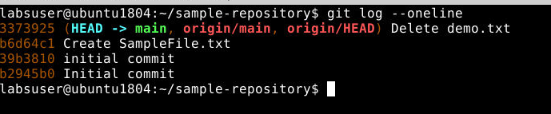

**Step 2:** Opening the file in the **vi editor** to implement necessary changes



**Step 3:** Executing **git status** to check the status of the repository

**git status**

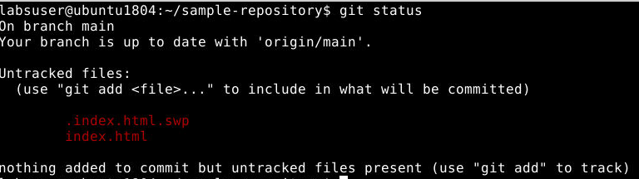

It shows the file is being modified.

**Step 4:** Using the **git add .** command to add the files to the staging area



**Step 5:** Executing **git commit --amend** to modify the most recent commit



* Editing the commit message in the text editor that shows up after executing the **amend** command. For instance, the commit message can be **Added style tags in the code**

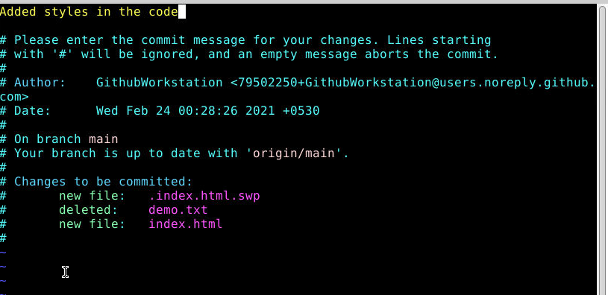

**Step 6:** Executing **git log --oneline** to check the recent commit with the modified message

