Lesson 3 Demo 6: Deleting Files in Git

This section will guide you to:

* Delete a file in Git

This lab has five subsections, namely:

1 Checking the list of files in the repository

2 Removing a file from the repository

3 Checking the list of files again

4 Executing **git status** to show that the removal of the file is still in staging and needs to be committed to the repository

5 Committing the changes

**Please note**: Make sure you have successfully completed all the previous demos of lesson 3.

**Step 1:** Checking the list of files in the repository

* In the terminal, go to your repository that you have cloned in the fourth demo of the second lesson. If you have not cloned the repository, ensure that you clone the repository as mentioned in that demo, and then enter the cloned repository directory using the **cd** command. Refer to the first demo of the third lesson to check the steps. Now, execute the following command to list all the files:

**git ls-files**

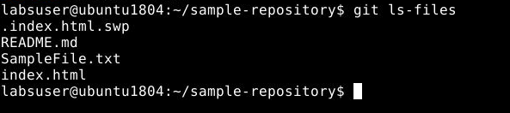

**Step 2:** Removing a file from the repository

* Use the following commandto remove the file from the repository:

**rm <YourFileName>**



**Step 3:** Checking the list of files again

* Use **git ls** command to check that the file is removed from the list

**git ls-files**

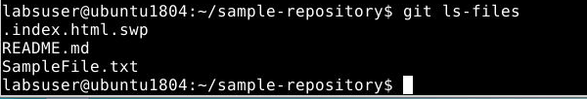

**Step 4:** Executing git status to show that the removal of the file is still in staging and needs to be committed to the repository

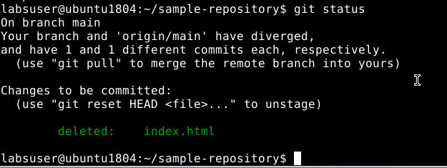

**Step 5:** Committing the changes

* Execute the **git add .** command
* Use the git commit command to commit the changes

**git commit -m “Removed file name”**

**Note**: Ensure that you provide the name of the file that you have deleted.

