Lesson 3 Demo 7: Ignoring Files in Git

This section will guide you to:

* Create .gitignore file

This lab has two subsections, namely:

1 Creating the .gitignore file

2 Checking the git status

**Please note**: Execute the following commands in a sample Git repository that you had created in the previous demos. Please complete all the previous demos of lessons two and three before you begin this demo.

**Step 1:** Creating the **.gitignore** file

Define the rules that you need to keep and save the file.

Example:

1. For readme in GitHub, I will only need a **README.md** file. I have ignored it if there is a **README.txt** file.
2. Also, I do not need a folder called *output*.
3. There will be no Java files added to the repository. So, I have ignored all the Java files.

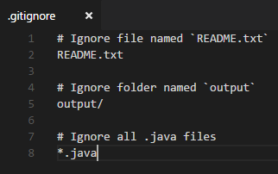

* In the terminal, execute the following commands to create the **.gitignore** file

**touch .gitignore**

**echo “README.txt”>>.gitignore**

**echo “output/”>>.gitignore**

**echo “.java”>>.gitignore**

**Step 2:** Checking the git status

If you try to add those files to the Git repository, they will be ignored.

* Use the following commands to create the .gitignore file

**git status**

