Lesson 3 Demo 1: Demonstrate the Centralized Git Workflow

This section will guide you to:

* Demonstrate the Git workflow

This lab has five subsections, namely:

1. Cloning a GitHub repository
2. Adding a file to the cloned repository
3. Checking the status of the repository
4. Adding the file to the staging area
5. Committing the changes and pushing the files to the GitHub repository

**Please note**: A **sample-repository** is already created in the second demo of the second lesson. If you do not have a sample-repository, first perform that demo, and then execute the steps from this demo. Also, check the fourth demo of the second lesson to understand how to clone a Git repository and then proceed with this demo.

**Step 1:** Cloning a GitHub repository

* Clone a GitHub repository in the local machine **(Refer to demo 4 of lesson 2)**
* Once you clone the repository using the command  
  **git clone <your_repository_name.git>**,you will see the repository created as shown below
* In this case, I have the repository name as sample-repository

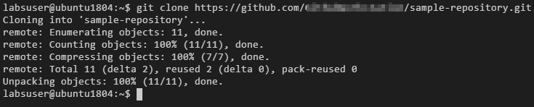

* Go to the repository folder using the **cd** command

**cd sample-repository/**

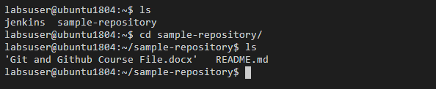

**Step 2:** Adding a file to the cloned repository

* Use the following command to add a **demo.txt** file:

**touch demo.txt**

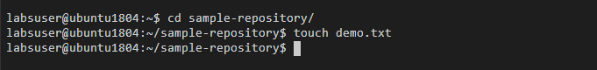

**Step 3:** Checking the status of the repository

* Use the following command to check the status of the repository:

**git status**

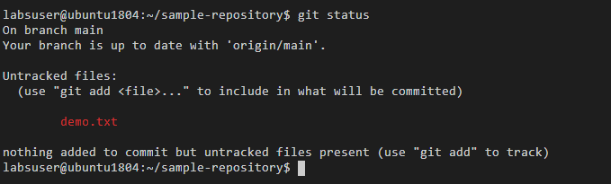

**Note:** It shows that you are on the branch master, and an **untracked file**, is available in the repository. An untracked file is the one which is not added to Git, and Git is not able to track it.

**Step 4:** Adding the file to the staging area

* Use the following command to add the file to the staging area:

**git add demo.txt**

* Check the repository status again

**git status**

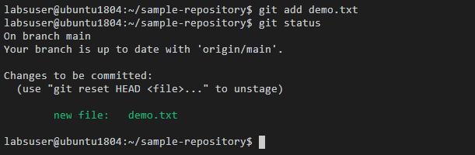

**Step 5:** Committing the changes and pushing the files to the GitHub repository

* Use the following command to commit the changes in the repository:

**git commit -m “Third commit: Added a txt file”**

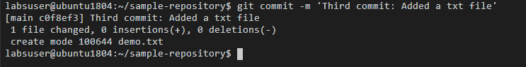

* Use the following command to push the file to the main branch:

**git push origin main**

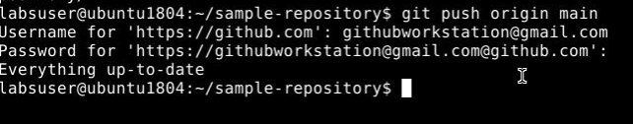

**Note**: Enter the username and password for the GitHub account to get the desired output as shown in the screenshot above.   
Also, if the command above throws an error, you can use: **git push -u origin master**