Lesson 3 Demo 2: Jenkins Setup

This section will guide you to:

* Download and set up the Jenkins app

This lab has two sub-sections, namely:

1. Downloading the Java Runtime Environment

2. Downloading and installing the Jenkins app

**Step 1:** Downloading the Java Runtime Environment

* Open the terminal
* Run ***sudo apt update*** to update the package lists
* Run ***sudo apt install openjdk-8-jdk*** to install the Java Runtime Environment
* Run ***java -version*** to verify the installation. It will print the JDK version as shown below:

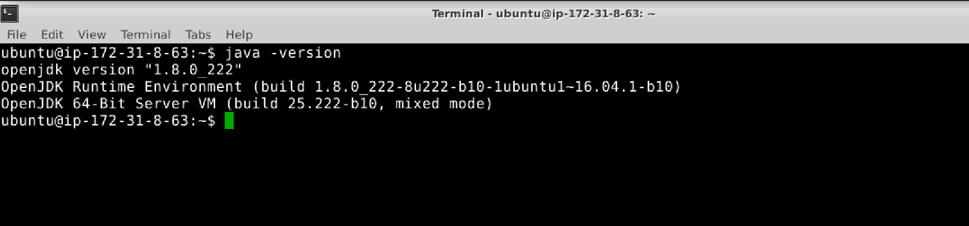

**Step 2:**  Downloading and installing the Jenkins app

* Open the terminal
* Run ***wget -q -O - https://pkg.jenkins.io/debian/jenkins.io.key | sudo apt-key add -*** to install Jenkins
* Run the command ***sudo sh -c 'echo deb http://pkg.jenkins.io/debian-stable binary/ > /etc/apt/sources.list.d/jenkins.list'.***
* Run ***sudo apt install jenkins*** to install Jenkins
* Run ***sudo service jenkins*** ***status*** to check the status of the installation
* Run ***sudo /etc/init.d/jenkins start*** to start Jenkins
* Jenkins will now open up at port 8081, you will need to enter the initial password.

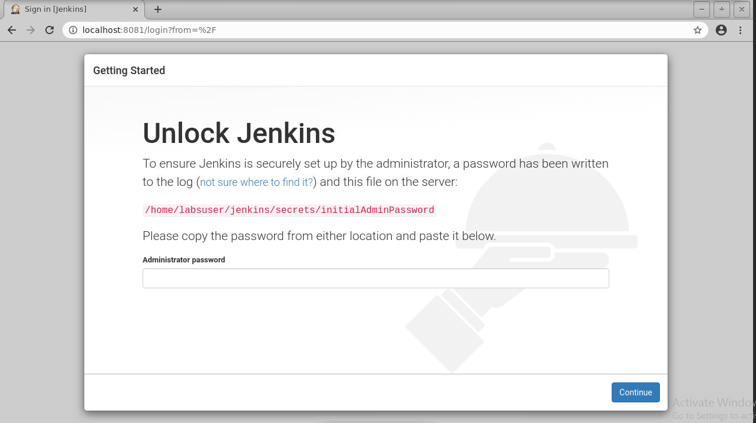

* ***In your terminal run the following command   
    
  $ cat jenkins/secrets/initialAdminPassword***



* Copy this password and paste it on your jenkins page in the browser
* Now, click on **install the suggested plugins**

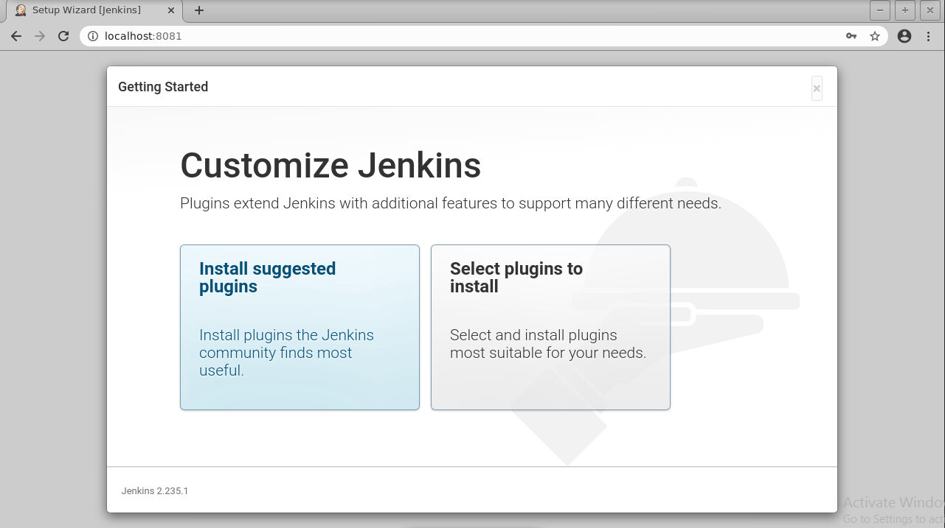

* You can either create an admin user or skip and continue as admin. Select **skip and continue as admin**
* In the Instance configuration page click **continue** and click on the **start using Jenkins button**
* Now, you can work with Jenkins as shown in the screenshot below:

