Lesson 3 Demo 4: Building a Maven Project

This section will guide you to:

* Build a Maven project in Jenkins

This lab has four sub-sections, namely:

1. Configuring git on Jenkins
2. Forking a sample repository
3. Creating a Jenkins build job to build a Maven project
4. Building the Maven project

**Step 1:** Configuring git on Jenkins.

* Go to ***Manage Jenkins*** from the Jenkins dashboard and select ***Global Tool Configuration***
* Scroll down to the ***Git*** section and click on ***Add git***

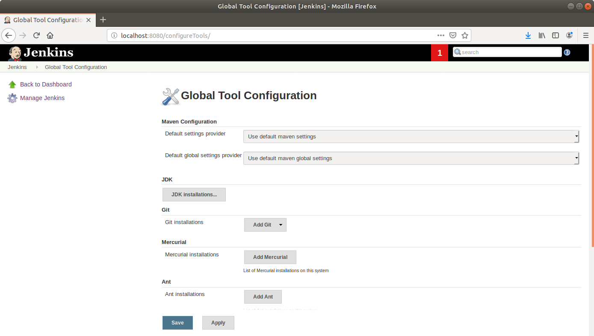

* Enter a **name** to refer to the git installation
* Enter the path to git at the *Path to git executable field (****/usr/bin/git****)* and click **Save**

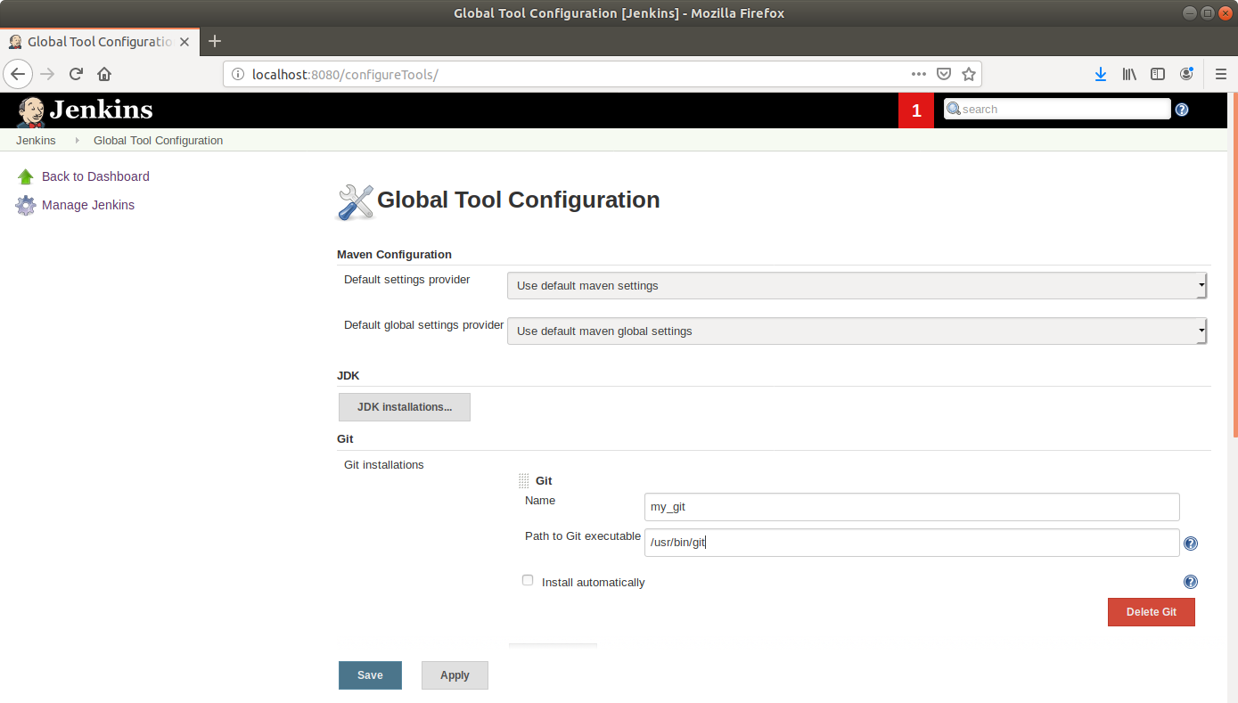

**Step 2:** Forking a sample repository

* Log in to your Github account
* Navigate to <https://github.com/jenkins-docs/simple-java-maven-app> and click on ***Fork***

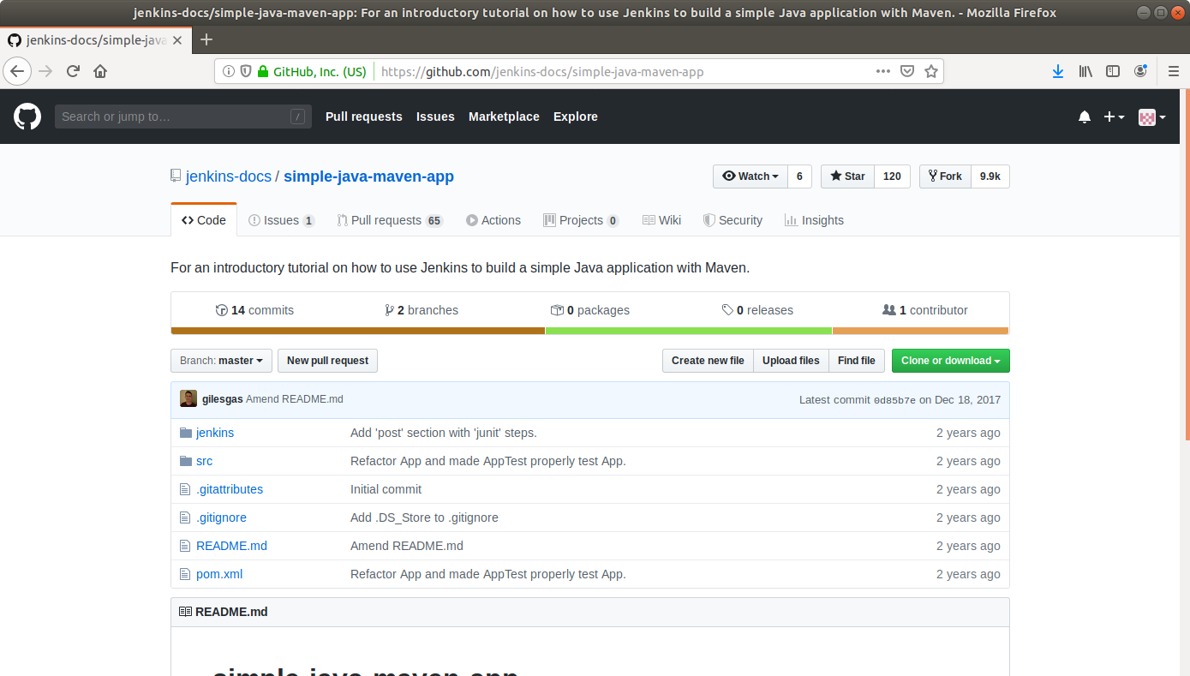

* Open the terminal
* Run ***git clone [Forked_REPO URL]*** to clone the repo locally

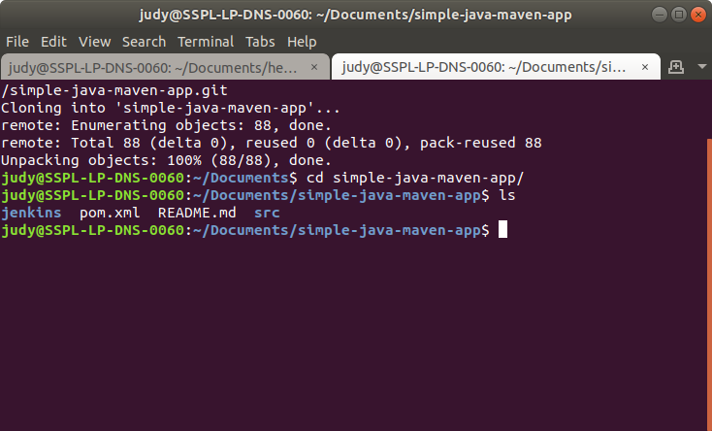

**Step 3:** Creating a Jenkins build job to build a Maven project

* Select ***Maven Project*** as the build job type

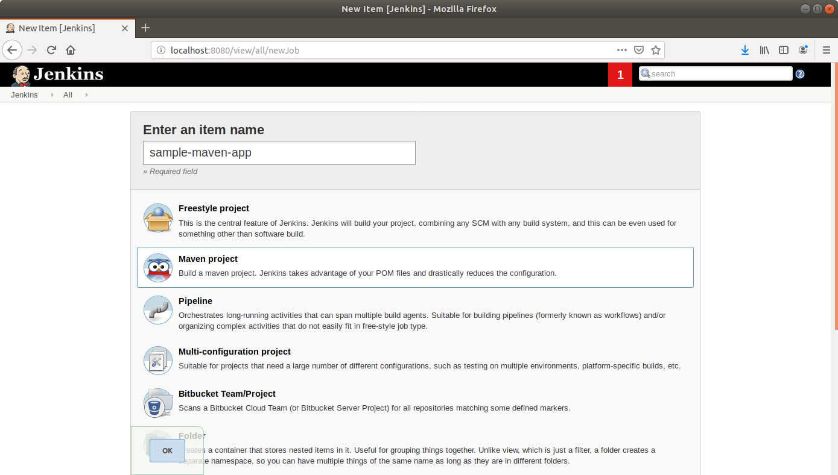

* Click ***OK***
* Leave the defaults as they are and scroll down to the ***Source Code Management*** section
* Select ***Git***
* Enter the local path to the app directory in the Repository URL field

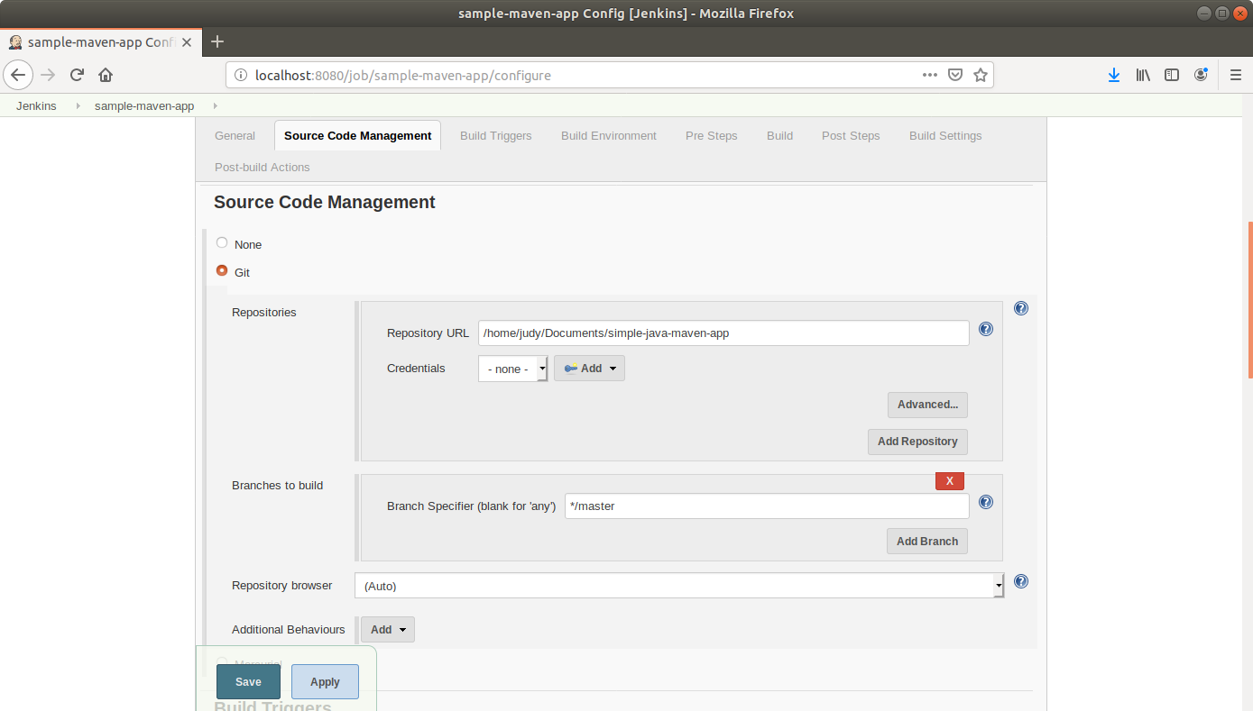

* Click ***Save***.

**Step 4:** Building the Maven project

* Click on the project name in the Jenkins **dashboard**
* Click ***Build Now*** in the project window. Jenkins will now build your project.

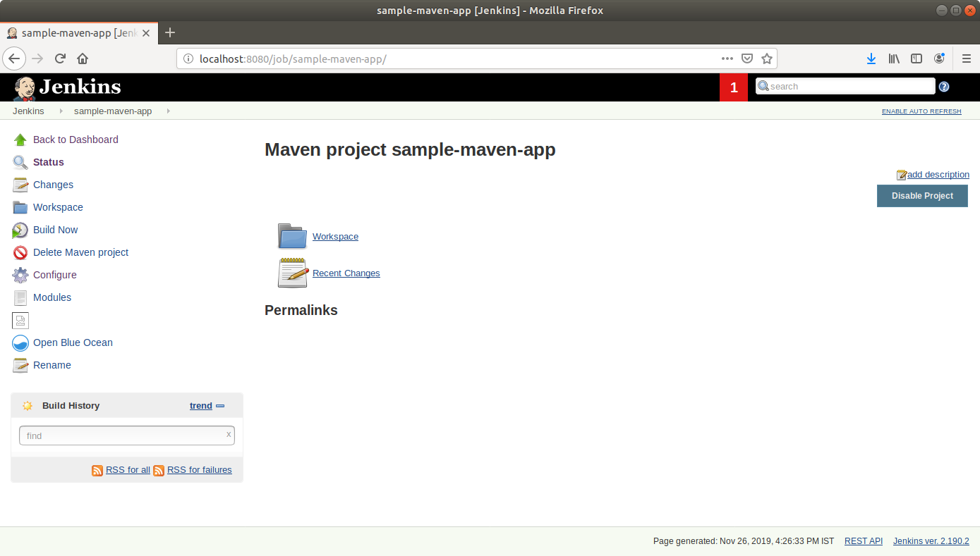

* Click on the ***Build History***to view the build results
* Click on the ***Console Output*** to view the build logs

