Lesson 4 Demo 4: Post-build Actions

This section will guide you to:

* Configure post-build actions

This lab has two sub-sections, namely:

1. Configuring SMTP settings to enable email alerts in Jenkins

2. Defining post-build actions in a build and testing the SMTP settings

**Step 1:** Configure SMTP settings to enable email alerts in Jenkins

* Go to Jenkins **dashboard**
* Click on **Manage Jenkins** in the Jenkins dashboard and select **Configure System**

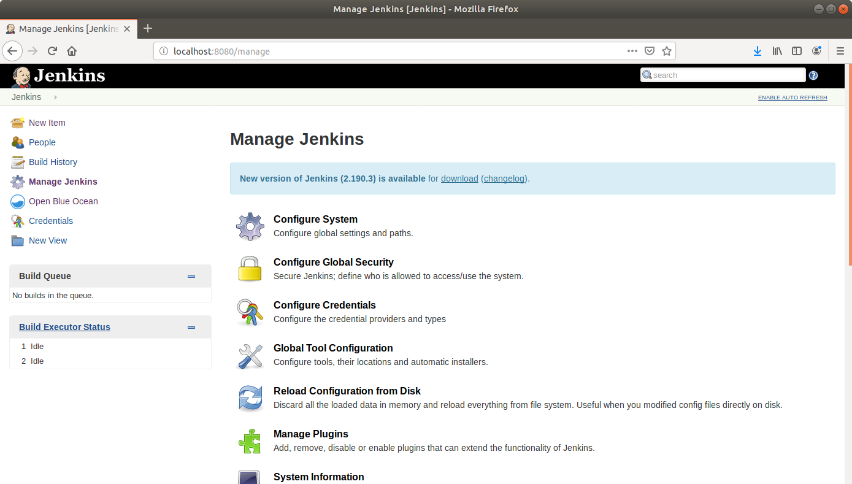

* Scroll down to the end of the page to the **Email Notification** section
* Click on the **Advanced**button to reveal advanced settings
* Fill the fields with appropriate values as shown below:

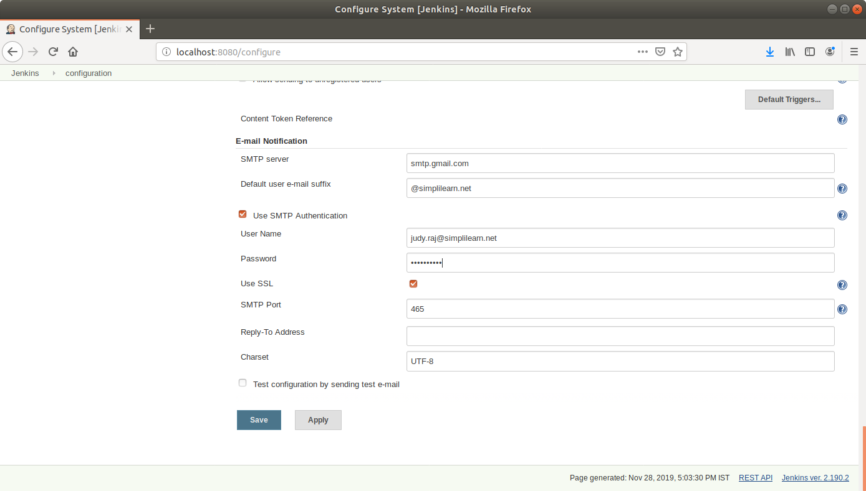

**SMTP server**: smtp.gmail.com

**Default user email suffix**: @gmail.com

**User Name**: <your email Id>

**Password:** <your password>

**Tick** the Use SSL checkbox

**Port**: 465

* Select the ***Test configuration*** *by sending test e-mail* and enter a recipient email to test the configuration
* **Note:** In case your test configuration mail fails reporting **Authentication Error: Bad password** you will have to make sure that you have turned the **Allow Less secure Apps: ON** in your Google account settings.
* Click **Save**

**Step 2:** Defining post-build actions in a build and testing the SMTP settings

* Go to Jenkins **dashboard**
* Click on **New Item**
* Enter a **name** for your build job
* Select **Freestyle project**as the build job type

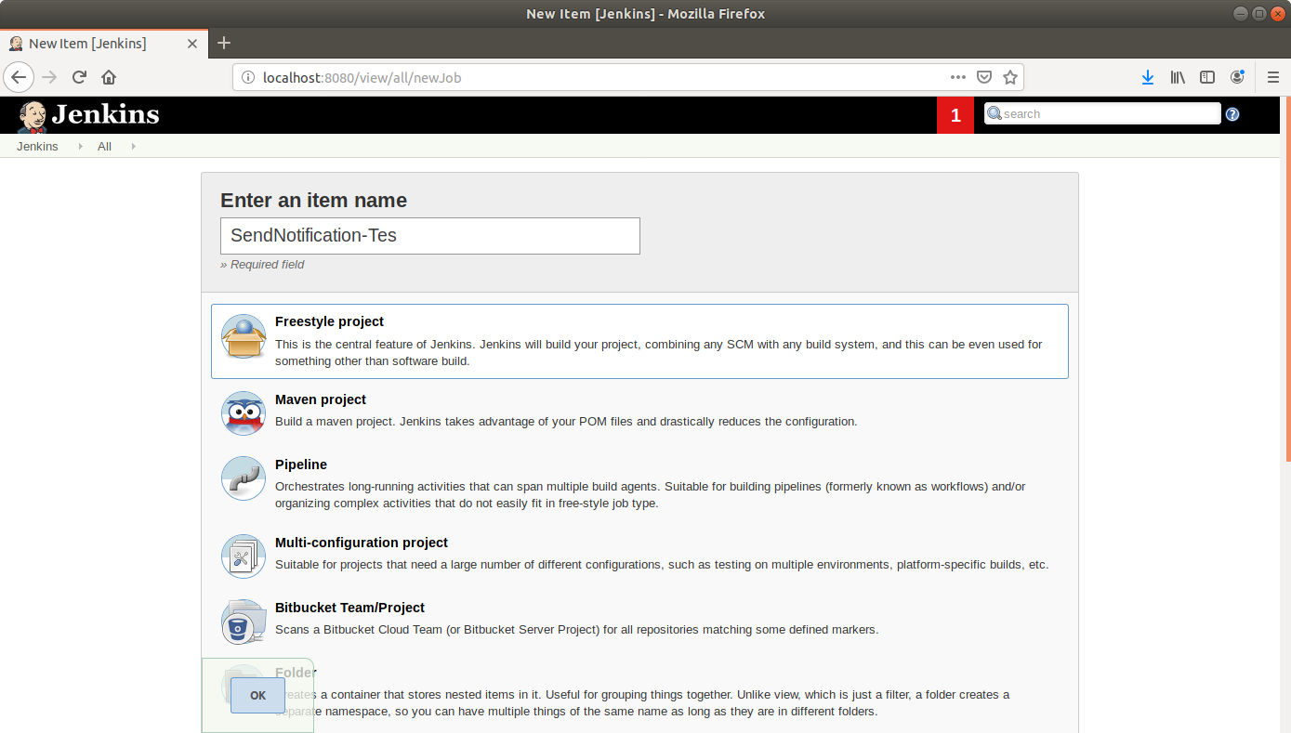

* Click **OK**
* Scroll down to the **Source Code Management** section and select **Git**
* Enter the link to the repository in the field that appears

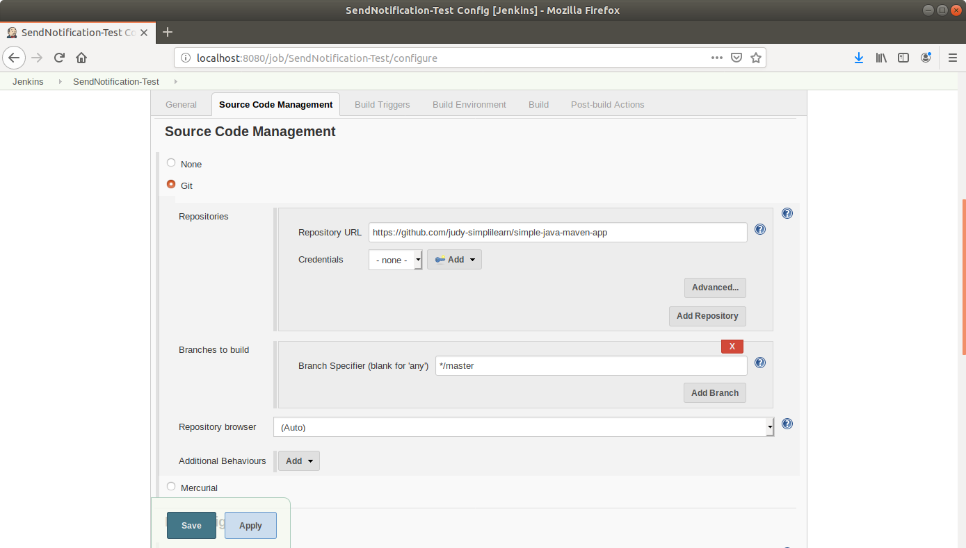

* Scroll down to the**Build** section and click on **Add build step**
* Select**Execute Shell**from the drop-down that appears
* Enter the following maven command in the textbox that appears:  
  **mvn compile**

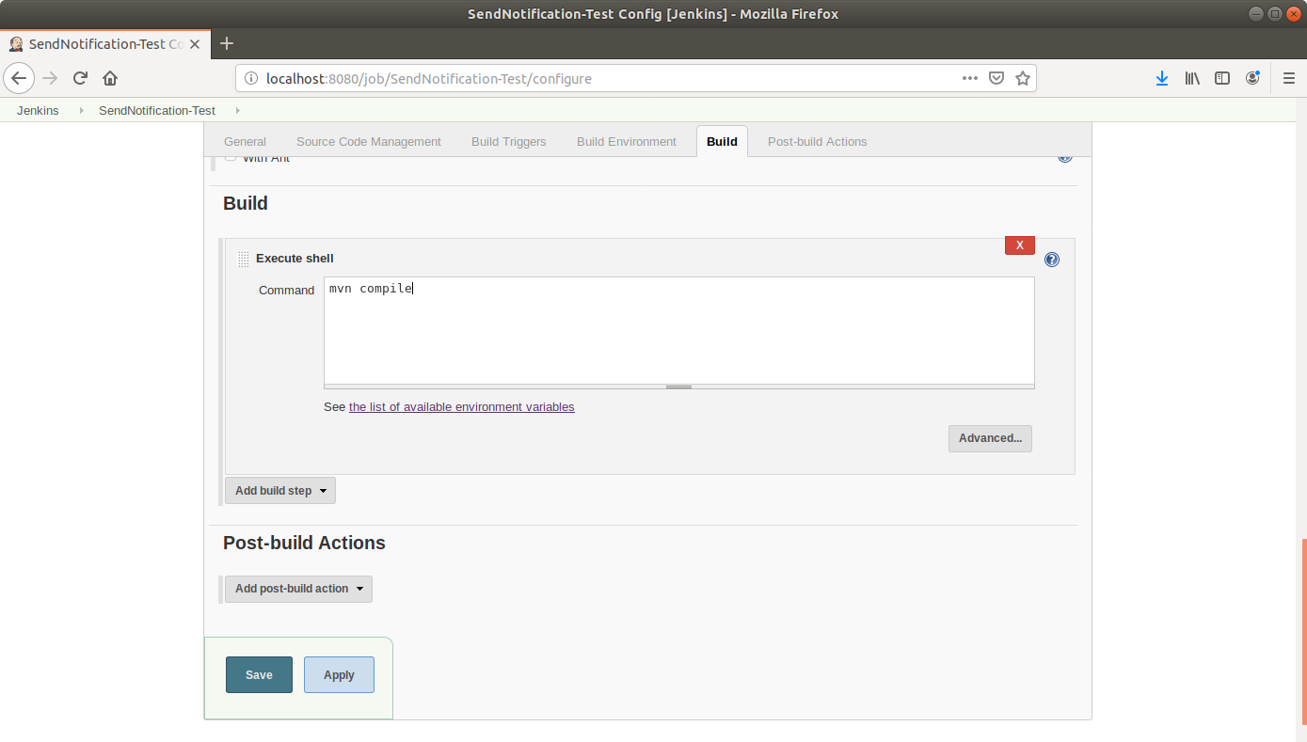

* Scroll down to the **Post-build Actions** tab and click on the **Add post-build action** button
* From the drop-down, select **Email notification** and fill the recipient address in the textbox that appears

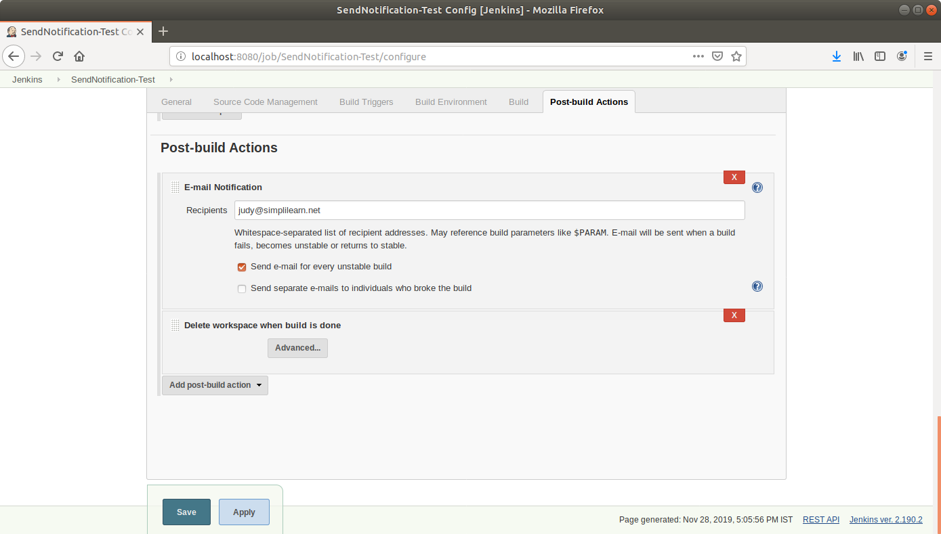

* Click on the **Add post-build action**button
* From the drop-down, select **Delete workspace****when build is done**
* Click **Save**
* Introduce an error in the Maven project to be built and commit to Git. An extra build tag is added in the **pom.xml** below

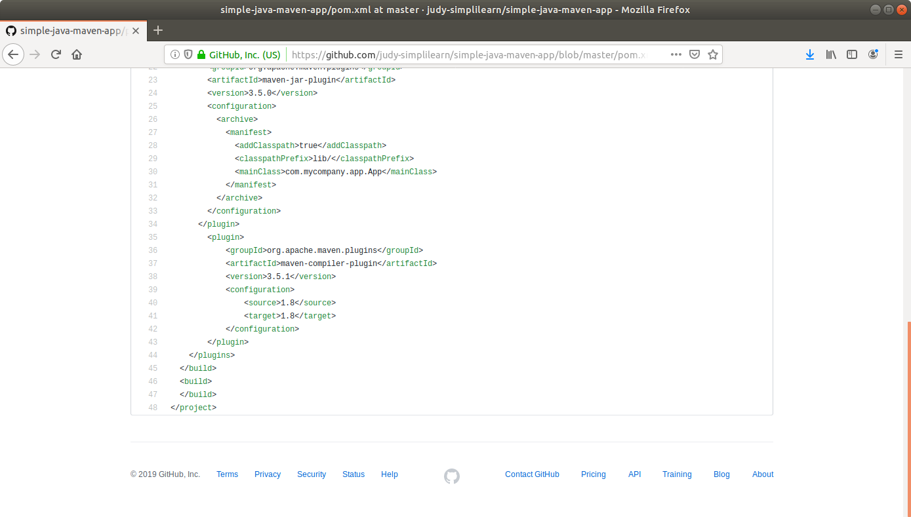

* Click **Build Now** in the project window to make sure that the build works. Jenkins will now build your project
* Click on the **Build History**to view the build results
* Click on the **Console Output** to view the build logs

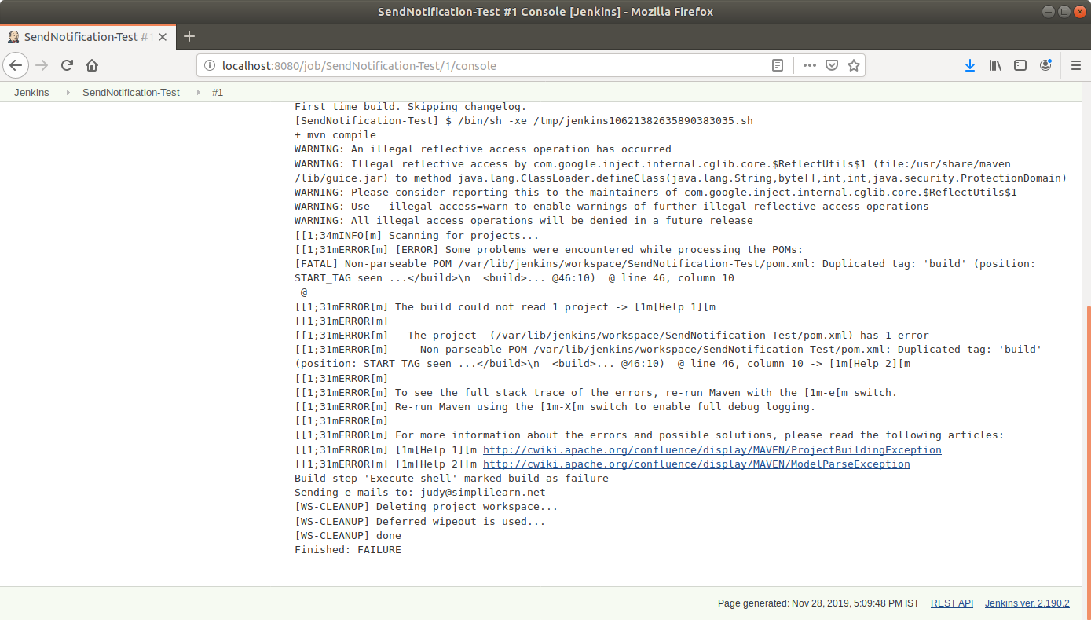

* Check the **email** to see the notification

