Lesson 4 Demo 5: Building Projects with Gradle

This section will guide you to:

* Build projects with Gradle in jenkins

This lab has three sub-sections, namely:

1. Configuring Gradle plugin for Jenkins

2. Creating a Gradle project

3. Building a project with Gradle in Jenkins

**Please Note**: Gradle plugin is installed by default. In case you don’t have it installed, you can install the same by following the step 1.

**Step 1:** Configuring Gradle plugin for Jenkins

* Go to Jenkins dashboard
* Click on **Manage Jenkins** and select **Manage Plugins**

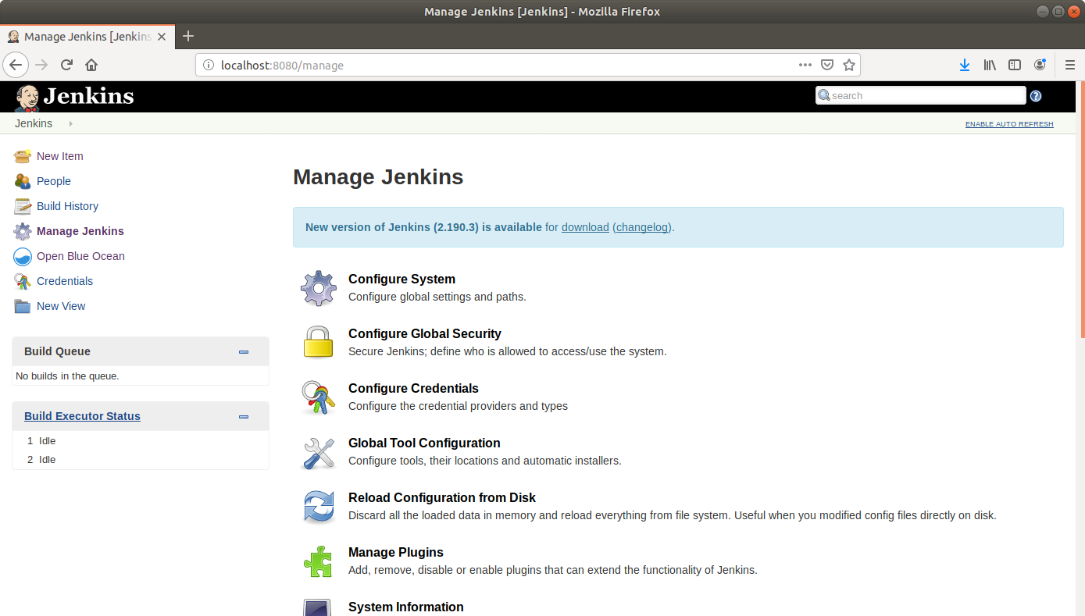

* Under the **Available** tab, select **Gradle**.

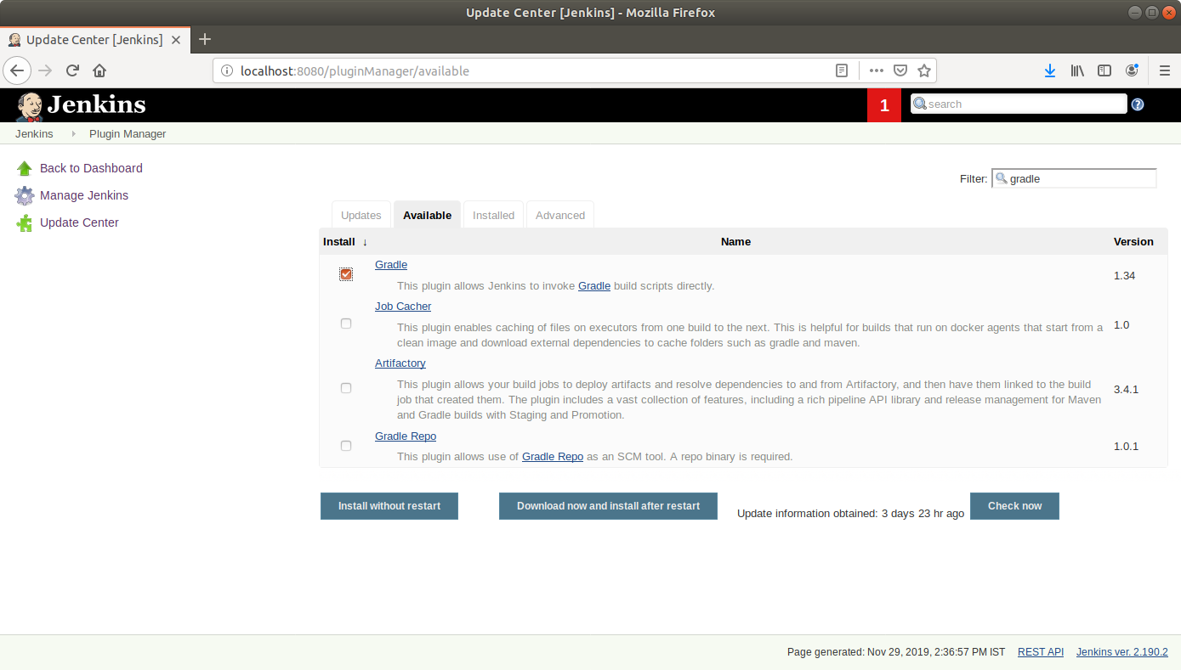

* Click on **Install without restart** and the plugin will be installed

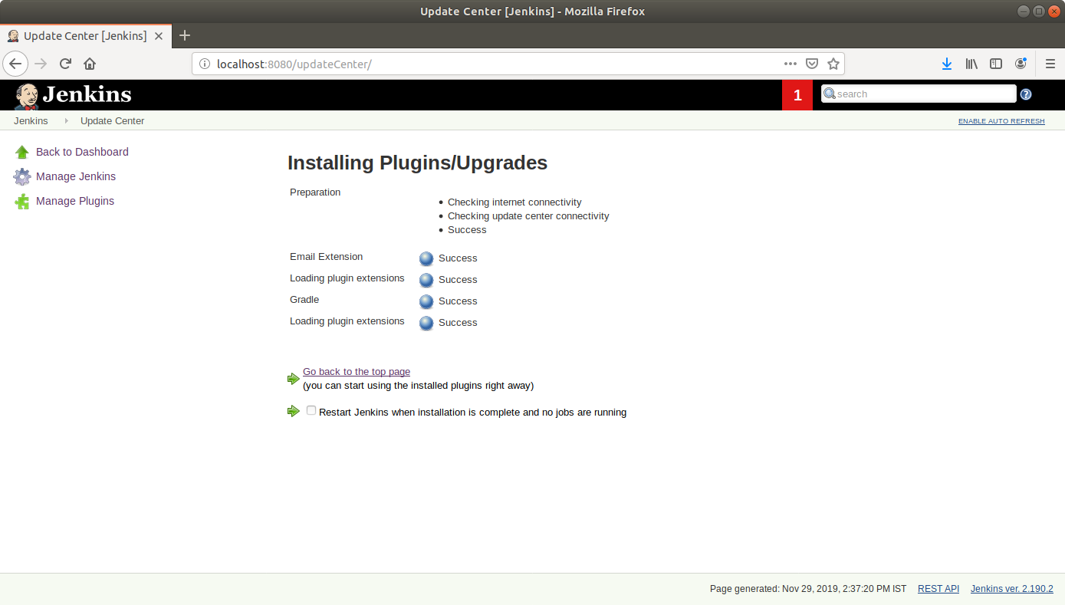

* Click on **Manage Jenkins**and select **Global Tool Configuration***.*
* Scroll down to the **Gradle** section and click on **Add Gradle**.

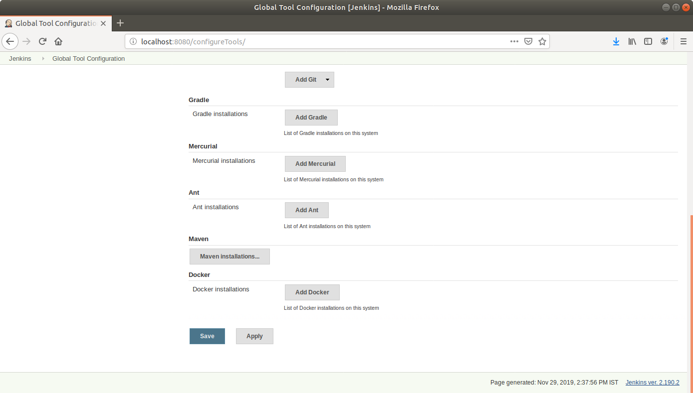

* Check the **Install automatically** box and specify a name for the installation

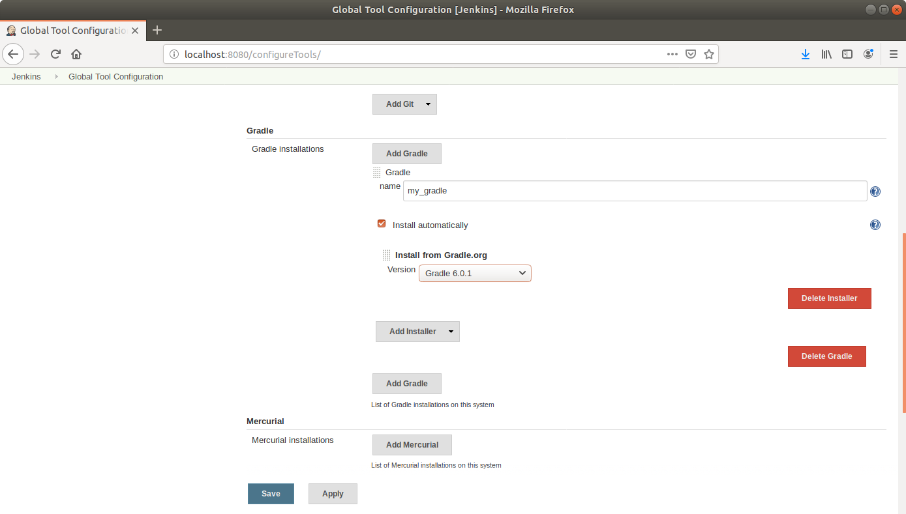

* Click **Save**

**Step 2:** Creating a Gradle project

* Open the terminal
* If you don’t have gradle installed, run **sudo apt-get install gradle** command
* Create a new directory and navigate to it  
  **mkdir gradle-demo   
  cd gradle-demo**
* Run **gradle init** to create a sample gradle project

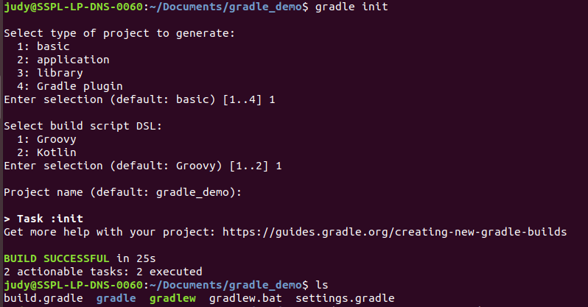

* Go to github.com and create a new repository

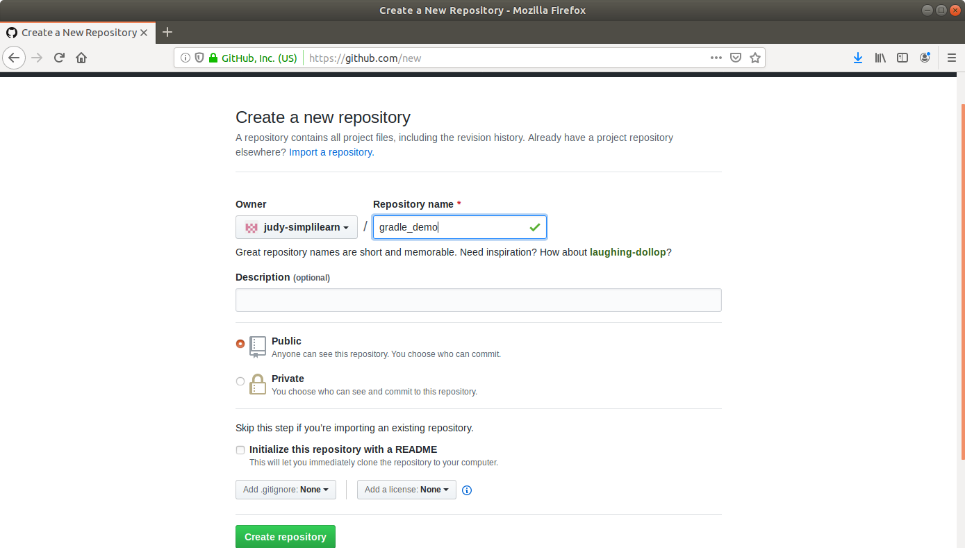

* Push the gradle project to the repository as shown below:  
   **git init**

**git add .**

**git commit -m “First Commit”**

**git remote add origin <your repository URL>**

**git push -u origin master**

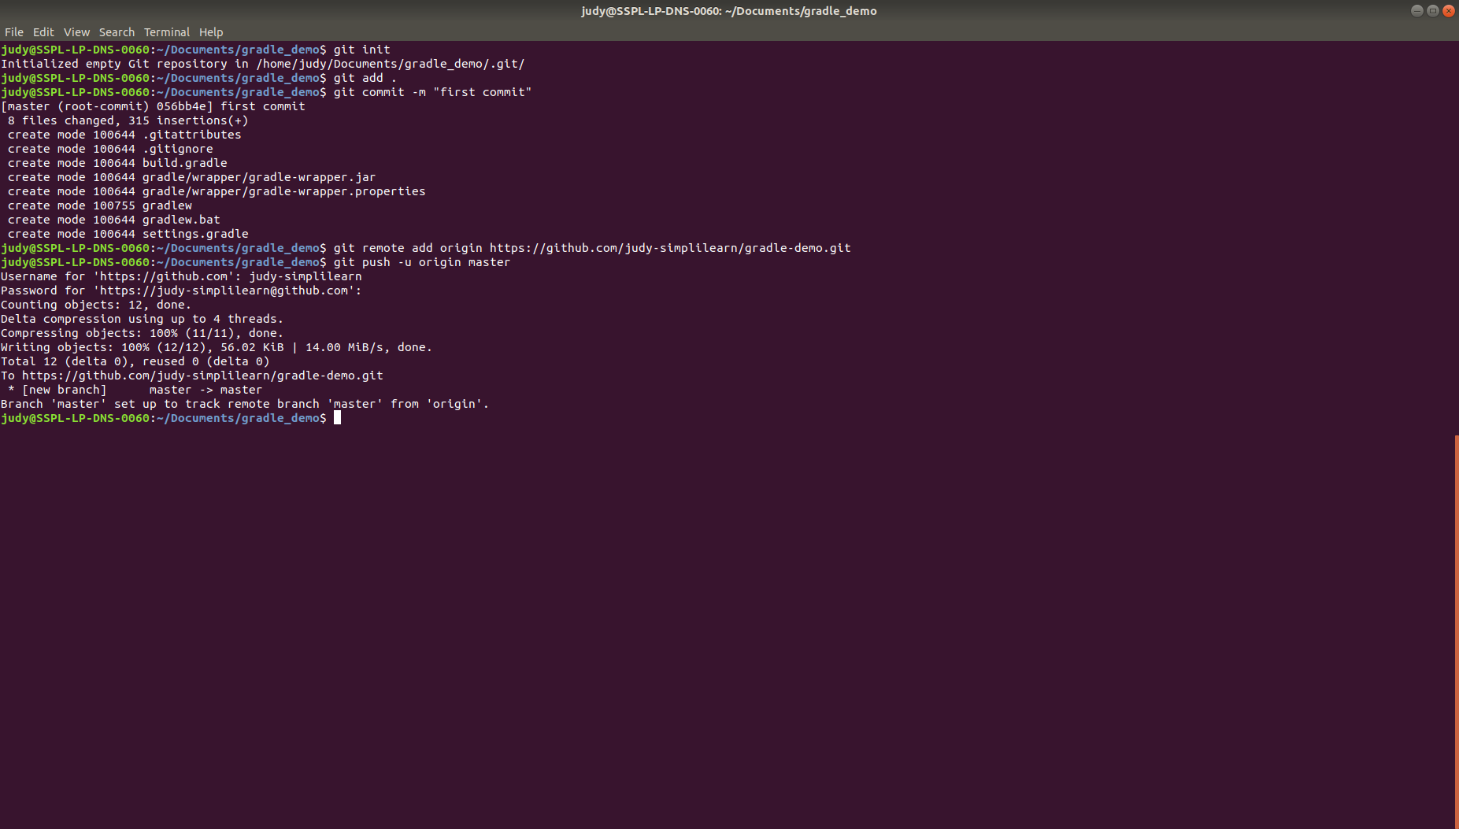

**Step 3:** Building a project with Gradle in Jenkins

* Go to Jenkins dashboard
* Click on **New Item**.
* Enter a **name** for your build job.
* Select **Freestyle project**as the build job type.

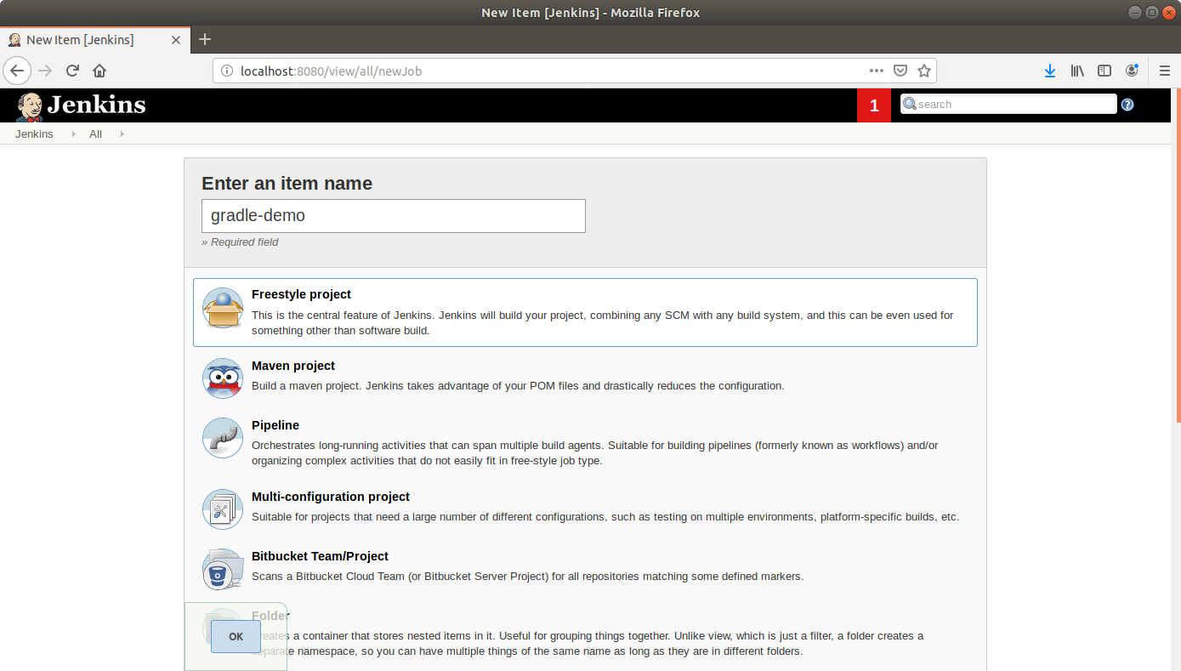

* Click **OK**
* Scroll down to the Source Code Management section and select **Git**
* Enter the link to the repository in the field that appears

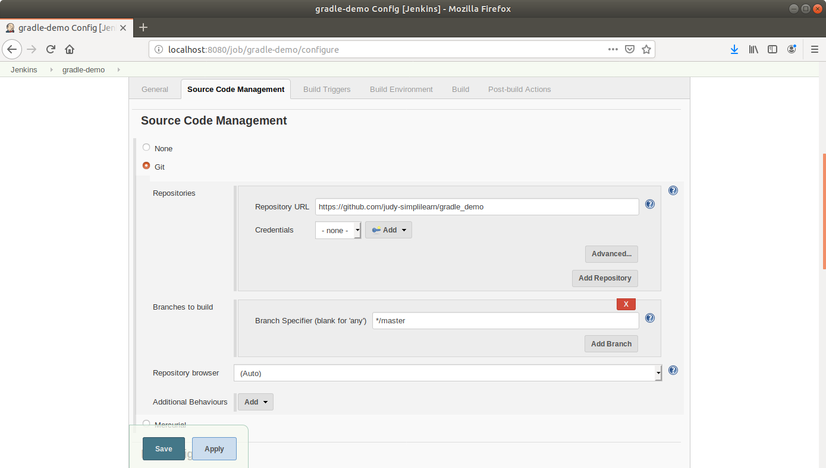

* Scroll down to the**Build** section and click on **Add build step**
* Select**Invoke Gradle Script**from the drop down that appears
* Fill up the form as shown below:

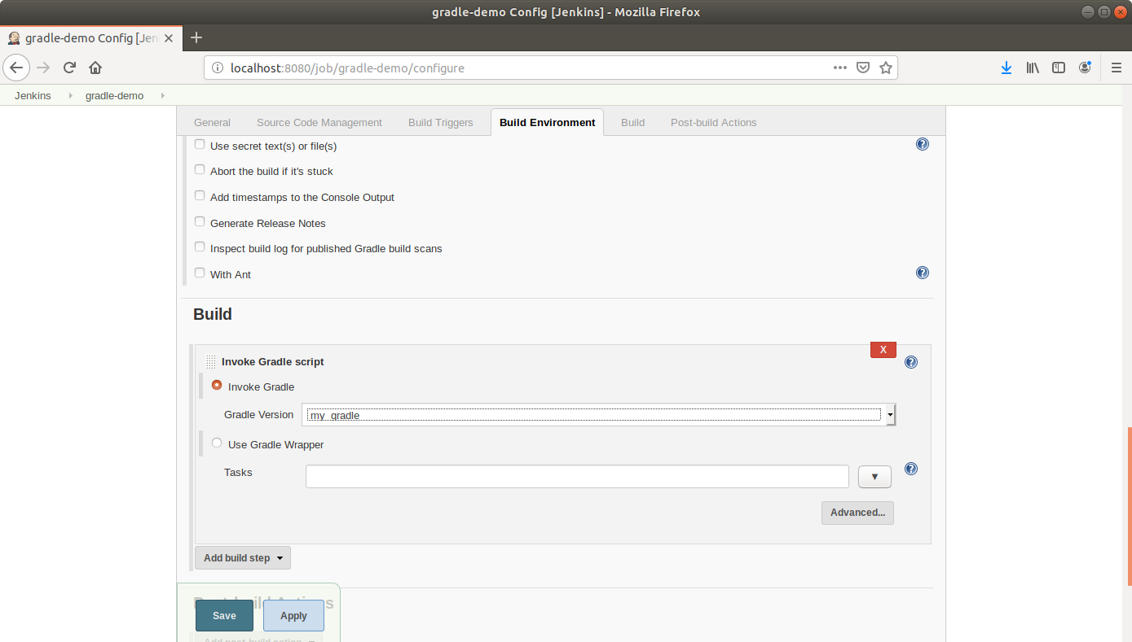

* Scroll down to the **Post-build Actions** tab and click on the **Add post-build action** button
* From the drop down, select **Email notification**and fill the recipient address in the textbox that appears
* Click **Save**
* Click **Build Now** in the project window to make sure that the build works. Jenkins will now build your project
* Click on the **Build History**to view the build results
* Click on the **Console Output** to view the build logs