Lesson 4 Demo 6: Parameterized Builds

This section will guide you to:

* Configure parameterized builds in Jenkins

This lab has two sub-sections, namely:

1. Configuring a parameterized build in Jenkins

2. Building a project with parameters in Jenkins

**Step 1:** Creating a parameterized build

* Go to Jenkins **dashboard**
* Click on **New Item**
* Enter a **name** for your build job
* Select **Freestyle project**as the build job type

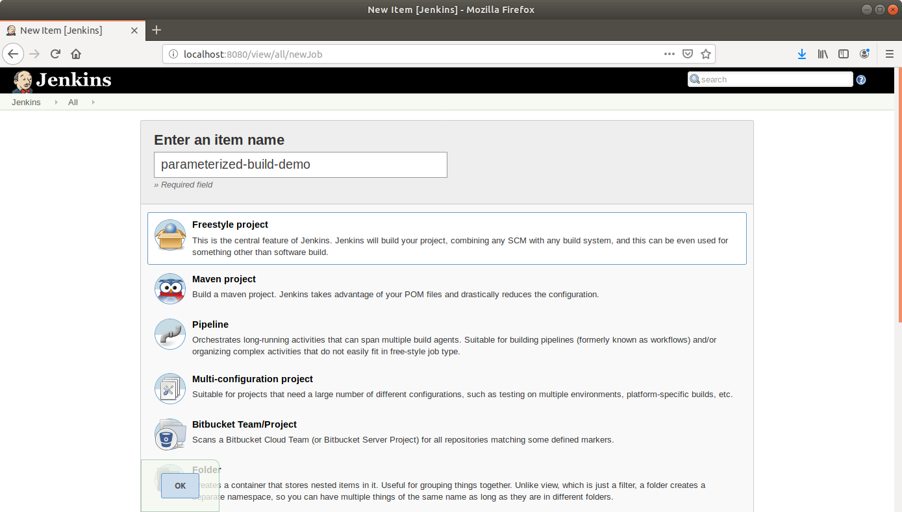

* Click **OK**
* On the configuration page, **select** the checkbox next to text that states,**This project is parameterized**
* Click on the **Add parameter** button

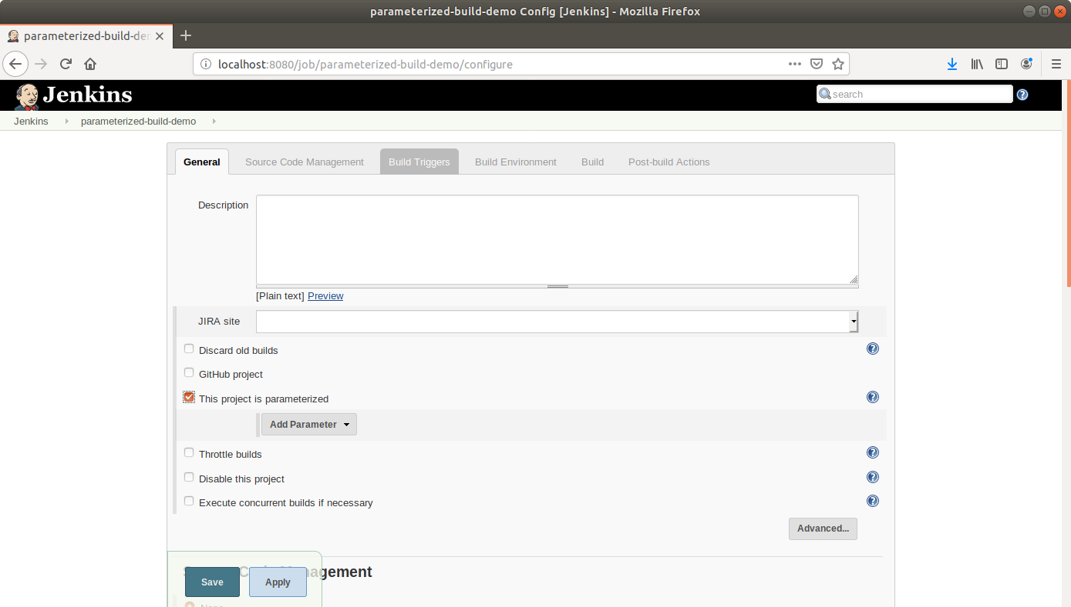

* From the drop-down menu, select **Boolean parameter**.
* Name the Boolean parameter **generate_javadoc** and enable the **Default Value** checkbox.

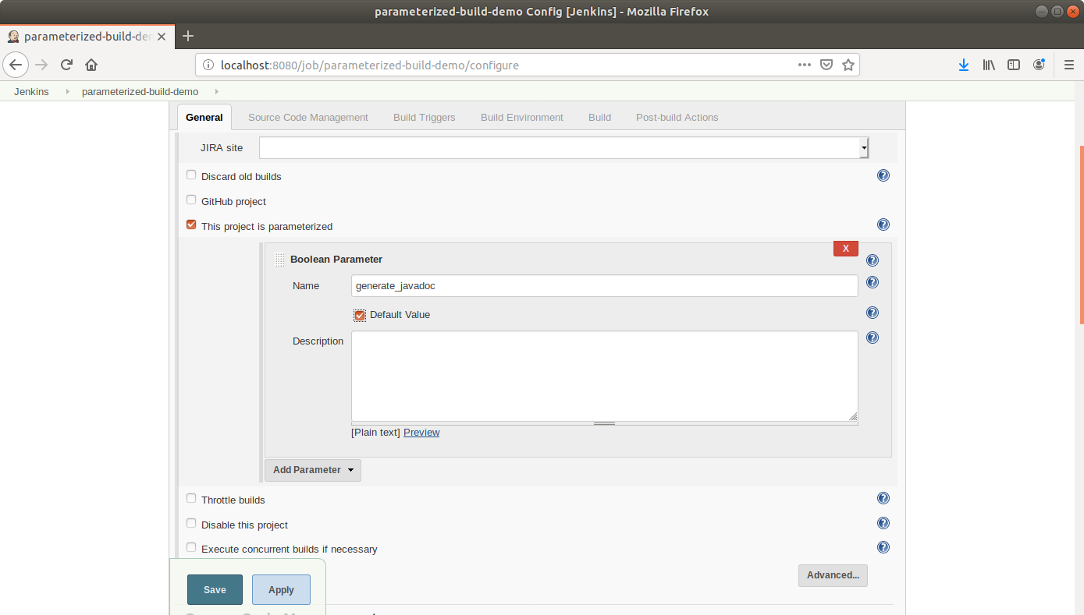

* Click the **Add Parameter** drop-down list again and choose a string parameter. Name this Jenkins build parameter **javadoc_location** and give it a default value(/home/labuser/).

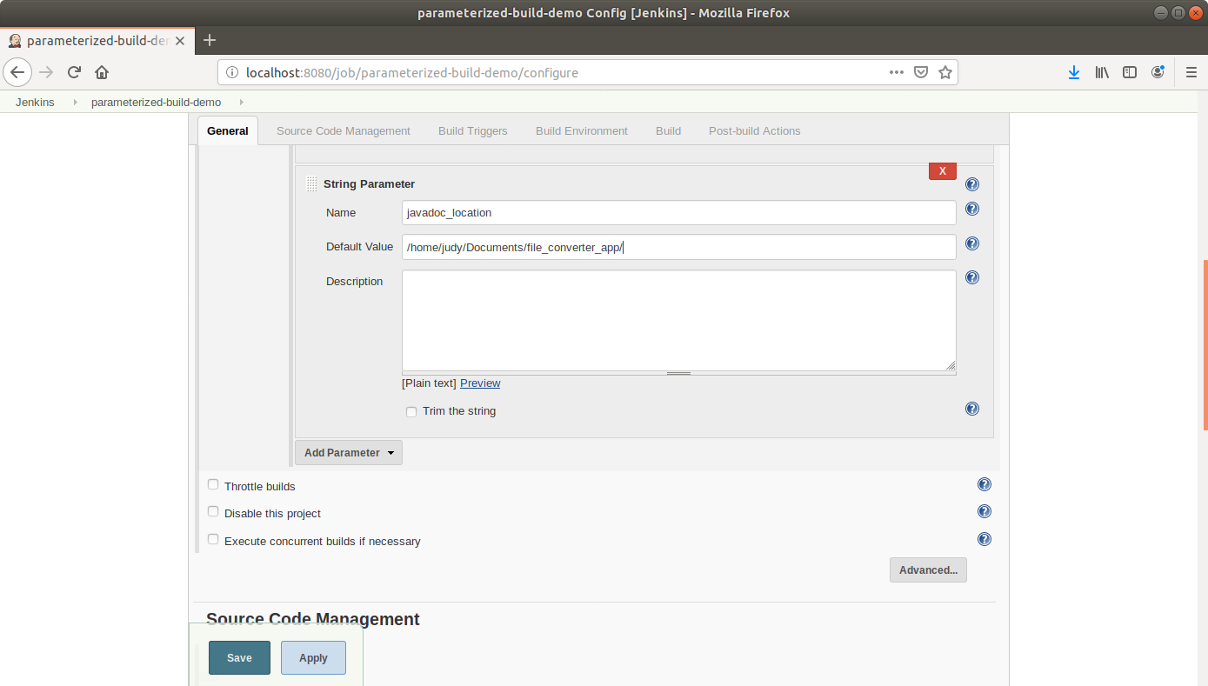

* Scroll down to the**Build** section and click on **Add build step**
* Select**Execute Shell Command**from the drop-down that appears

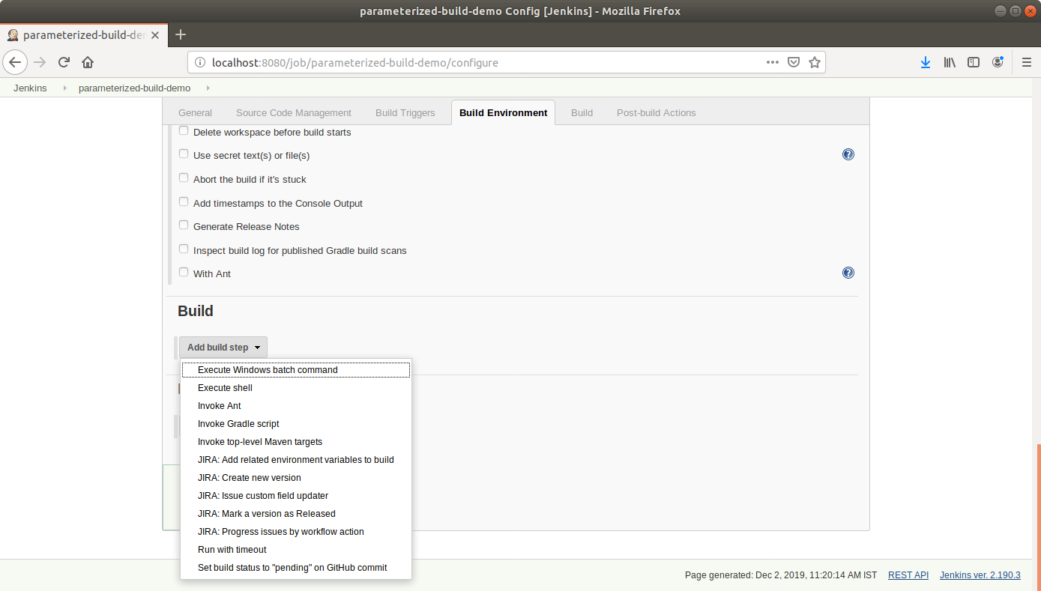

* In the text input area, enter the following text:

**echo $generate_javadoc**

**echo $javadoc_location**

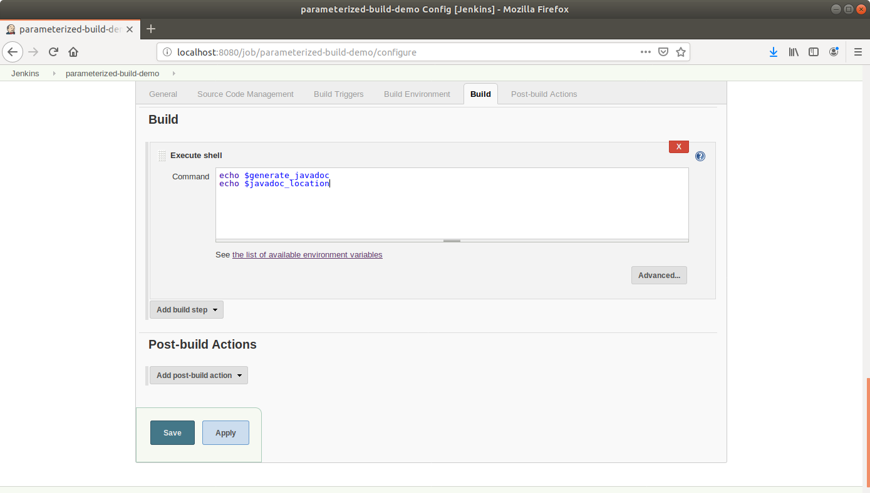

* Click **Save**

**Step 2:** Building a project with parameters in Jenkins

* Click **Build With Parameters** in the project window to make sure the build works

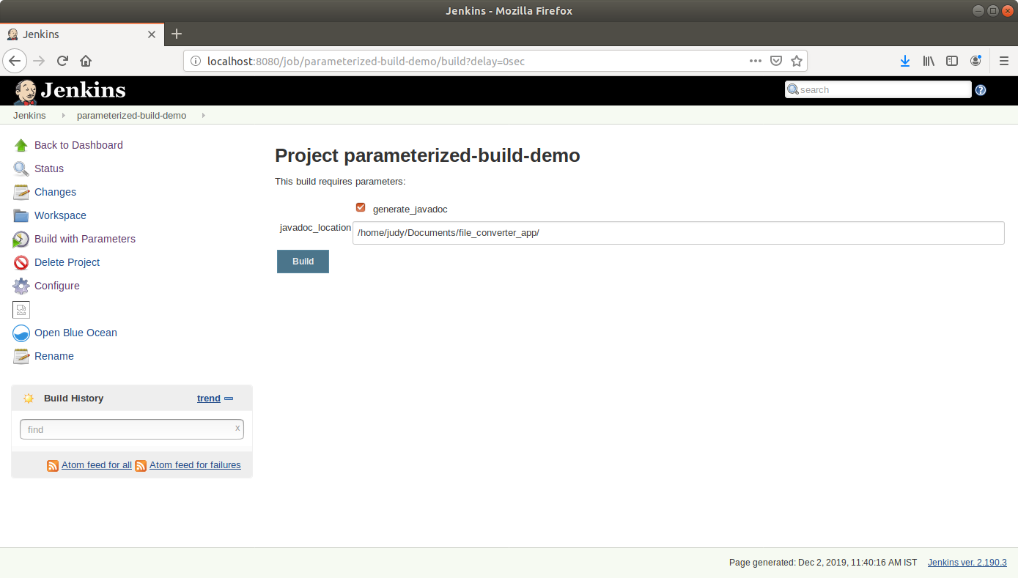

* In the page that appears, accept the defaults and click the **Build** button. Jenkins will now build your project.
* Click on the **Build History**to view the build results
* Click on the **Console Output** to view the build logs

