Lesson 4 Demo 7: Building from Tags

This section will guide you to:

* Configure a build job in Jenkins to build from a Git tag

This lab has three sub-sections, namely:

1. Adding the Git parameter plugin to Jenkins

2. Creating a tag in Git

3. Building a project from a Git tag in Jenkins

**Step 1:** Adding the Git parameter plugin to Jenkins

* Go to Jenkins **dashboard**
* Click on **Manage Jenkins** in the Jenkins dashboard and select **Manage Plugins**

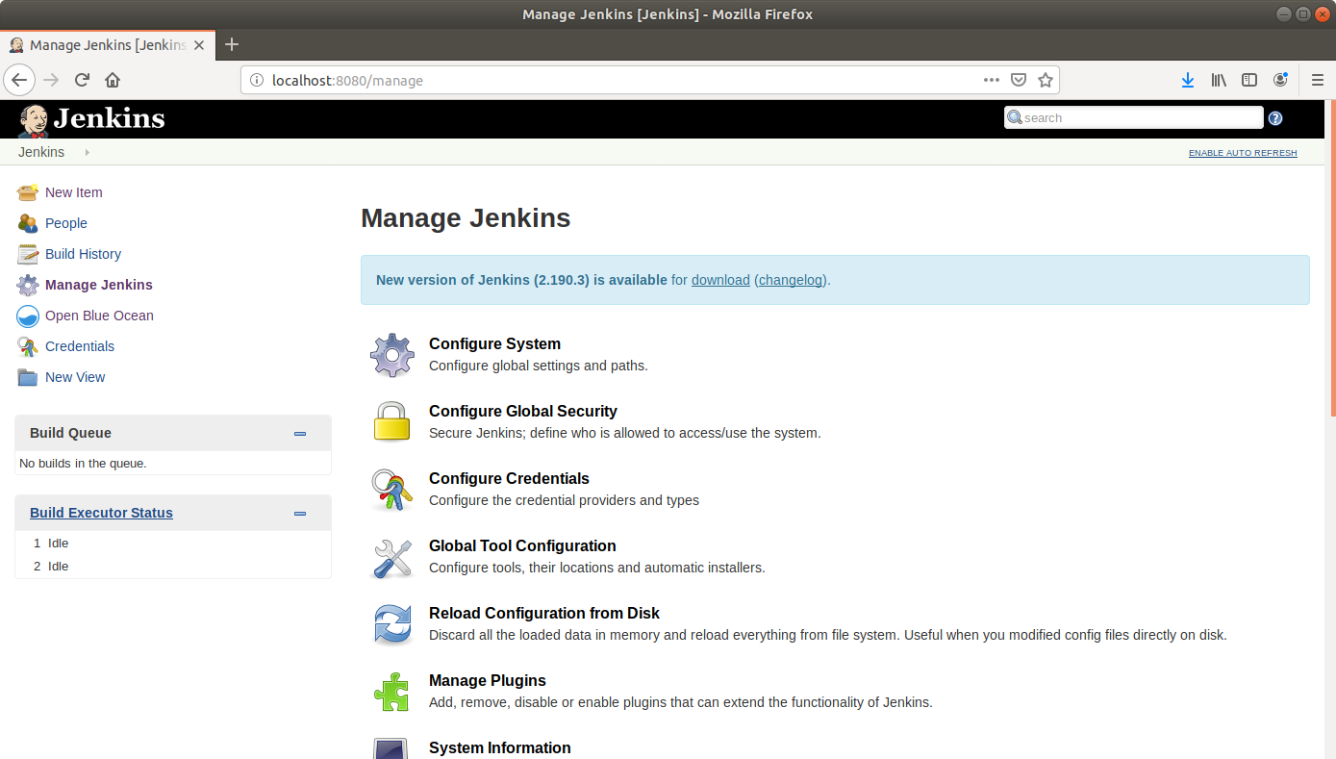

* Under the **Available** tab, select **Git Parameter**

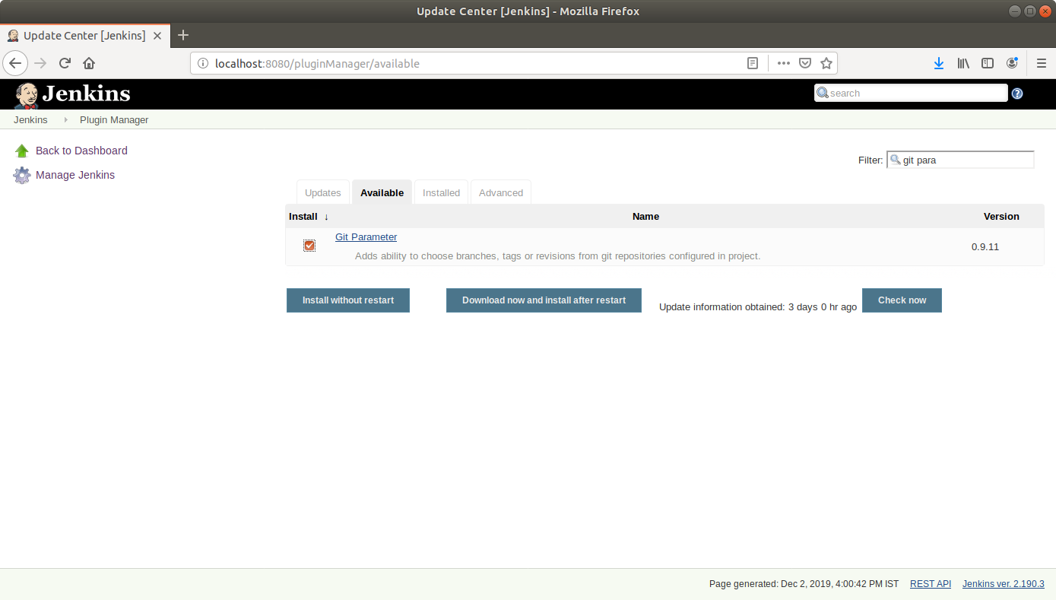

* Click on **Install without restart** and the plugin will be installed

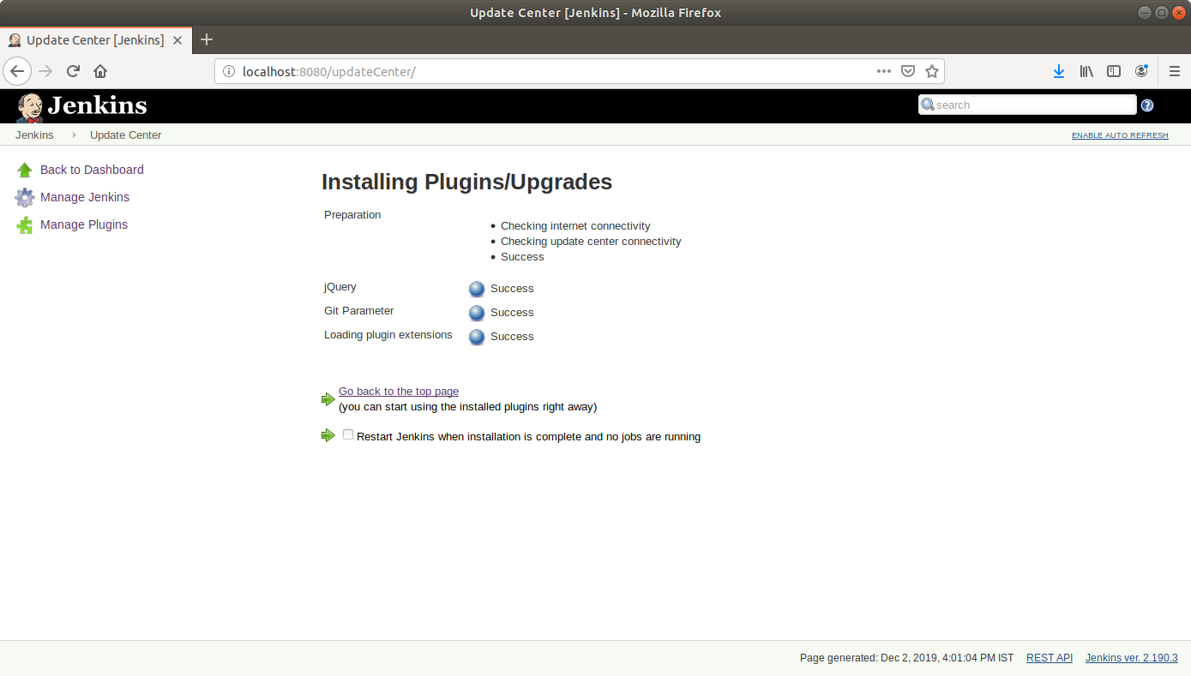

**Step 2:** Creating a tag in Git

* Go to **github.com** and open a repository  
    
  **Please note:** You can use the **sample-java-maven-app** repository that we created in the previous demos. You can also use any other repository that you had created earlier.
* Click on the releases tab

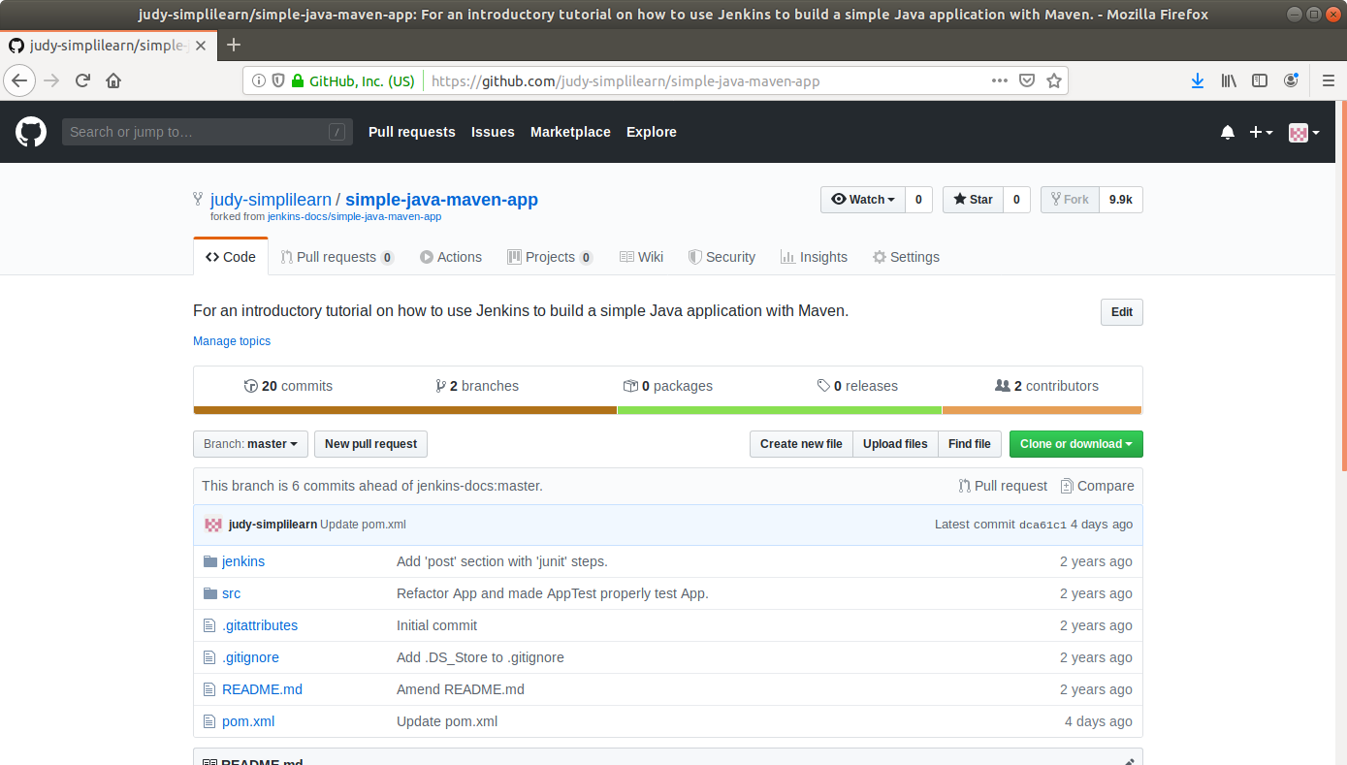

* Click on the **Create a new release**button

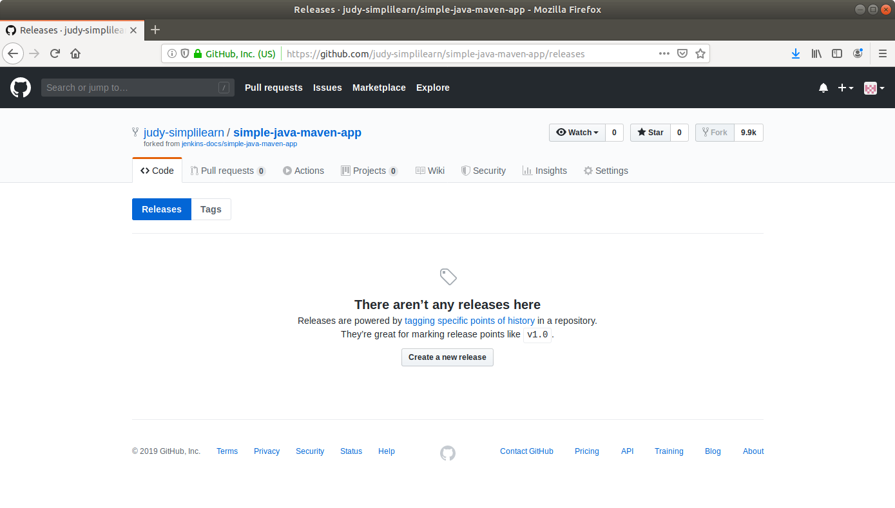

* Enter a **tag name** and fill out the other form fields

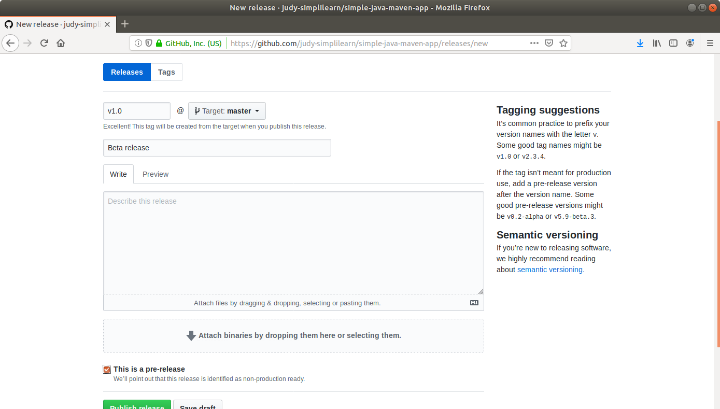

* Click **Publish release** at the bottom

**Step 3:** Building a project from a Git tag in Jenkins

* Go to Jenkins **dashboard**
* Click on **New Item** in the Jenkins dashboard
* Enter a **name** for your build job
* Select **Freestyle project**as the build job type

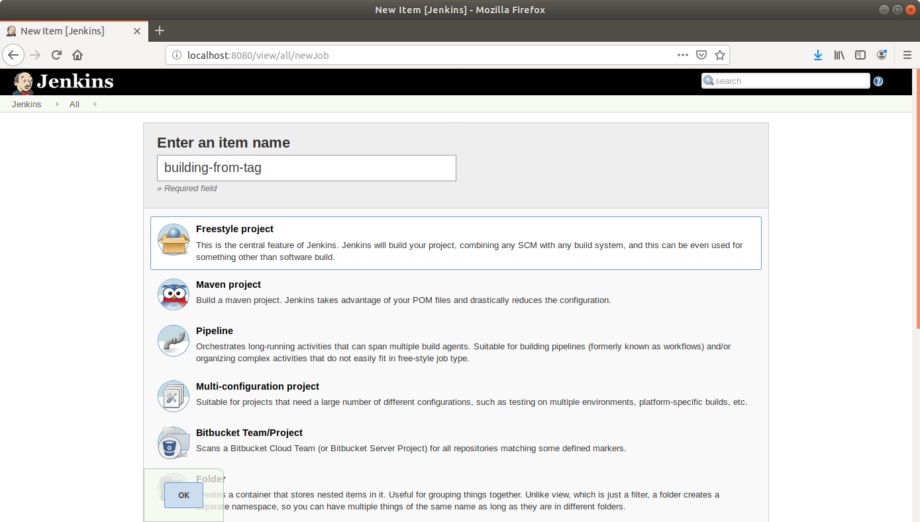

* Click **OK**
* On the configuration page, select the checkbox next to text that states,**This project is parameterized**
* Click on the **Add parameter** button that appears

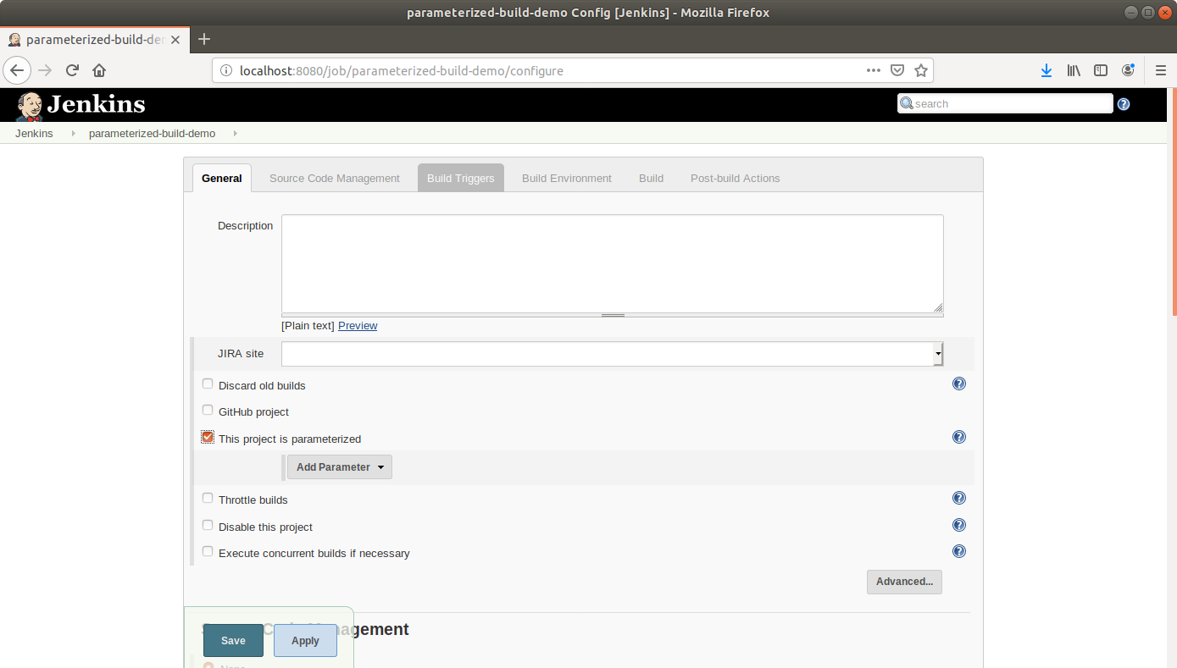

* From the drop-down menu that appears, select **Git parameter**
* Name the Git parameter **tag**, and choose parameter type **Tag**

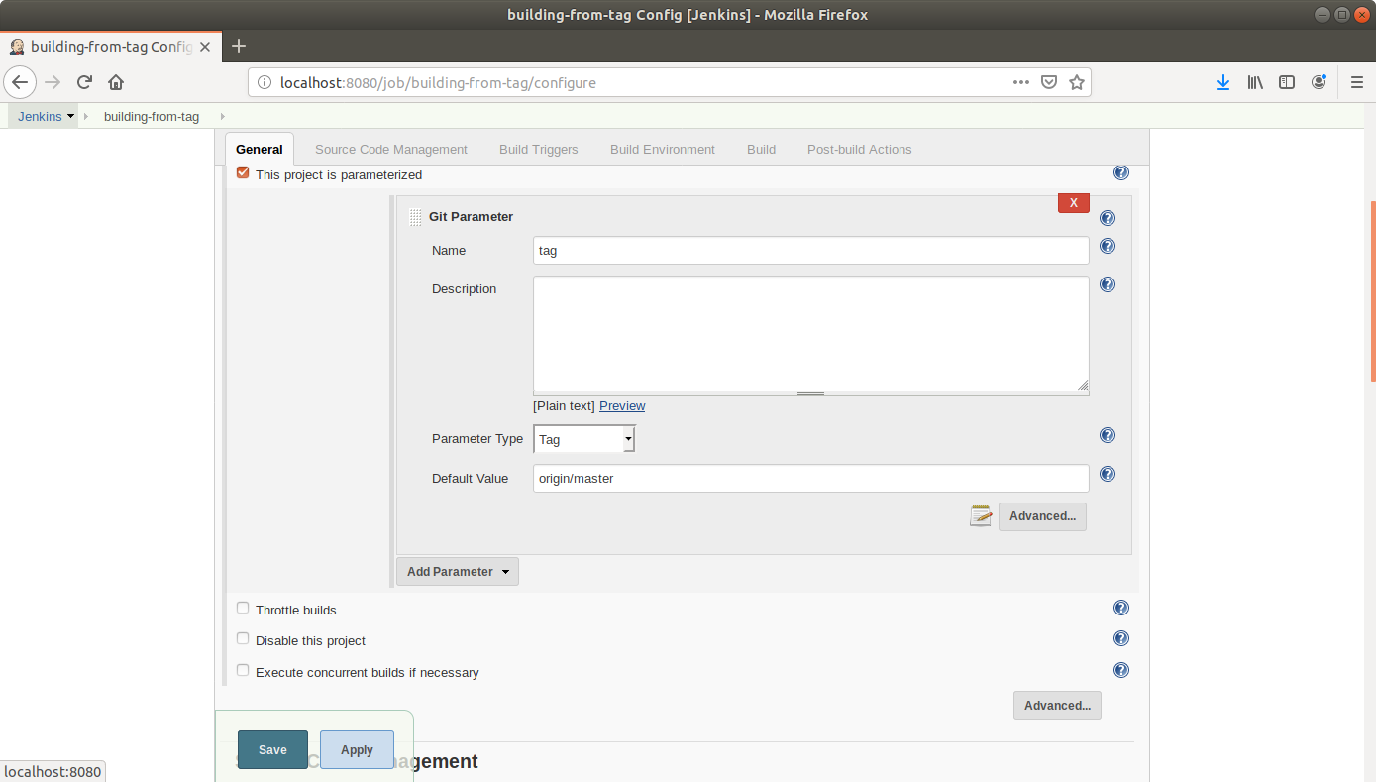

* Add a default value (**origin/master**)
* Scroll down to the Source Code Management section and select **Git**
* Enter the link to the repository in the field that appears

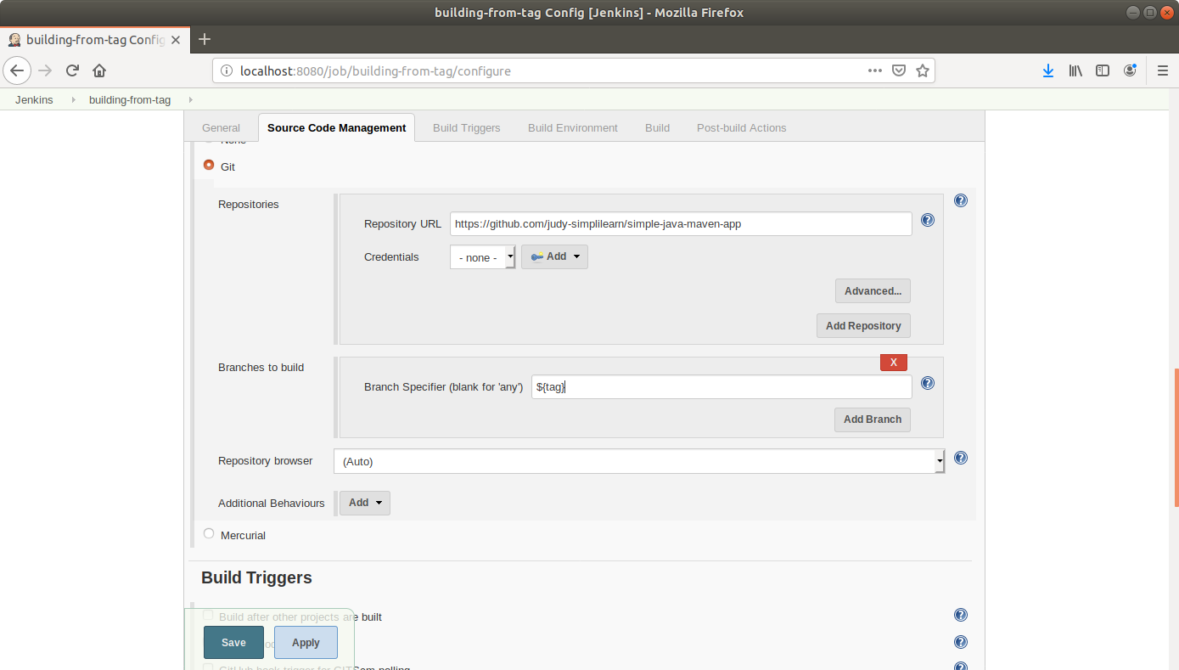

* In the **Branches to Build**field, enter the variable name as, **${tag}**
* Click **Save**
* Click **Build With Parameters** in the project window to make sure the build works
* In the page that appears, accept the defaults if correct or enter the tag value, and click the **Build** button. Jenkins will now build your project

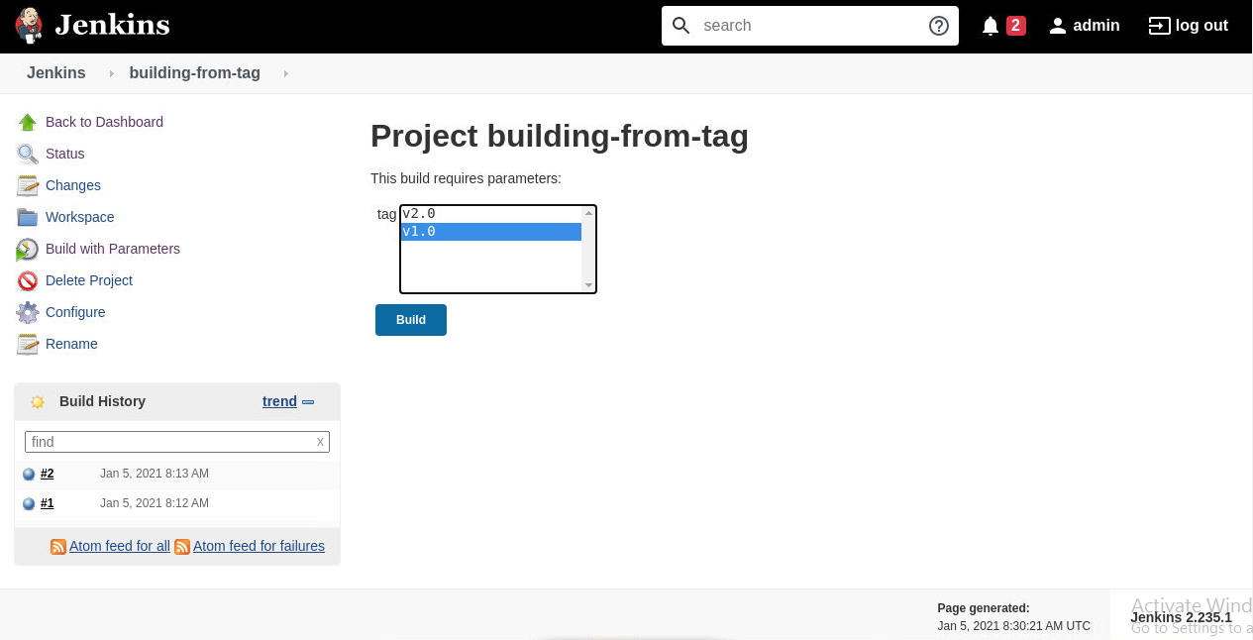

* Click on the **Build History**to view the build results
* Click on the **Console Output** to view the build logs

