Lesson 4 Demo 8 Remote Triggering Parameterized Builds

This section will guide you to:

* Trigger parameterized builds in Jenkins remotely

This lab has two sub-sections, namely:

1. Configuring a parameterized build in Jenkins

2. Triggering a parameterized build remotely

**Step 1:** Configuring a parameterized build in Jenkins

* Go to Jenkins **dashboard**
* Navigate to **Manage Jenkins**→ **Manage Plugins**→ **Available**
* Search for **Build with Parameters** Plugin and click on **install without restart**
* From the Jenkins **Dashboard**, click on ***New Item***
* Enter a **name** for your build job
* Select ***Freestyle project***as the build job type

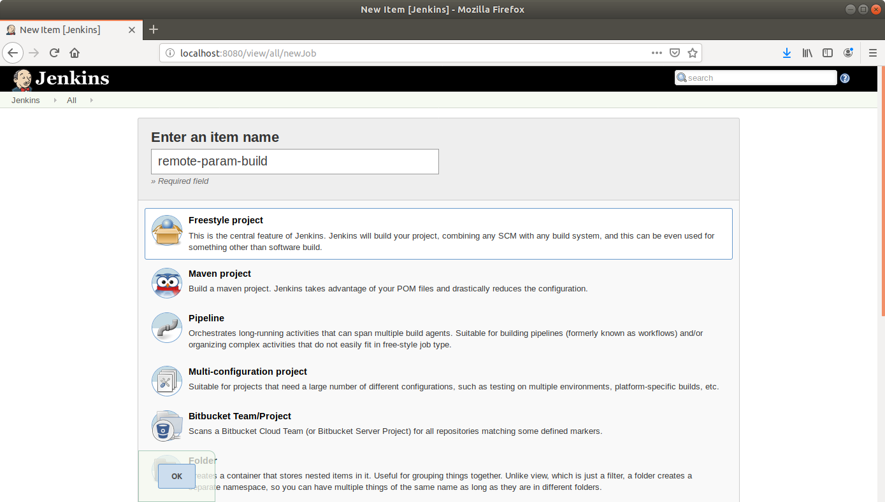

* Click **OK**
* On the configuration page, select the checkbox next to text that states,***This project is parameterized***
* Click on the ***Add parameter*** button that appears

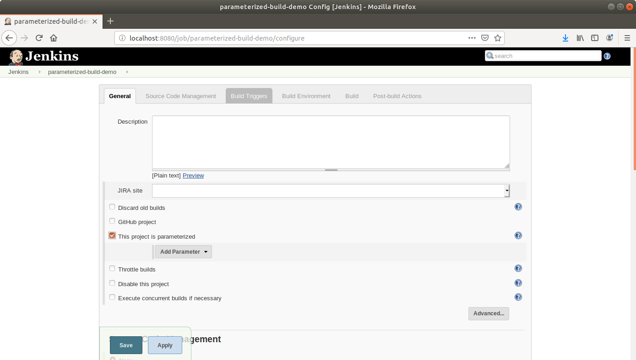

* From the drop-down menu that appears, select ***String parameter***
* Name the parameter ***my_param***, and enter the ***Default Value.*** *(Ex: Hi)*

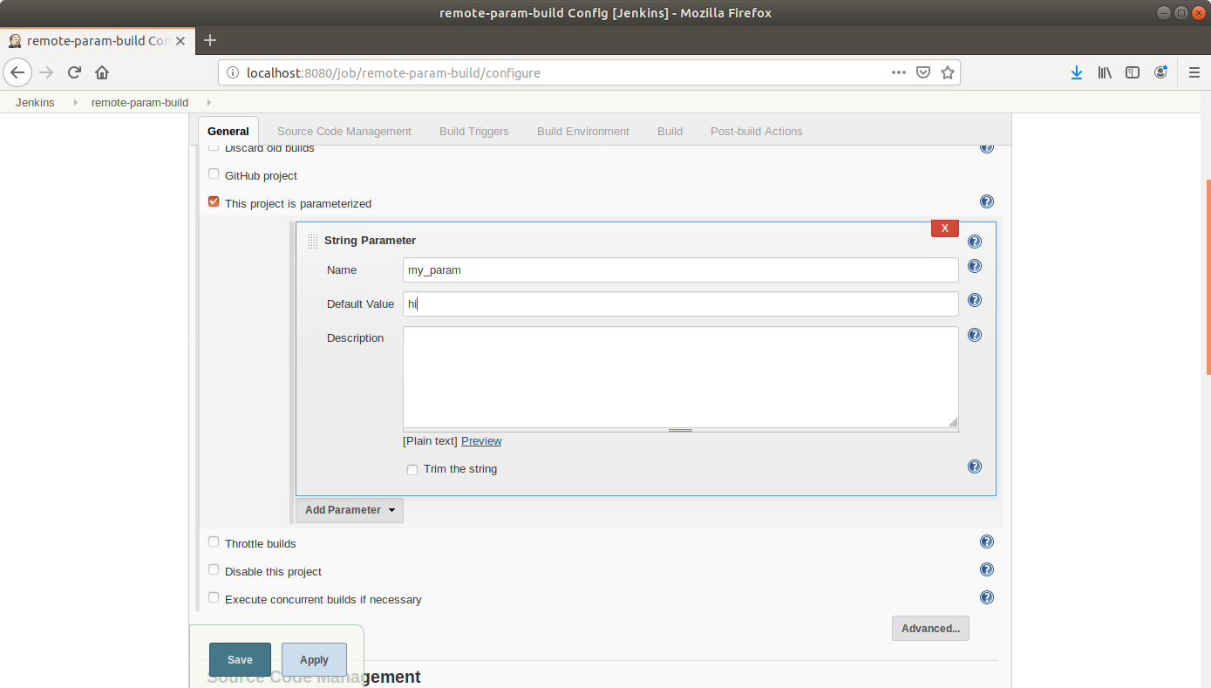

* Under the Build Triggers section select **Trigger builds remotely** and type **Sam** as the token value

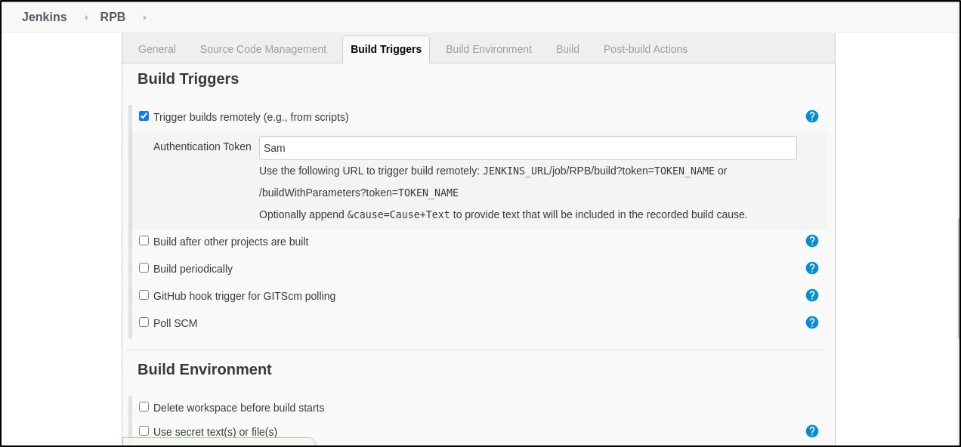

* Scroll down to the***Build*** section and click on ***Add build step***
* Select***Execute Shell Command***from the drop-down that appears

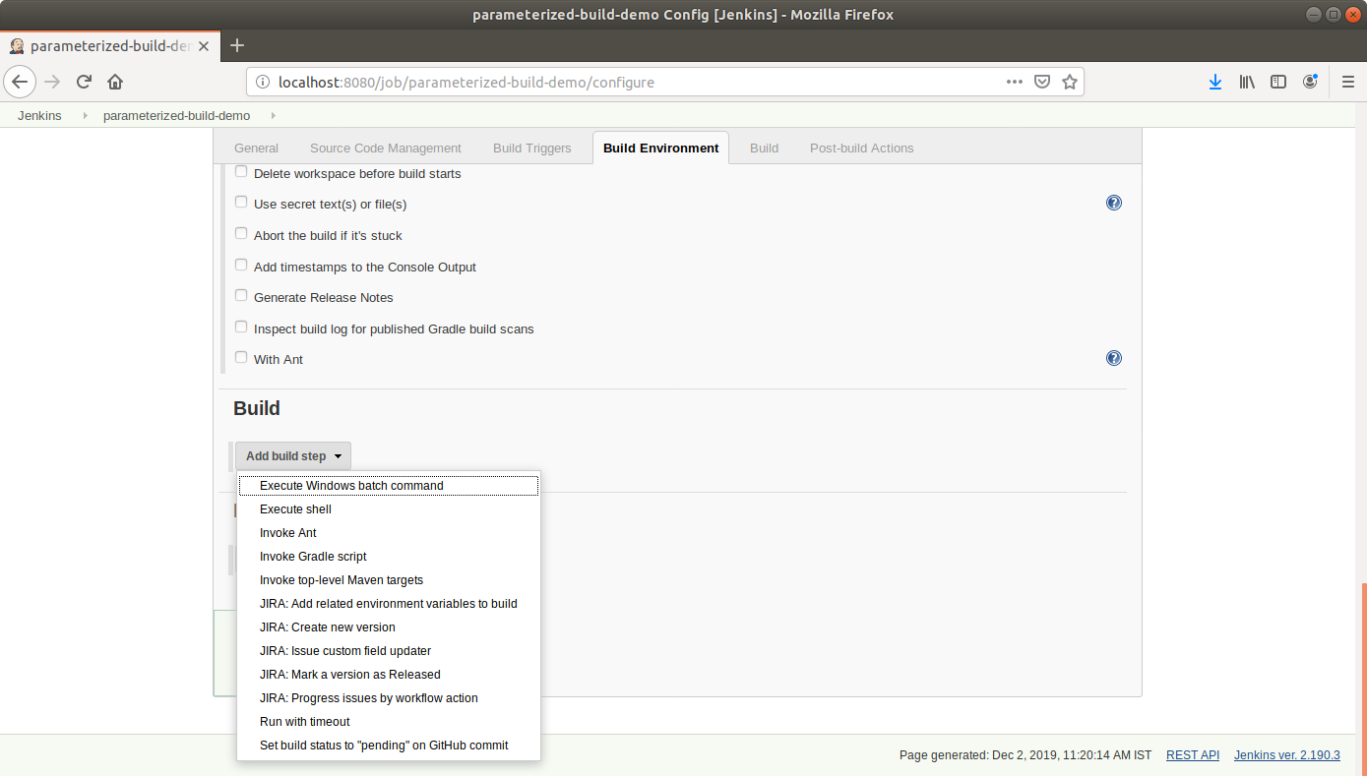

* In the text input area that appears, enter the following text:

**echo $my_param**

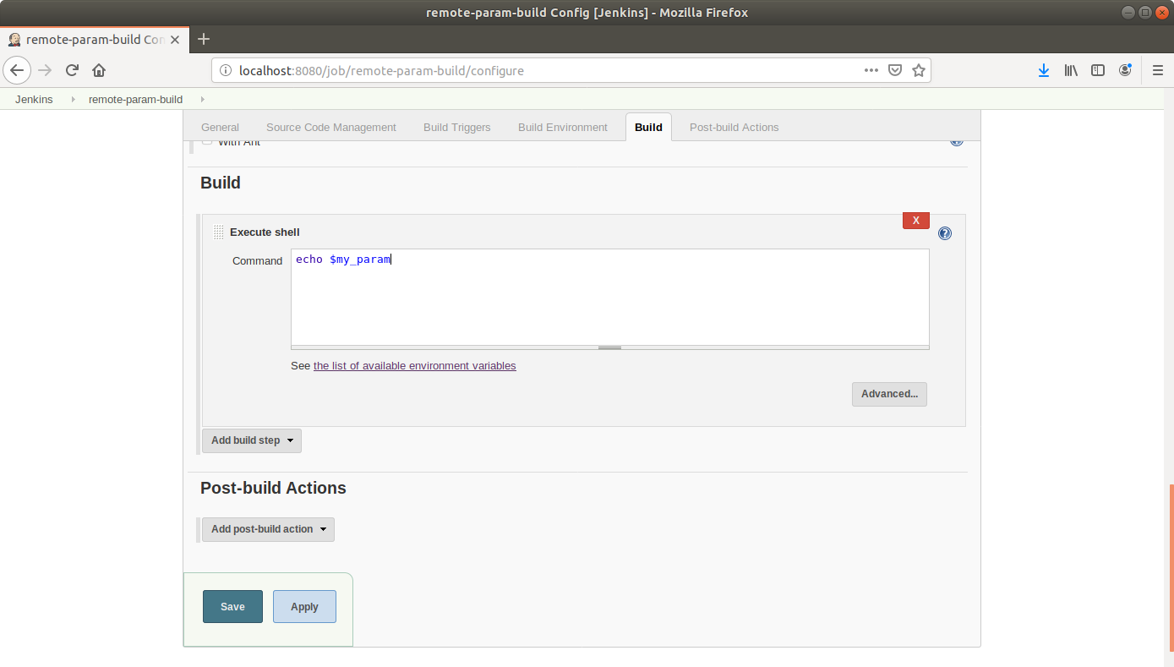

* Click **Save**

**Step 2:** Triggering a parameterized build remotely

* Copy the **url** to the job from the project window

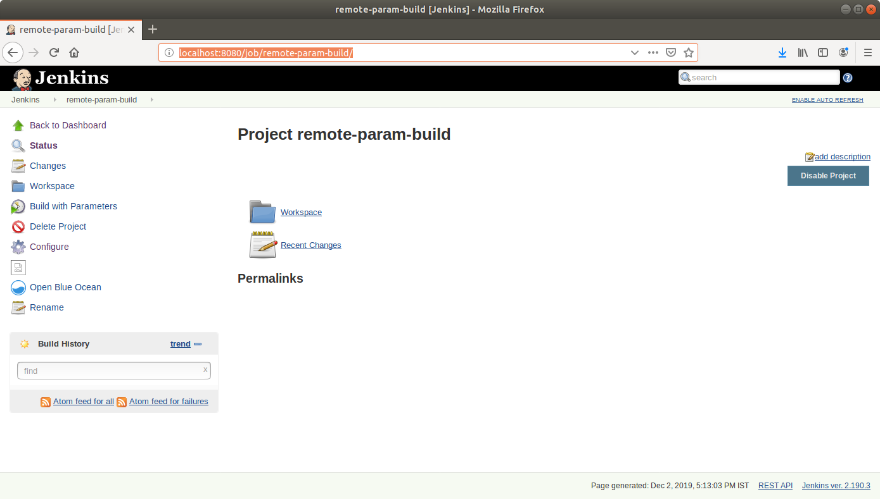

* Open the terminal
* Suffix the parameter and its value to the url copied in the previous step and send a *GET* request using *Curl*

**curl -X GET <YourJenkinsJobUrl>/buildWithParameters?token=Sam**

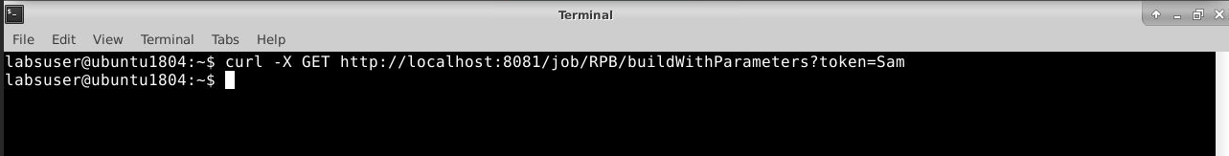

* Open the **job** in the Jenkins UI
* Click on the ***Build History***to view the build results
* Click on the ***Console Output*** to view the build logs
* The parameter value will be displayed in the console output

