Lesson 4 Demo 9: Enabling Security

This section will guide you to:

* Enable security in jenkins

This lab has three sub-sections, namely:

1. Enabling security Jenkins

2. Setting up an account

**Step 1:** Enabling security Jenkins

* Go to Jenkins **dashboard**
* Click on ***Manage Jenkins*** and select ***Configure Global Security***

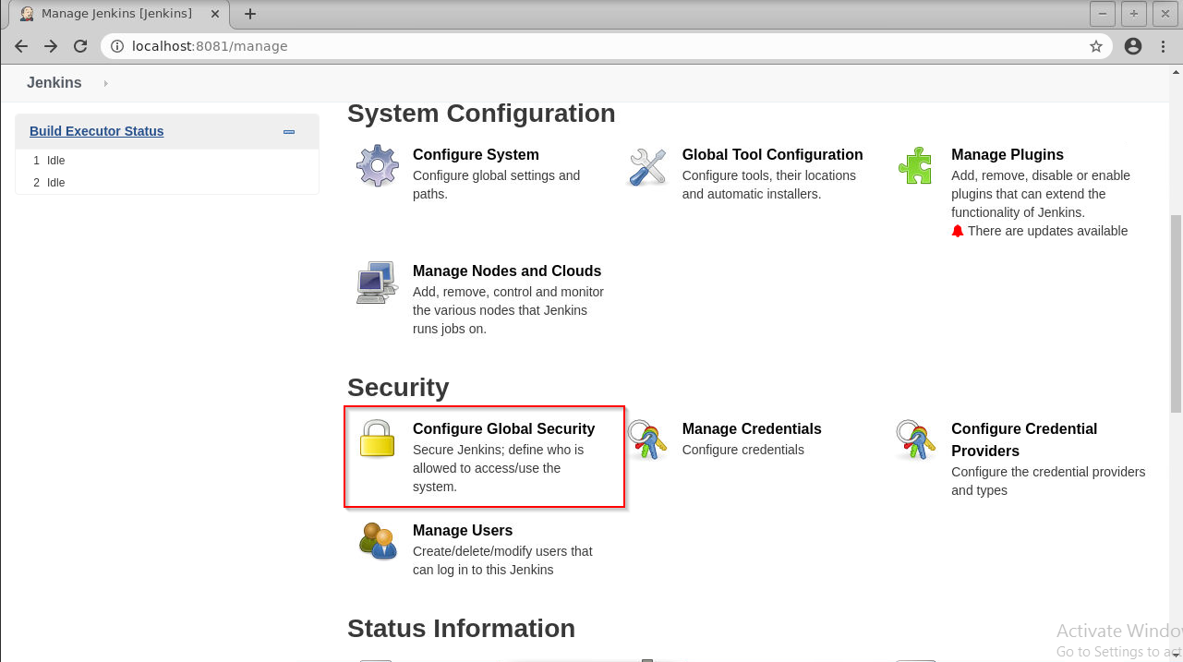

* Under *Security Realm*, choose ***Jenkins’ own user database*** and check the box that says ***Allow users to sign up***

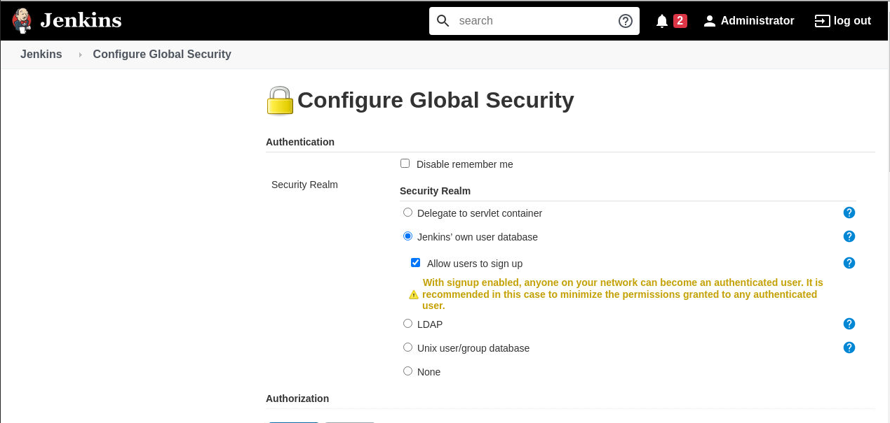

* Under *Authorization*, select ***Logged-in users can do anything***

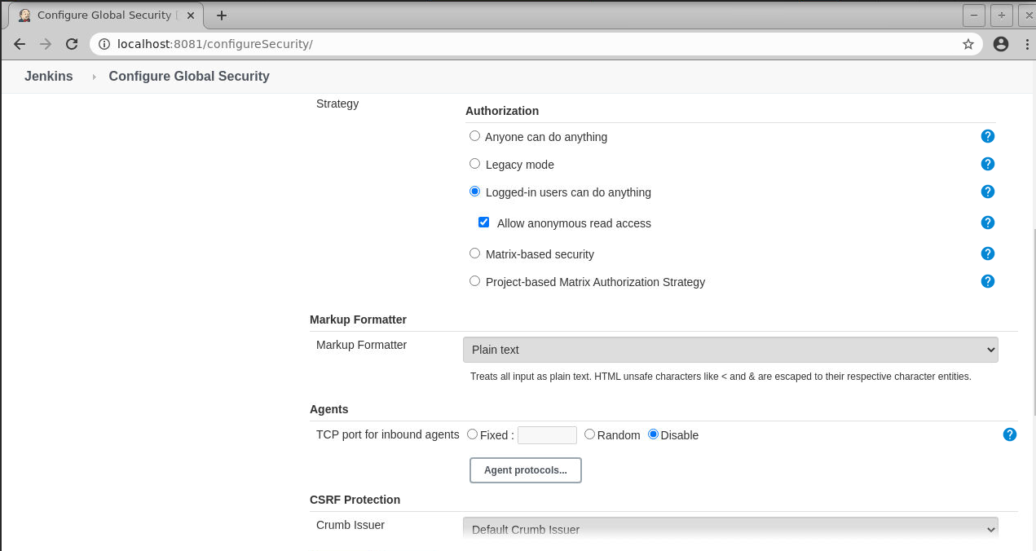

* Click **Save**

**Step 2:** Setting up an account

* Navigate to the Jenkins Dashboard
* Click on **Sign up** at the top right corner

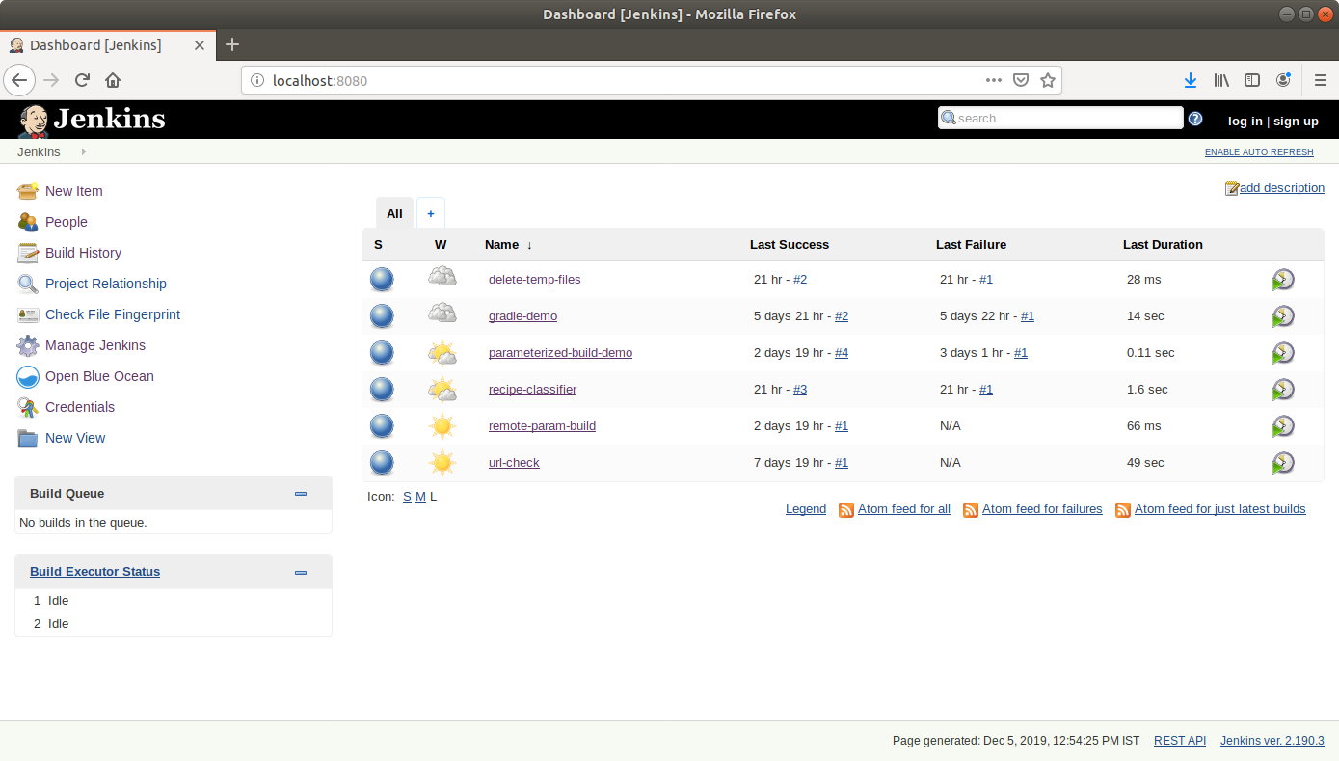

* Fill the required fields in the sign-up form

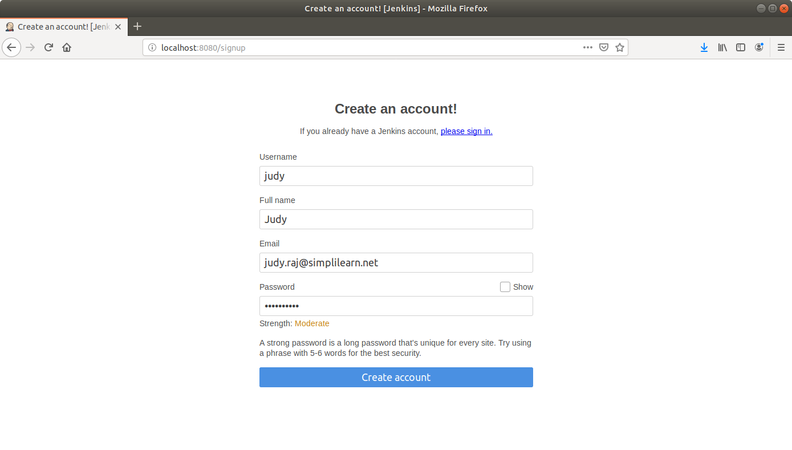

* Click ***Create account***
* You can now log in with your credentials