Lesson 4 Demo 1: Freestyle Build Jobs

This section will guide you to:

* Create a freestyle build job in Jenkins

This lab has four sub-sections, namely:

1. Creating a Git repository
2. Adding a Java program to the repository
3. Creating a freestyle build job in Jenkins
4. Building the Java program with Jenkins

**Step 1:** Creating a Git repository

* Open the browser and log in to your **Github** account
* Click on the plus icon next to the profile picture and select **New repository** from the drop-down menu

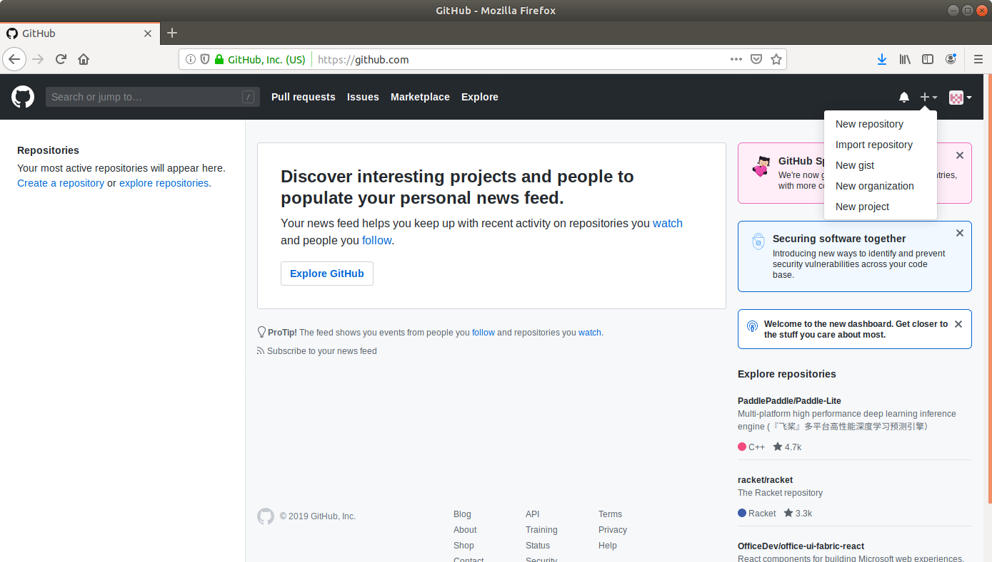

* Fill the fields in the create repository form appropriately

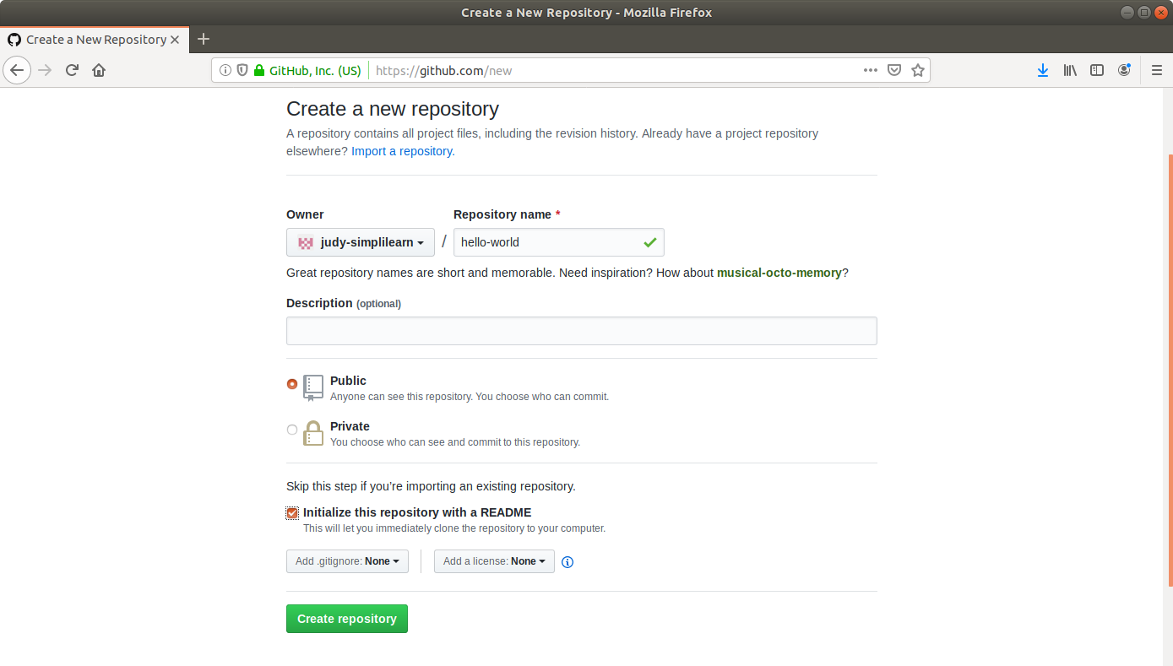

* Click on the **Create Repository** button

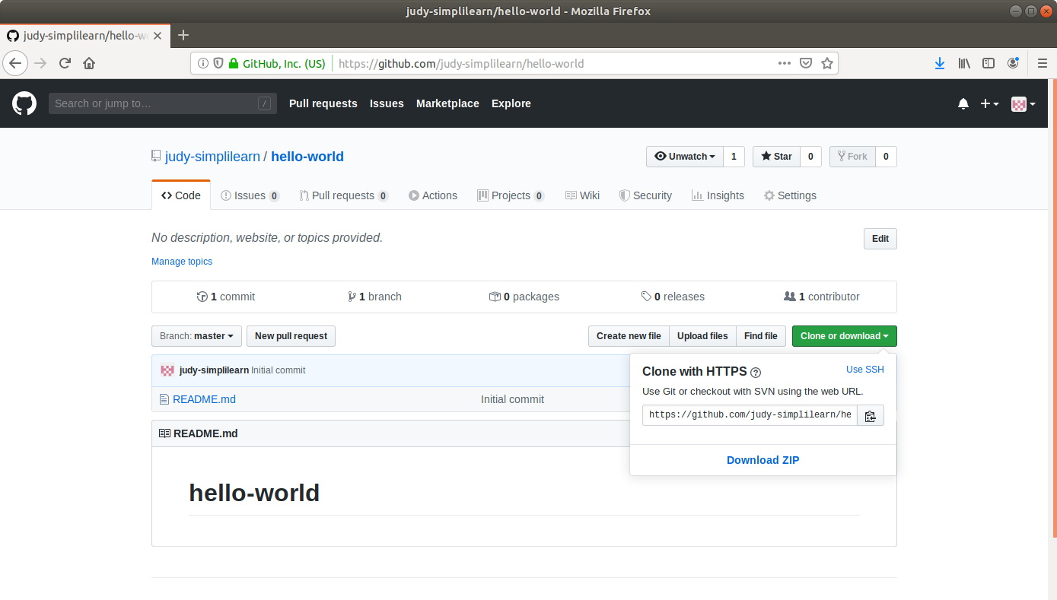

* Click on **Clone or Download**to copy the repository URL

**Step 2:** Adding a Java program to the repository

* Open the terminal
* Run **mkdir hello-world** to create a directory
* Navigate to the *hello-world* directory. (ie) run **cd hello-world**
* Run **vi HelloWorld.java** to open the java file in a text editor
* Paste the code below into the file:

**public class HelloWorld {**

**public static void main(String[] args) {**

**System.out.println("Hello, World");**

**}**

}

* Save the file and exit the text editor
* Run **git init**
* Run **git add .**
* Run **git commit -m “Add new files”**
* Run **git remote add origin [Repository_URL]**
* Run **git push -u origin master**

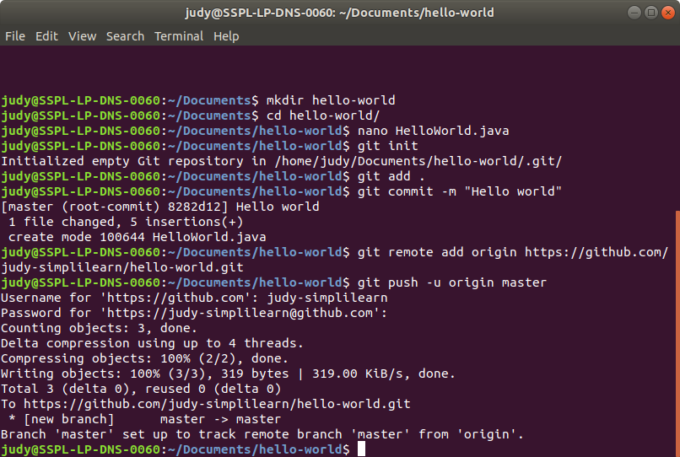

**Step 3:** Creating a freestyle build job in Jenkins

* Click on **New Item** in the Jenkins dashboard
* Enter a **name** for your project
* Select **Freestyle project**as the build job type

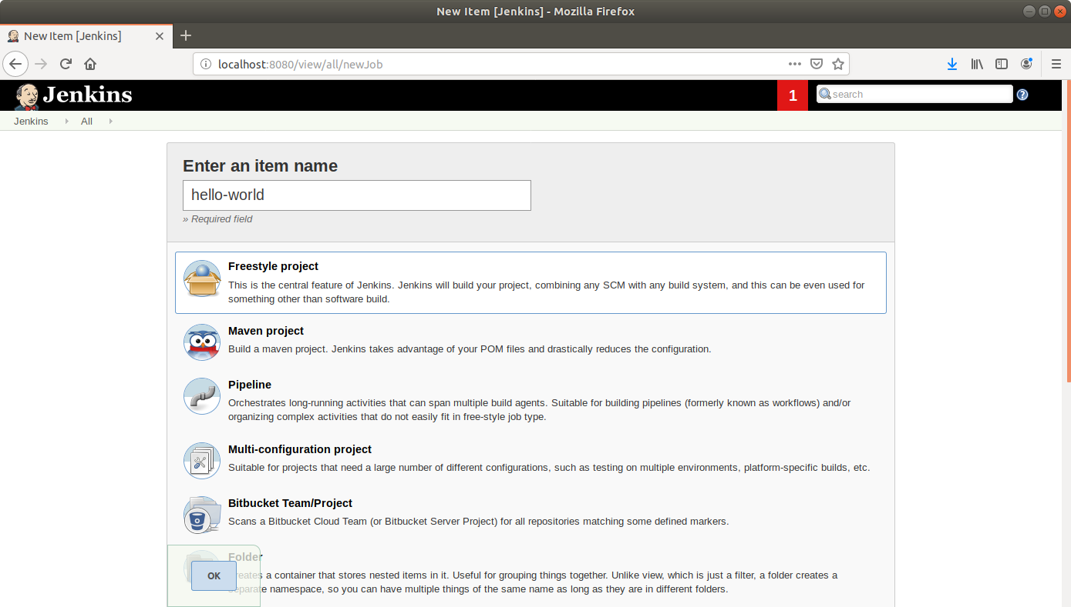

* Click **OK**
* Scroll down to the **Source Code Management** section and select ***Git***
* Enter the repository **URL**

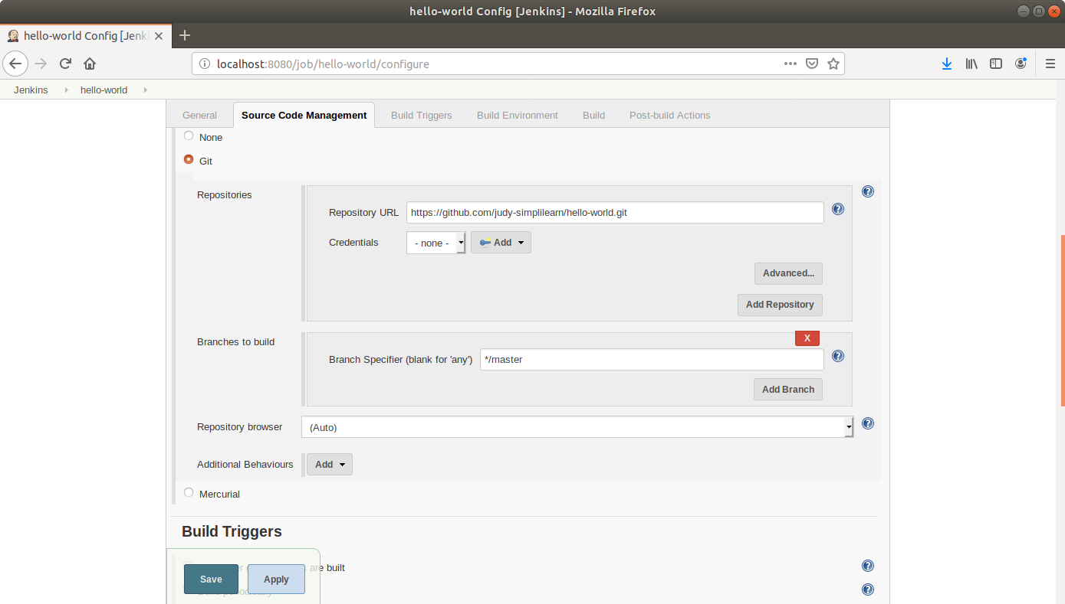

* Click **Save**

**Step 4:** Building the Java program with Jenkins

* Click on the project name in the Jenkins **dashboard**

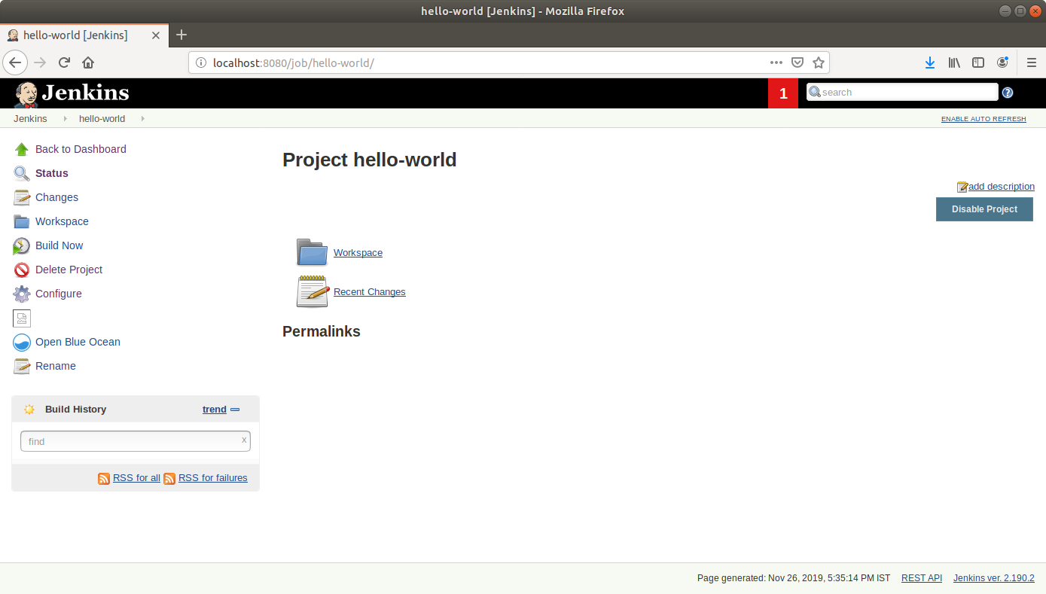

* Click **Build Now** in the project window. Jenkins will now build your project
* Click on the **Build History**to view the build results
* Click on the **Console Output** to view the build logs

