Lesson 4 Demo 3: Polling SCM

This section will guide you to:

* Schedule a freestyle build job in Jenkins that polls the SCM every night

This lab has two sub-sections, namely:

1. Scheduling a build job to poll an SCM and run Maven build steps

2. Testing a scheduled build

**Step 1:** Scheduling a build job to poll an SCM and run Maven build steps

* Go to Jenkins **dashboard**
* Click on **New Item**
* Enter a **name** for your project
* Select **Freestyle project**as the build job type

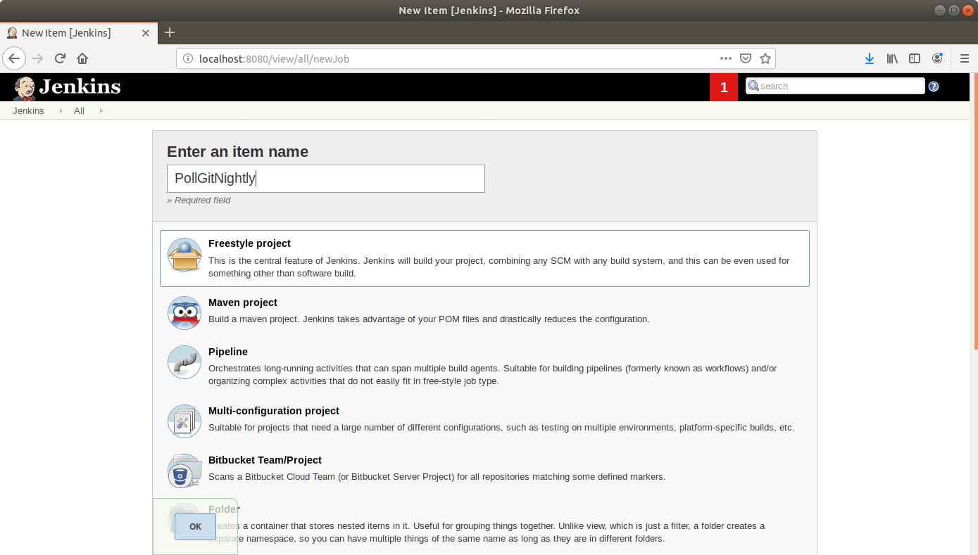

* Click **OK**
* Enter job details like **description**

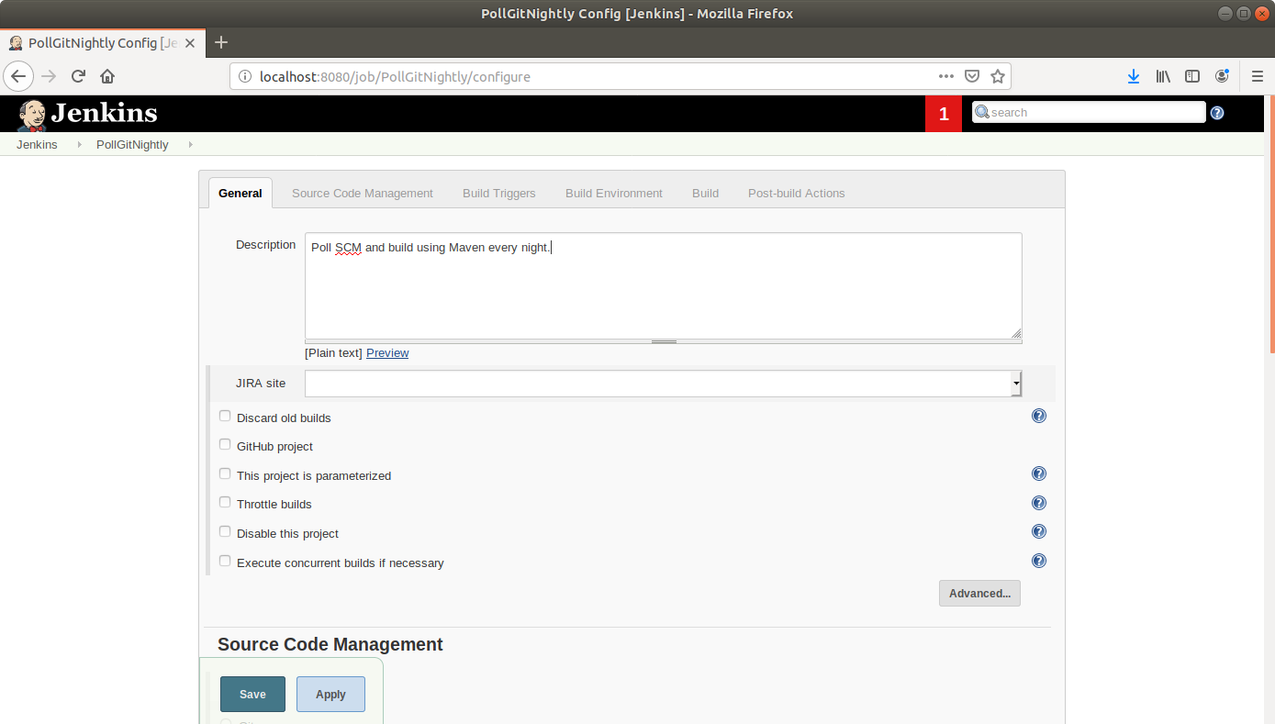

* Scroll down to the **Source Code Management** section and select **Git**
* Enter the link to the repository in the field that appears

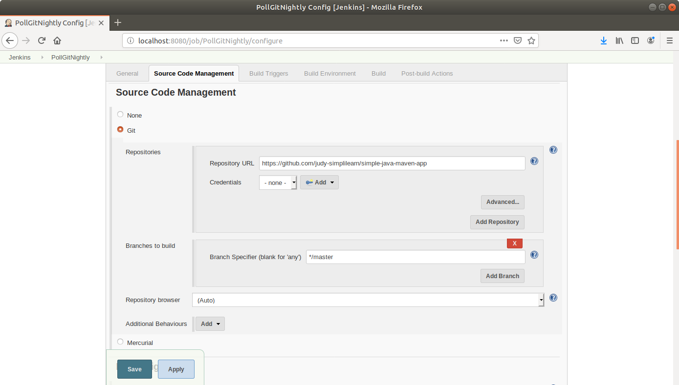

* Scroll down to the **Build Triggers** section and select the **Poll SCM** option
* In the box that appears, enter the cron syntax to schedule a build every night at 12. (ie) **0 0 * * \***

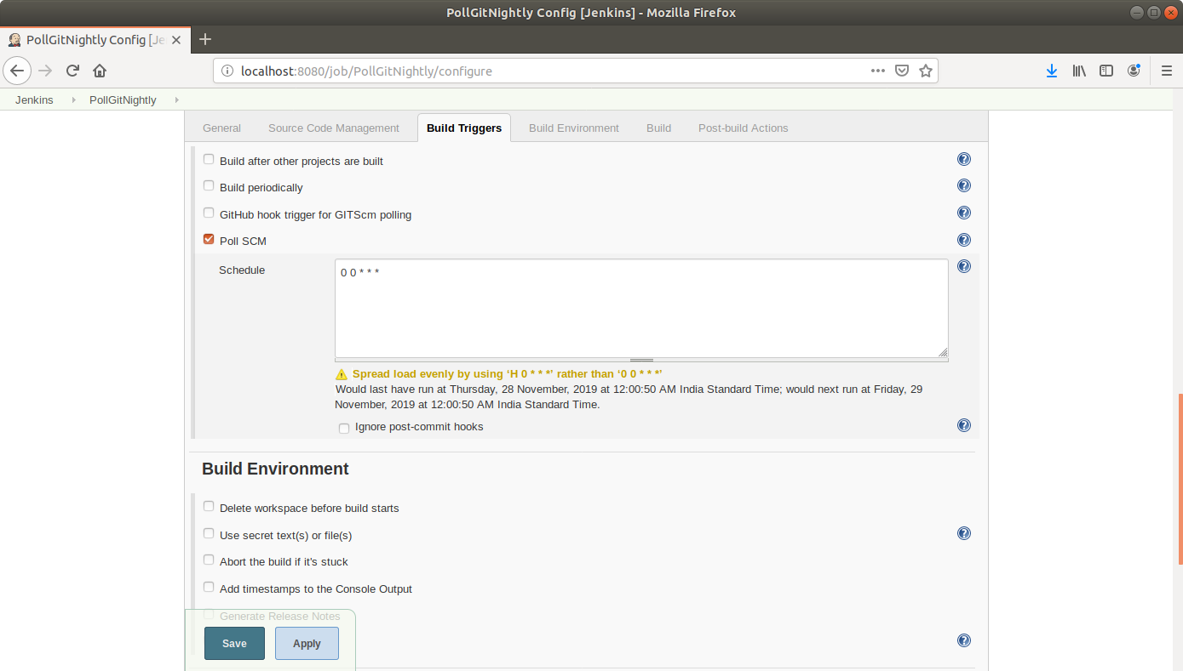

* Scroll down to the**Build** section and click on **Add build step**
* Select**Execute Shell**from the drop-down that appears
* Enter the following maven command in the textbox that appears:  
  **mvn clean install**

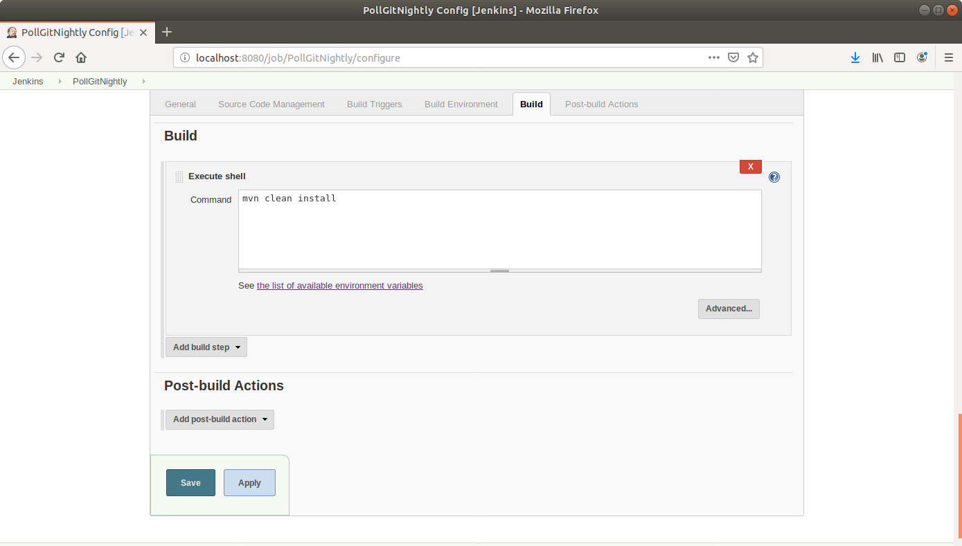

* Click Save.

**Step 2:** Testing a scheduled build

* Click on the project name in the Jenkins dashboard
* Click **Build Now** in the project window to make sure the build works. Jenkins will now build your project
* Click on the **Build History** to view the build results
* Click on the **Console Output** to view the build logs

