Lesson 6 Demo 3: Testing Code Coverage

This section will guide you to:

* Create and commit a Jenkinsfile which uses JaCoCo
* Configure a pipeline to run from a Jenkinsfile and publish coverage results

This guide has six subsections, namely:

1. Creating a Git repository for the Review Analyzer program
2. Generating a spring boot project
3. Adding the code for word count to the repository
4. Creating and committing a Jenkinsfile
5. Creating a multistage pipeline in Jenkins
6. Running a multistage pipeline in Jenkins

**Please Note**: This demo is incremental, you should have completed the previous demos in order to proceed with this demo.

**Step 1:** Creating a Git repository for the Review Analyzer program

* Log in to your **Github** account
* Click on the **plus** icon next to the profile picture and select ***New repository*** from the drop-down menu

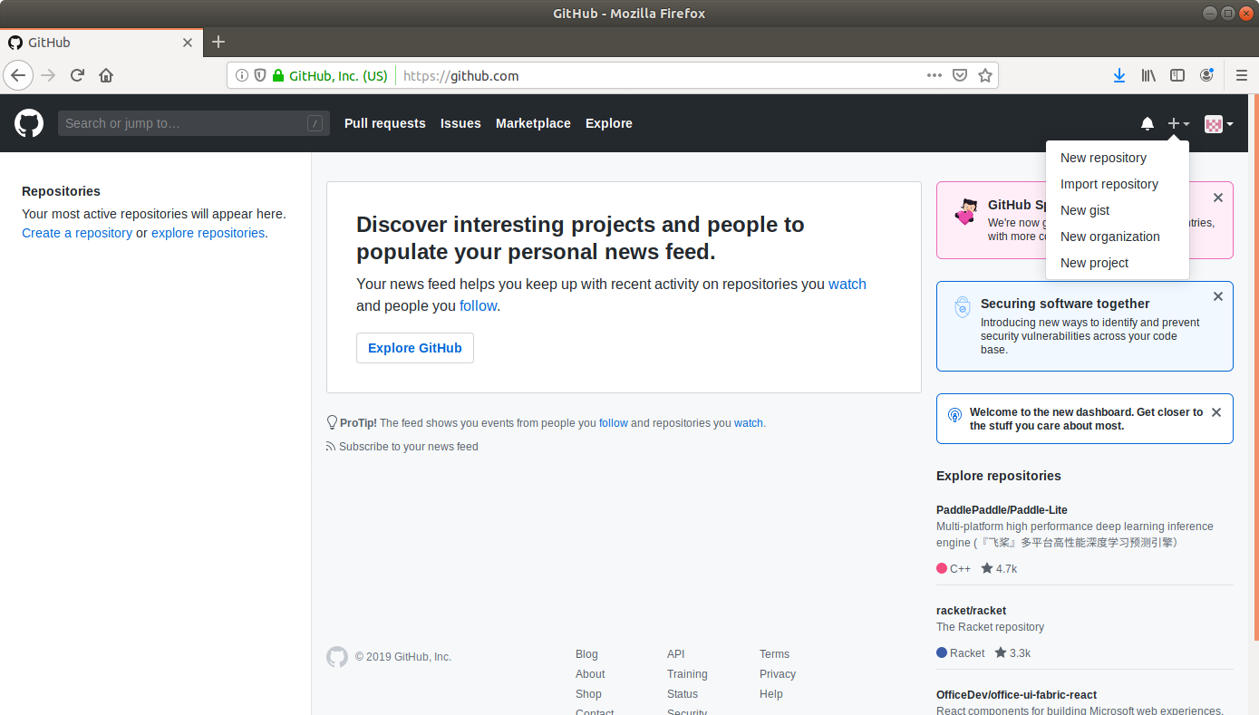

* Fill the required fields in the **Create Repository** form by giving the name as **ReviewAnalyser** and selecting the type of repository as **Public**

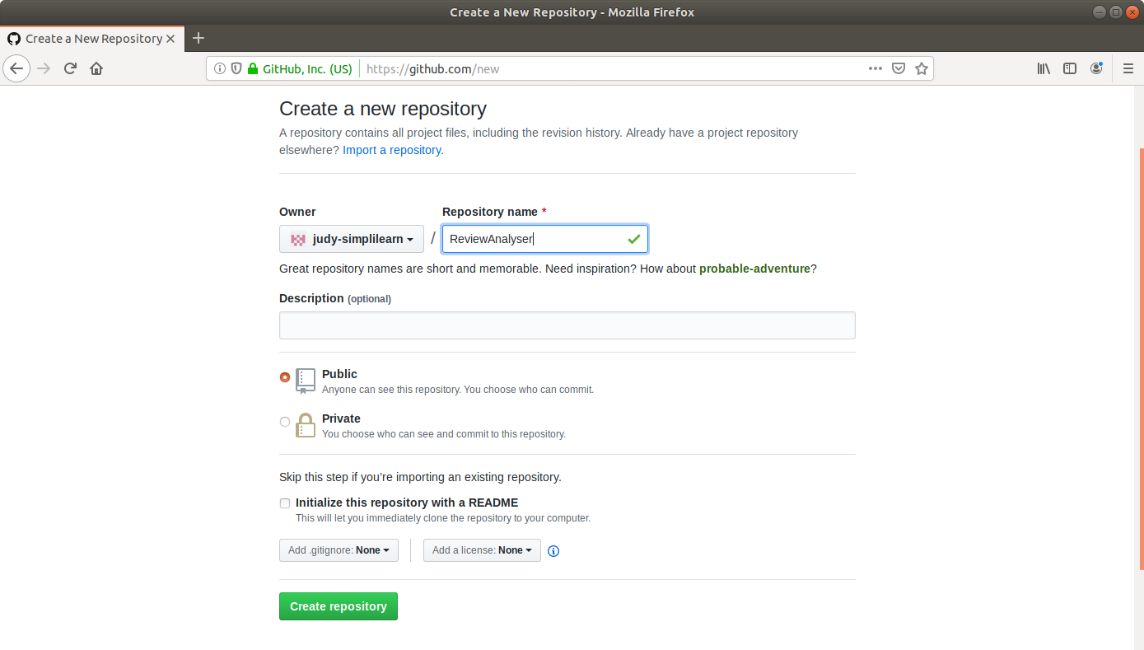

* Click on the **Create Repository** button
* Click on the **Clone or download** button and copy the URL

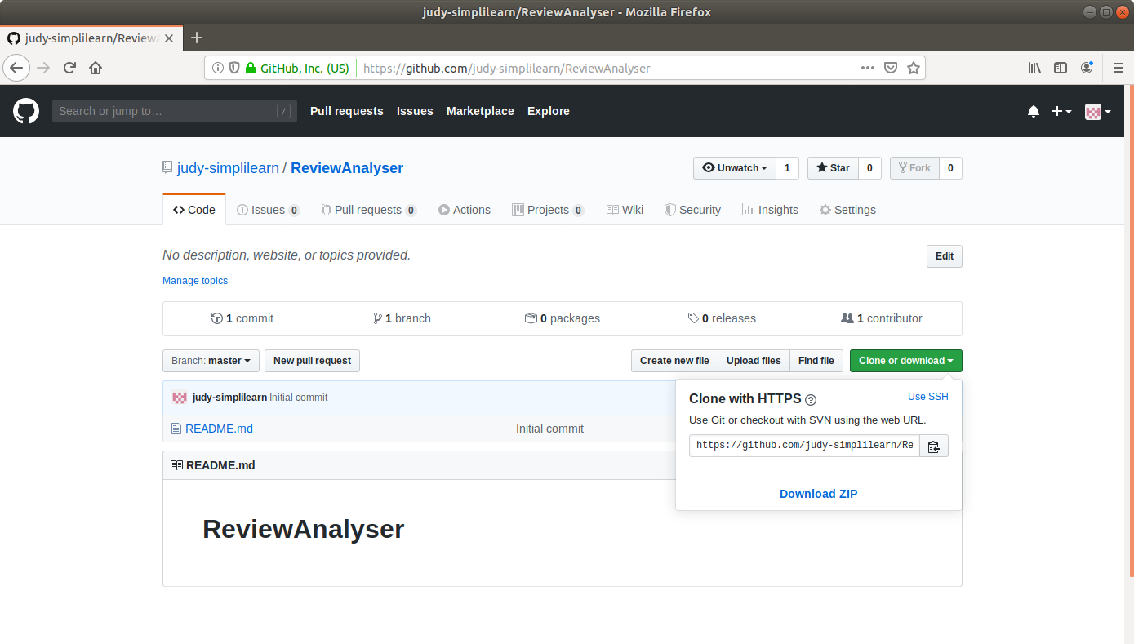

**Step 2:** Generating a spring boot project

* Go to ​start.​spring.​io/​
* Select Maven as the project type
* Fill Group and Artifact with appropriate values. For example, *com.simplilearn* and *ReviewAnalyser*
* Add **Spring** **Web** to Dependencies
* Select Packaging: Jar
* Select Java: 8

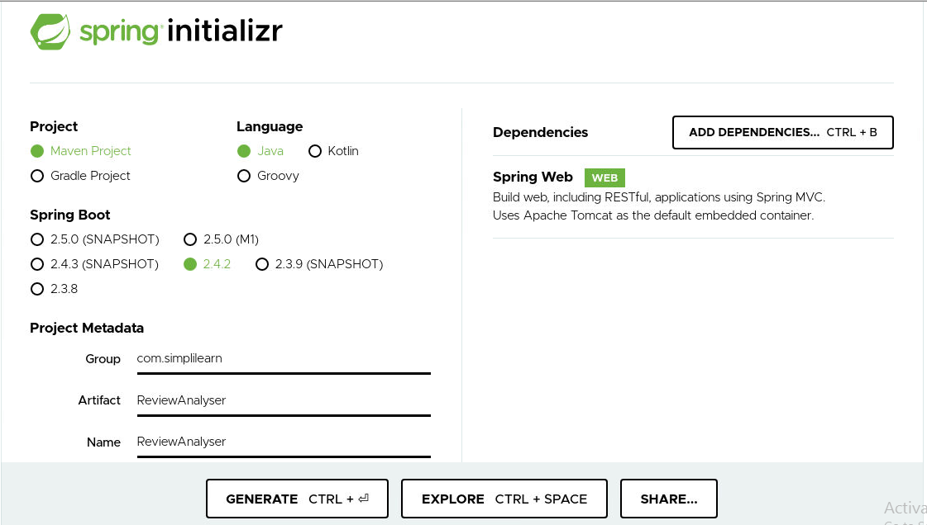

* Click on **Generate Project**
* The generated skeleton project should be downloaded as a zip file

**Step 3:** Adding the code for word count to the repository

* Open the terminal
* Run **git clone [URL]** to clone the repository
* Unzip the downloaded spring boot project to the cloned repository

**cd /home/labsuser/Downloads**

**unzip ReviewAnalyser.zip**

* Copy the contents of ReviewAnalyser folder present in downloads and paste it into your repository folder
* On executing the following commands you should see the contents as shown below:

**cd /home/labsuser/ReviewAnalyser**

**ls**

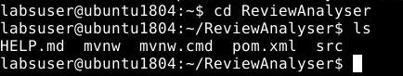

* Navigate to the *ReviewAnalyser* folder within the ***src*** folder

**cd /home/labsuser/ReviewAnalyser/src/main/java/com/simplilearn/ReviewAnalyser**

* Open theReviewAnalyserApplication.java in a text editor

**vi ReviewAnalyserApplication.java**

* Delete the existing content and add the following code to the file

**package com.simplilearn.ReviewAnalyser;**

**import org.springframework.boot.SpringApplication;**

**import org.springframework.boot.autoconfigure.SpringBootApplication;**

**@SpringBootApplication**

**public class ReviewAnalyserApplication {**

**public static double getWordCount(String review){**

**int count = 0;**

**String string[] = review.toLowerCase().split("([,.\\s]+)");**

**for(String s : string){**

**count++;**

**}**

**return count;**

**}**

**public static void main(String[] args) {**

**SpringApplication.run(ReviewAnalyserApplication.class, args);**

**}**

**}**

* Save the file and exit using the command **[esc] shift+:wq**
* Navigate to the *ReviewAnalyser* folder within the ***test*** folder

**cd /home/labsuser/ReviewAnalyser/src/test/java/com/simplilearn/ReviewAnalyser**

* Open theReviewAnalyserApplicationTests.java in a text editor

**vi ReviewAnalyserApplicationTests.java**

* Delete the existing content and add the following code to the file:

**package com.simplilearn.ReviewAnalyser;**

**import org.junit.Test;**

**import static org.junit.Assert.*;**

**import org.springframework.boot.test.context.SpringBootTest;**

**@SpringBootTest**

**class ReviewAnalyserApplicationTests {**

**private ReviewAnalyserApplication analyser = new ReviewAnalyserApplication();**

**@Test**

**public void testWordCount() {**

**assertEquals(7,analyser.getWordCount("Train to win in the digital economy"));**

**}**

**}**

* Save the file and exit the text editor using the command **[esc] shift+:wq**
* Run the following command to navigate to the pom file:  
    
  **cd /home/labsuser/ReviewAnalyser**

**vi pom.xml**

* Add the following dependency in the <dependencies> section of the **pom.xml**:

**<dependency>**

**<groupId>junit</groupId>**

**<artifactId>junit-dep</artifactId>**

**<version>4.8.2</version>**

**<scope>test</scope>**

**</dependency>**

* Add the jacoco plugin to **pom.xml** with the following xml code in the <plugins> section:

**<plugin>**

**<groupId>org.jacoco</groupId>**

**<artifactId>jacoco-maven-plugin</artifactId>**

**<version>0.8.3</version>**

**<executions>**

**<execution>**

**<id>default-prepare-agent</id>**

**<goals>**

**<goal>prepare-agent</goal>**

**</goals>**

**</execution>**

**<execution>**

**<id>default-report</id>**

**<phase>prepare-package</phase>**

**<goals>**

**<goal>report</goal>**

**</goals>**

**</execution>**

**</executions>**

**</plugin>**

* Save the file and exit the text editor using the command **[esc] shift+:wq**

**Step 4:** Creating and committing a Jenkinsfile

* Navigate to the *ReviewAnalyser* root directory where the pom.xml is located

**cd /home/labsuser/ReviewAnalyser**

* Open a new text file **vi Jenkinsfile** and add the following script to it:

**pipeline {**

**agent any**

**stages {**

**stage("Compile") {**

**steps {**

**sh "mvn compile"**

**}**

**}**

**stage("Unit test") {**

**steps {**

**sh "mvn test"**

**}**

**}**

**}**

**post {**

**always {**

**step([$class: 'JacocoPublisher',**

**execPattern: 'target/*.exec',**

**classPattern: 'target/classes',**

**sourcePattern: 'src/main/java',**

**exclusionPattern: 'src/test*'**

**])**

**}**

**}**

**}**

* Save the file as **Jenkinsfile** using the command **[esc] shift+:wq**
* Commit the changes to the remote SCM
* Run **git add .**
* Run **git commit -m “Add logic and test”**
* Run **git push -u origin master**

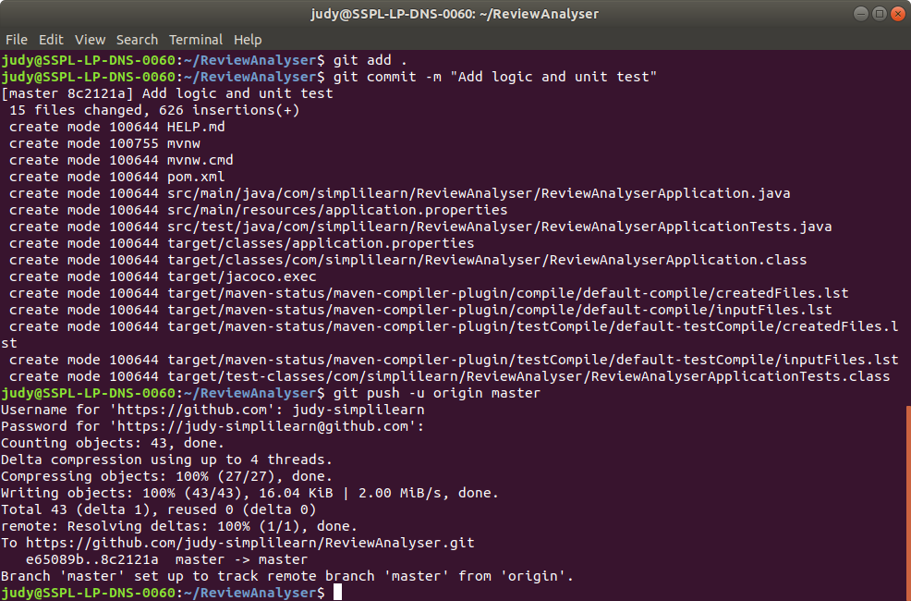

**Please Note:** In case you get an error while executing **git push -u origin master**, execute **git push -u origin main**

**Step 5:** Creating a multistage pipeline in Jenkins

* Go to Jenkins **dashboard**
* Click on ***New Item***
* Enter a **name** for your build job (Ex: review-analyser)
* Select ***Pipeline***as the build job type

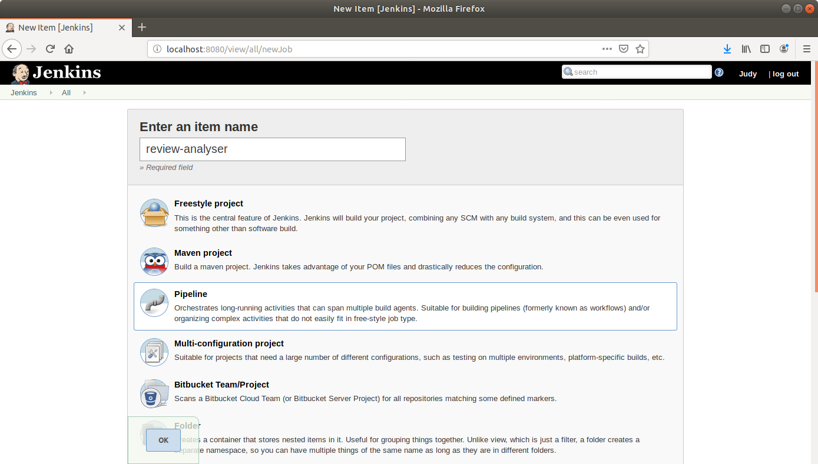

* Click **OK**
* On the configuration page, scroll down to the **Pipeline** section
* Change ***Definition*** from ***Pipeline script*** to ***Pipeline script from SCM***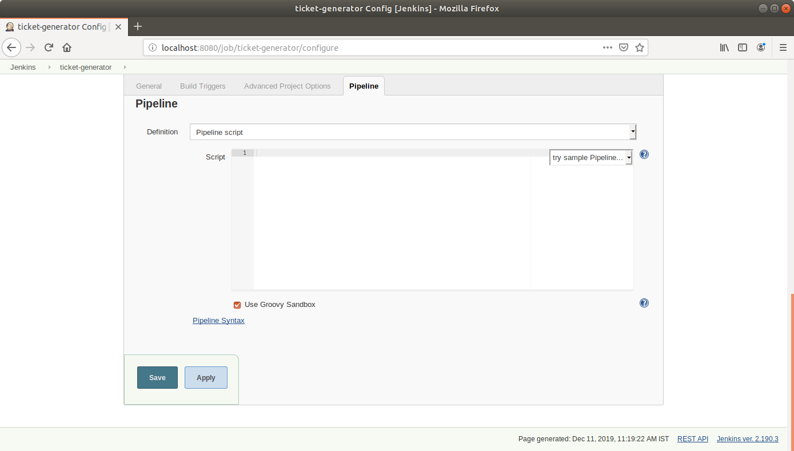
* Select ***Git*** *in SCM*
* Add the repository URL and the branch to build   
  (Please check if your repository has a master or main branch and specify accordingly)

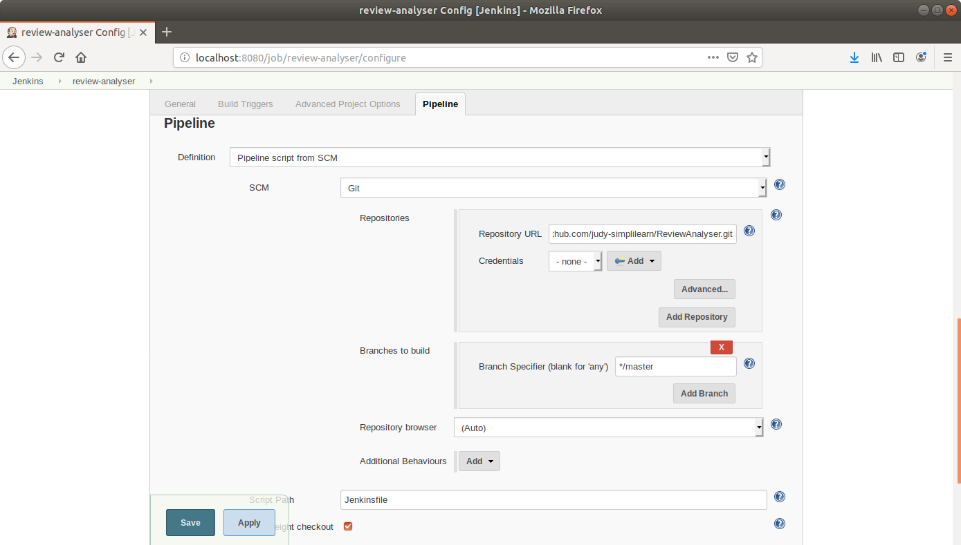

* Click **Save**

**Step 6:** Running a multistage pipeline in Jenkins

* Click on ***Build Now***in the project window
* Jenkins will now build your pipeline and output the logs

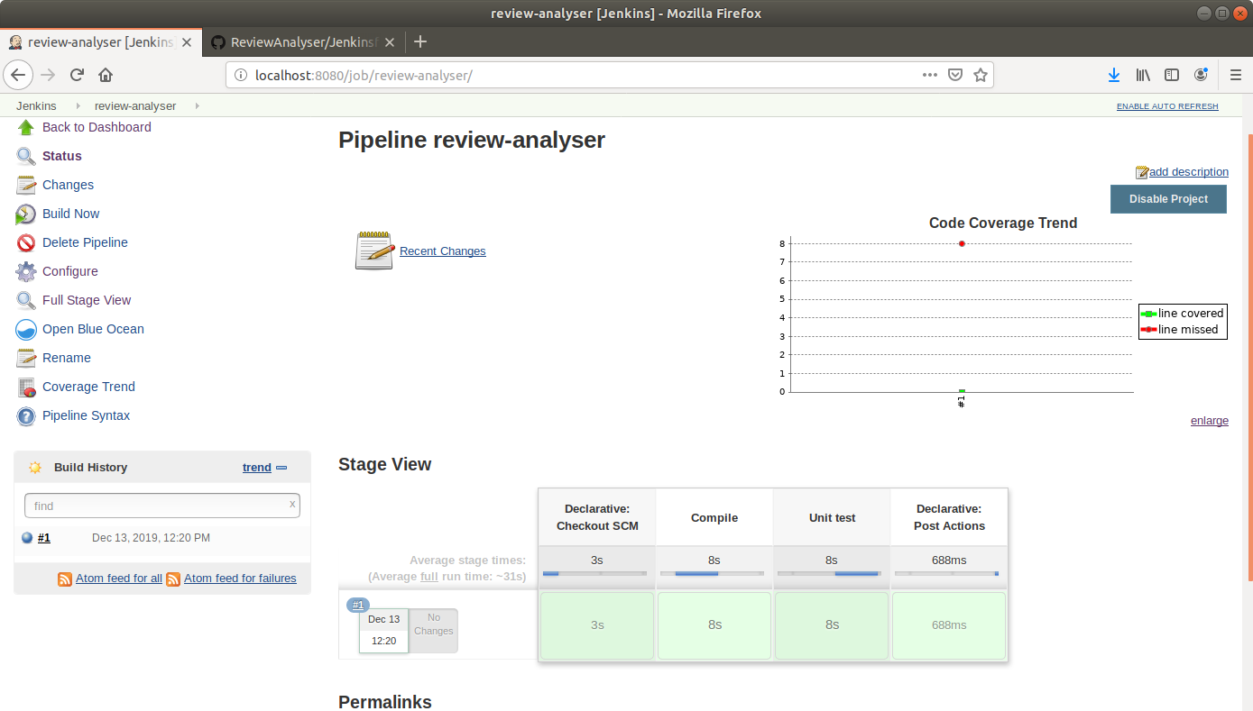

* Click on ***Coverage Trend*** to view the coverage trend

