Lesson 6 Demo 5: Integrate JMeter with Jenkins

This section will guide you to:

* Configure JMeter with Jenkins

This guide has five subsections, namely:

1. Installing JMeter
2. Creating test cases in Jmeter
3. Logging in to Jenkins
4. Adding the performance plugin
5. Creating Jenkins job for JMeter

**Step 1:** Installing JMeter

* Open your Linux terminal and run the below command to check if JDK is installed: **java -version**
* Click the following URL to download the latest version of JMeter. You can download the binary or source file of this tool from this location. Click on the ‘**Apache-JMeter-5.4.1.zip’**link to download the binary zip file of JMeter.

[**http://jmeter.apache.org/download_jmeter.cgi**](http://jmeter.apache.org/download_jmeter.cgi)

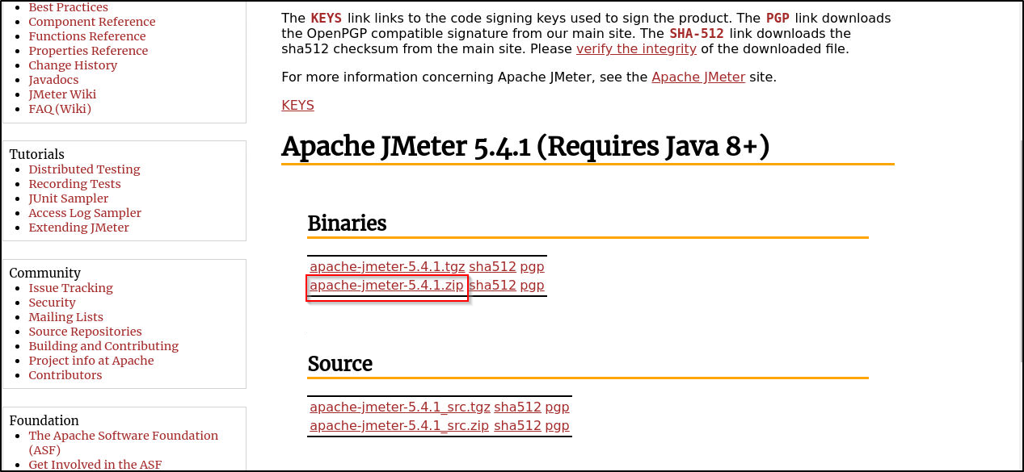

* The file will be downloaded in the **Downloads** folder. Run the following commands to extract the zip file:  
  **cd /home/labsuser/Downloads**

**unzip apache-jmeter-5.4.1.zip**

* Navigate to the bin of the unzipped folder:

**cd /home/labsuser/Downloads/apache-jmeter-5.4.1/bin**

* Execute the below command to add the following line in user.properties file:  
  **vi user.properties**

Add the below line in the file:

**jmeter.save.saveservice.output_format=xml**

save the file and exit using the command **[esc] shift+:wq**

* Run the below command to run Jmeter:

**./jmeter**

**Step 2:** Creating test cases in Jmeter

* Once your jmeter opens up, give the name for the Test Plan as: **JmeterJenkinsIntegration**, then click on the Save icon, and select the **/home/labuser** folder as the location to save.

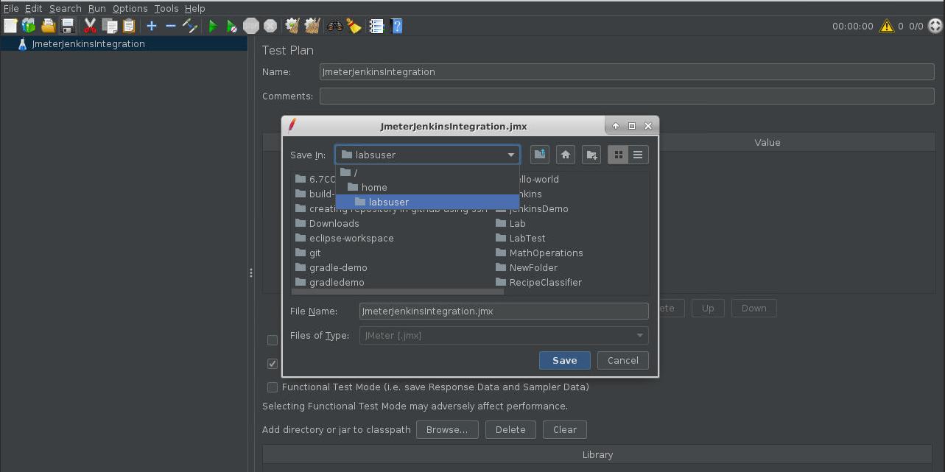

* Right click on **JmeterJenkinsIntegration** in the left pane and select **add** **threads(user)** > **thread group** as shown below:

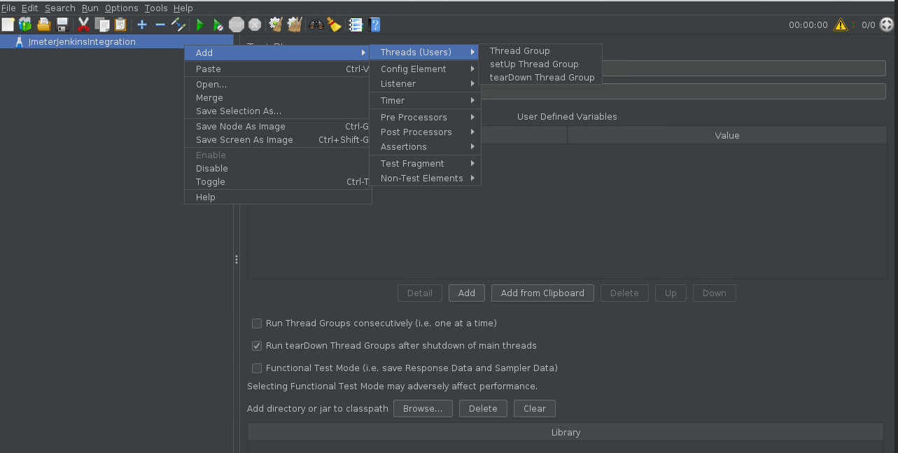

* Name your thread group as User
* Right click on **User** -> **Add** -> **Sampler** -> **HTTP Request**
* Enter the **Server name or IP**: www.merriam-webster.com and **Path**: /word-of-the-day
* Right click on **User** -> **Add** -> **Listener**-> **View Results in Table**

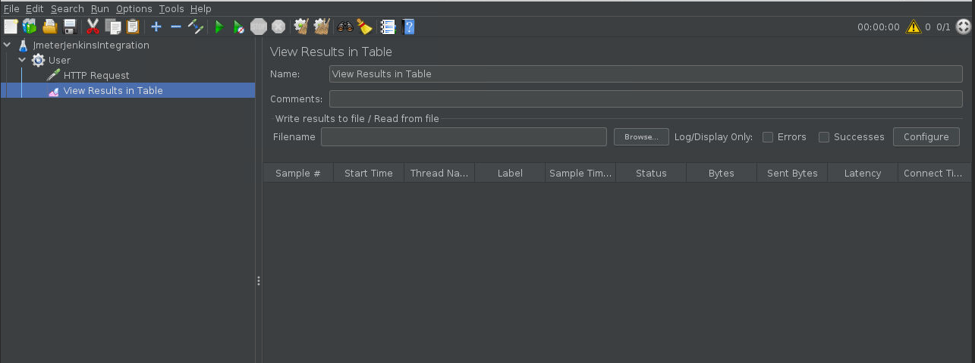

* Click on the **run** button to run the test
* You can see the status marked in green once the test run is complete.
* This means that the test cases are ready  
  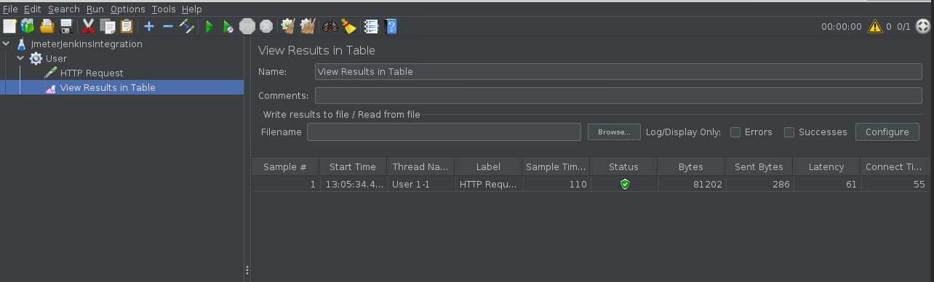

**Step 3:** Logging in to Jenkins

* Open your browser and navigate to **localhost:8081**
* Provide your username and password and click on **Login**

**Step 4:** Adding the performance plugin

* Install the **performance plugin** via **Manage Jenkins -> Manage Plugins**

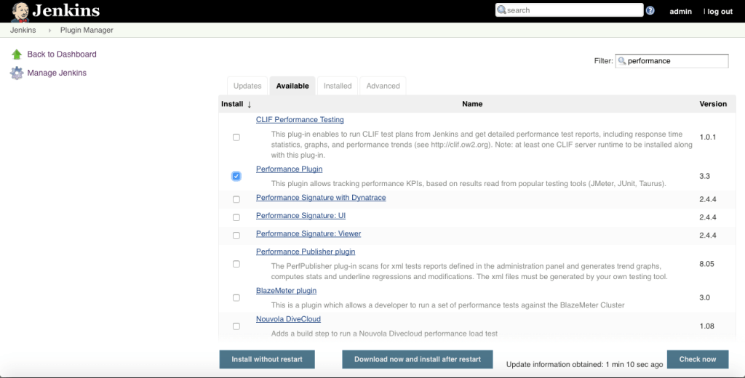

* Click on **Install without restart**

**Step 5:** Creating Jenkins job for JMeter

* Go to Jenkins home page and click on **Create New Job**, specify a name, select **Freestyle Project,** and click **OK**
* Now you will have to configure the job. In the **Build** section, select **Execute Shell**,and enter the commands given below:

**cd /home/labsuser/Downloads/apache-jmeter-5.4.1/bin/**

**sh jmeter.sh -Jjmeter.save.saveservice.output_format=xml -n -t /home/labsuser/JmeterJenkinsIntegration.jmx -l /home/labsuser/TestResult1.jtl**

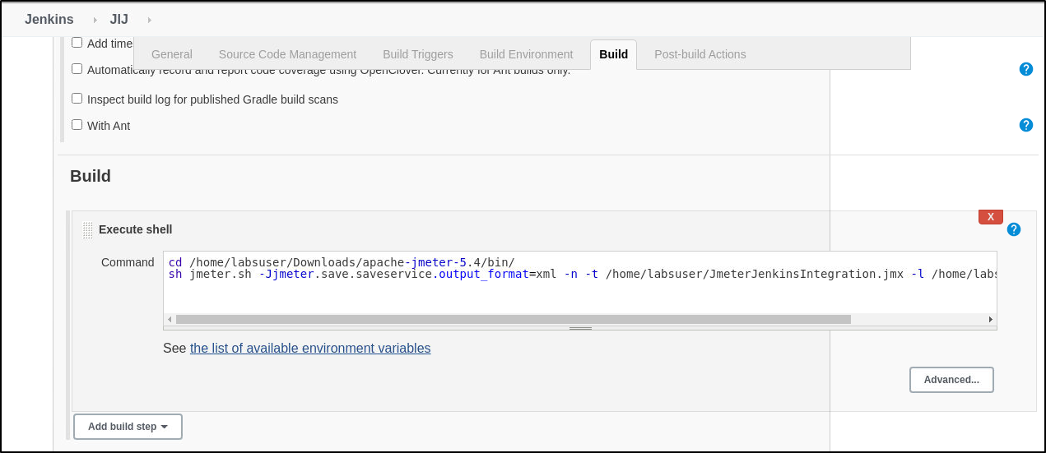

* In the **Post build Actions** sections, click on **add a post build step** and select **publish performance test result report**
* In the **Source data files** textbox enter the path to your test result file **/*home/*labsuser/TestResult1.jtl**
* Select the evaluation mode as: **Standard mode**
* Configure the job as shown in the screenshots below:

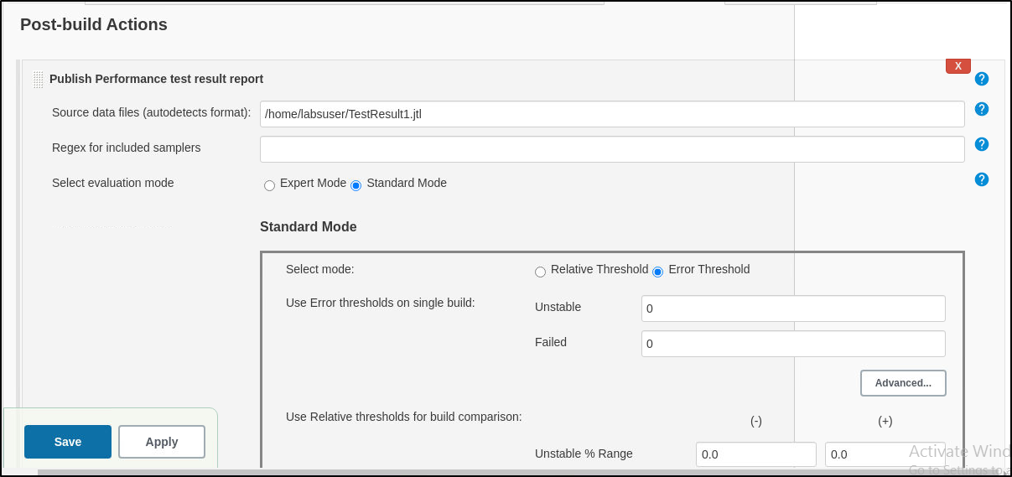

* Build the job and check the performance report on the job page