Lesson 9 Demo 1: Create Multiple Slave Nodes

This section will guide you to:

* Create a master/slave architecture in Jenkins.

**Please Note**: You need to have Jenkins installed to proceed with this demo.

This guide has two subsections, namely:

1. Log in to Jenkins
2. Create slave nodes

**Step 1:** Log in to Jenkins

* Open your browser and navigate to **localhost:8081**
* Provide your username and password and click on **Login**

**Step 2:** Create slave nodes

* Navigate to **Manage Jenkins**
* Click on **Configure Global Security**

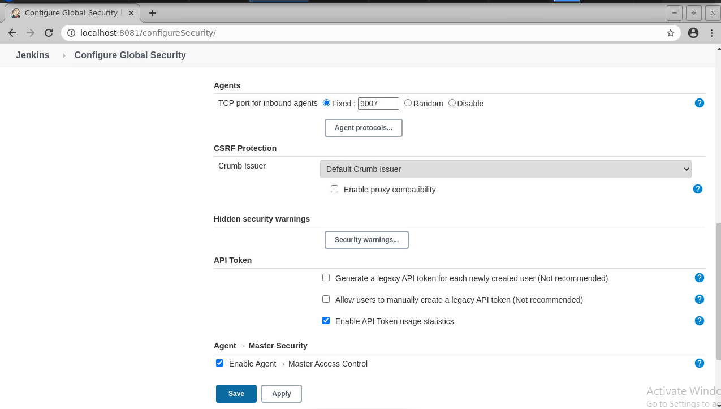

* Scroll down to Agents and enable inbound traffic at port **9007**
* Click on **Apply** and then click on **Save**
* Navigate to **Manage Jenkins**
* Click on **Manage Node and Clouds**
* Click on **New Node**
* Enter a **node_name (slave-node-1)** and check the **permanent agent** button
* Click on **Ok**

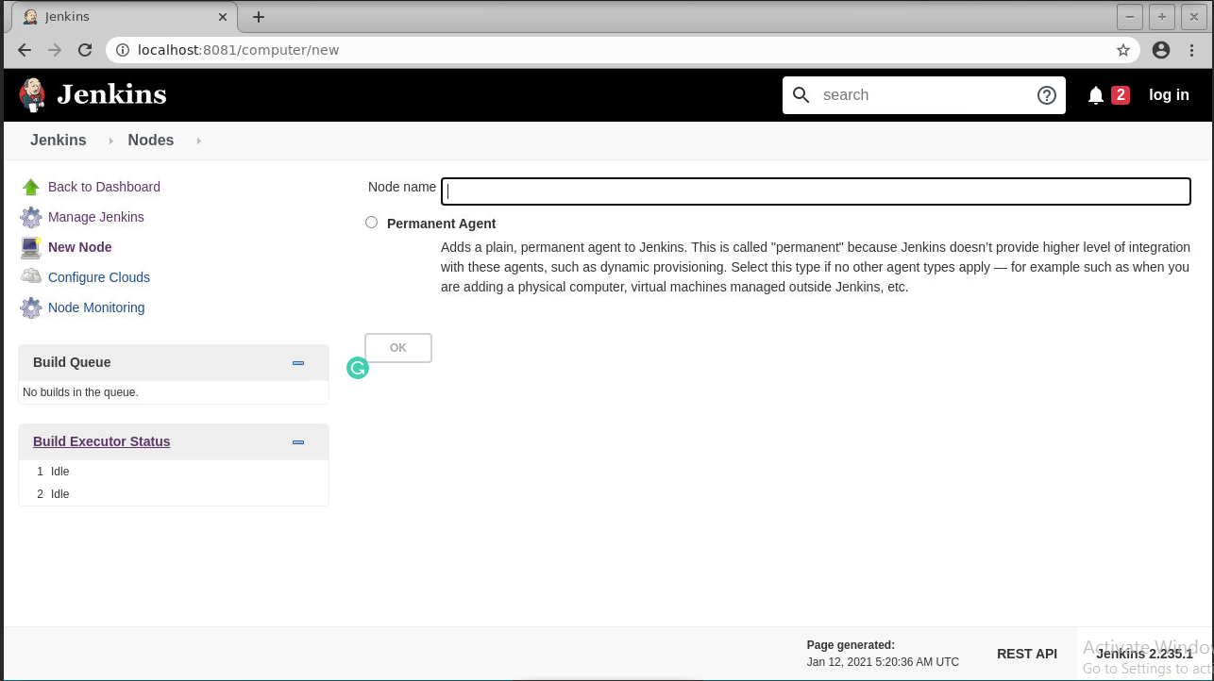

* Provide name, number of executors, root directory path, label, usage, and launch method, as shown below:

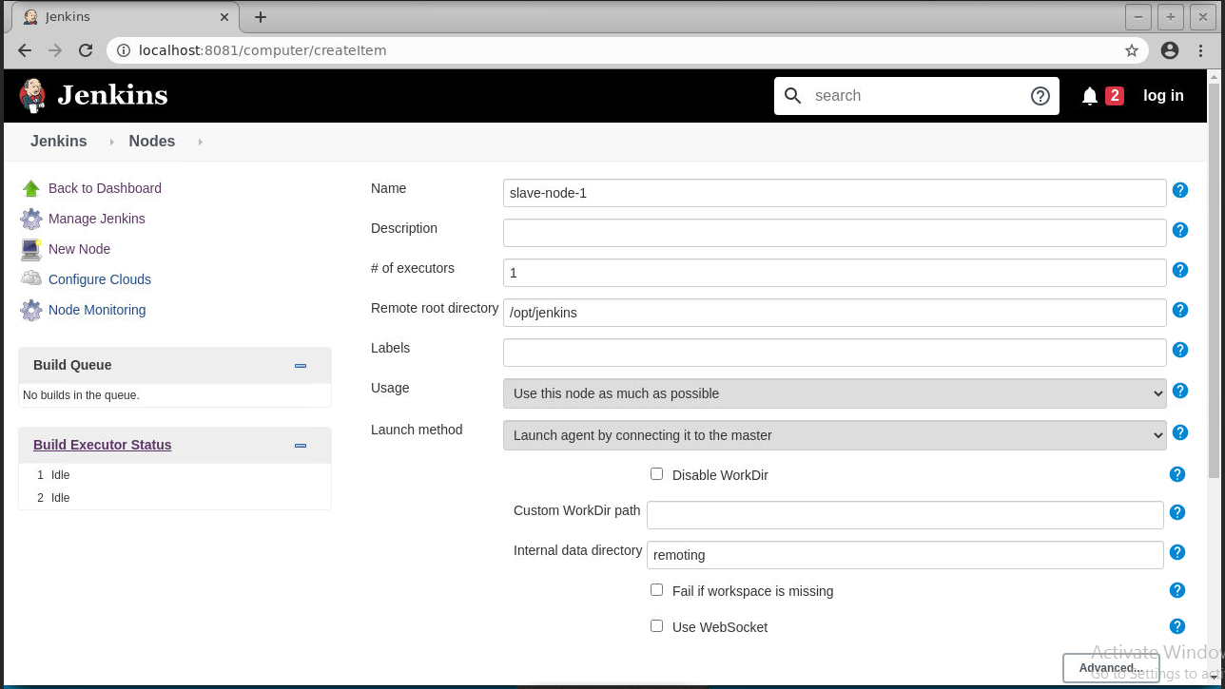

* Click on **Save**
* Once the configuration is complete, you can see the slave machine on the dashboard.

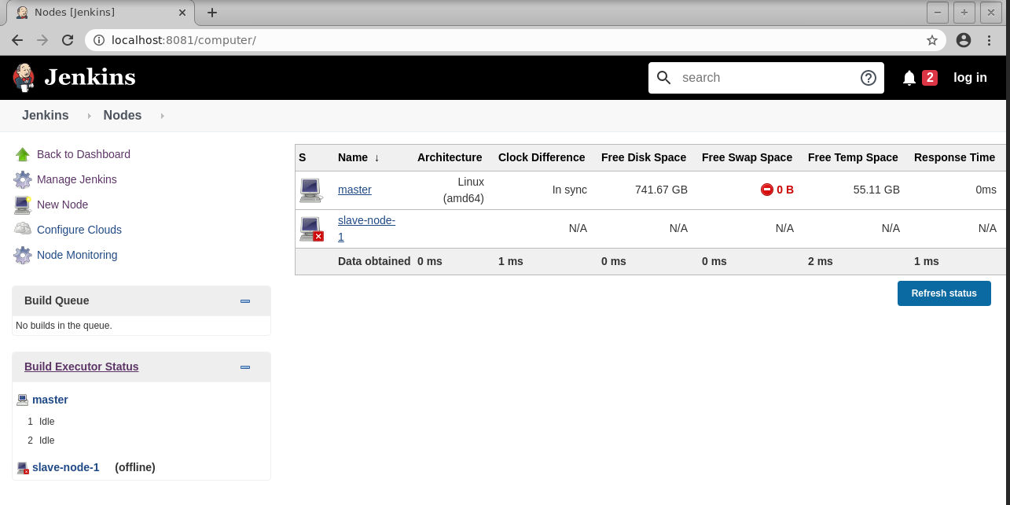

* Click on the **slave-node-1**
* Create a directory at the path specified as the Remote root directory

**sudo mkdir /*opt/jenkins***

***cd opt/jenkins***

* Download the **jar** file in the ***/opt/jenkins*** by running the following command:

**sudo wget http://localhost:8081/jnlpJars/agent.jar**

* Now copy the command shown in the agent slave-node-1

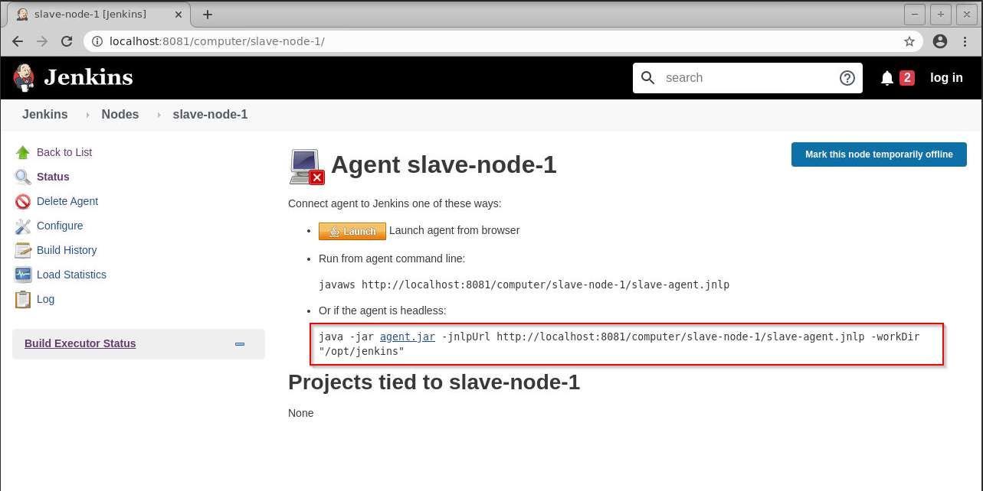

* Run the command to start the slave node

**sudo java -jar agent.jar -jnlpUrl http://localhost:8081/computer/slave-node-1/slave-agent.jnlp -workDir "/opt/jenkins"**

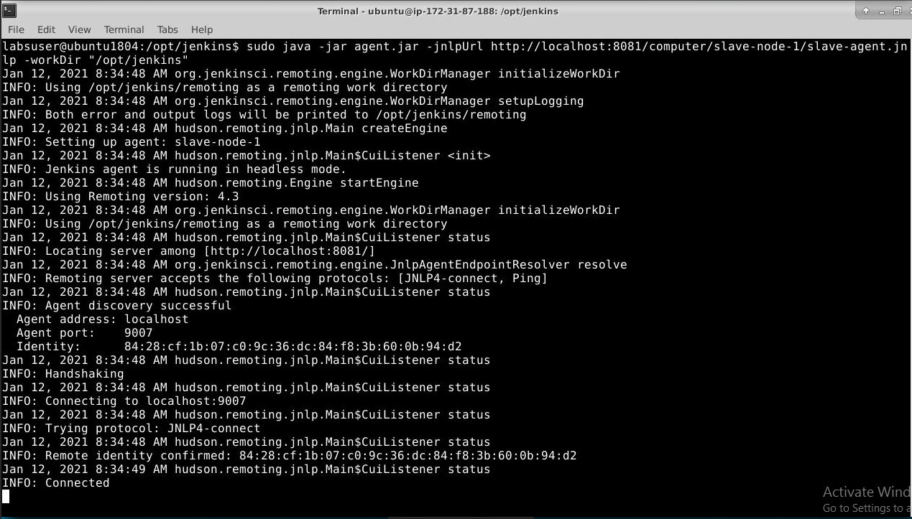

* The slave node will show as connected to the master UI

