Lesson 4 Demo 1: Create and Update a Cookbook

This section will guide you to:

* Create and update a cookbook

This lab has two sub-sections namely:

1. Creating a cookbook using Chef
2. Updating a cookbook

***NOTE:*** *The demos are incremental, please make sure you have completed the previous demos of lesson 3 before proceeding with this demo.*

**Step 1: Creating a cookbook using Chef**

* Generate a cookbook in the cookbooks folder of your chef-repo using the below commands:

**cd ~/chef-repo/cookbooks**

**chef generate cookbook <your_cookbookname>**

***Note:*** *Replace <your_cookbookname> with a name for your cookbook*

For example: **chef generate cookbook test_cookbook** where test_cookbook is an arbitrary name.

***Note****: Give any name to the cookbook but make sure to keep it constant throughout the demos.*

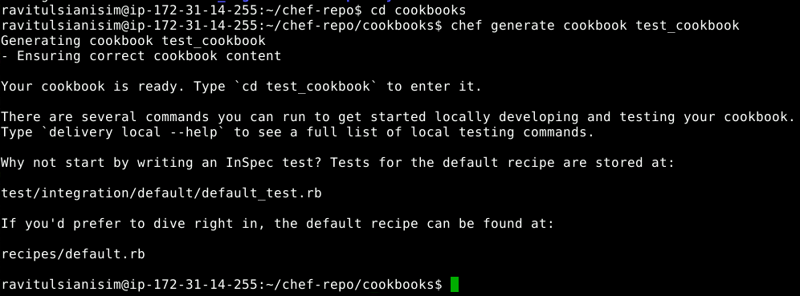

* Navigate to your cookbook directory. In our case we navigate to the test_cookbook directory using the command:

**cd test_cookbook**

* Type **ls** command to view the following components in the cookbook:



**Step 2: Updating a cookbook**

* Update the cookbooks/test_cookbook/recipes/default.rb recipe in the generated cookbook
* Navigate to cd recipes, open default.rb file

**cd recipes**

**vim default.rb**

* Add the following code in the default.rb file:

**execute "update-upgrade" do**

**command "sudo apt-get update && sudo DEBIAN_FRONTEND=noninteractive apt-get -y -o Dpkg::Options::='--force-confdef' -o Dpkg::Options::='--force-confold' upgrade"**

**action :run**

**end**

* Save and exit using **[esc][shift]** and type "**:wq**"
* To test the recipe, add the test_cookbook to the Chef server:

**knife cookbook upload test_cookbook**

* Verify that the recipe has been added to the Chef server:

**knife cookbook list**

