Lesson 4 Demo 2: Create a Chef Role

This section will guide you to:

* Create a role and run the Chef client

This lab has one sub-section namely:

1. Creating a Chef role

***NOTE:*** *The demos are incremental. Please ensure you have successfully completed the previous demos.*

**Step 1: Creating a Chef role**

* Navigate to the chef-repo using the command:

**cd ~/chef-repo**

* Create a Chef Role using the below command:

**knife role create <ROLE_NAME>**

**Note:** Replace <ROLE_NAME> with the name you want for a role. Let’s create a role named **roleexample** using the command given below:

**knife role create roleexample**

* In case you get an error similar to the one shown below:



You have to define the environment variable so run the below command:

**cat << EOF >> ~/.bashrc**

**export EDITOR=$(which vi)**

**EOF**

**. ~/.bashrc**

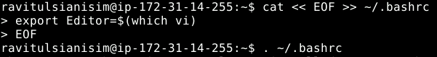

* In the $EDITOR enter the role data in JSON: Type **$EDITOR** on the terminal and it will lead you to this page:

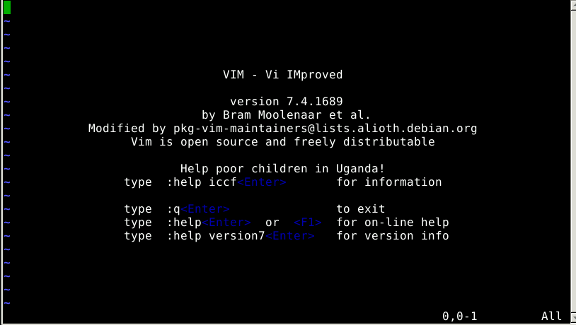

* Add the below commands in the vim editor:

**{**

**"name": "roleexample",**

**"default_attributes": {**

**},**

**"json_class": "Chef::Role",**

**"run_list": ["recipe[cookbook_name::recipe_name]",**

**"role[role_name]"**

**],**

**"description": "",**

**"chef_type": "role",**

**"override_attributes": {**

**}**

**}**

* Once done, save the file using **[esc][shift]+:**, type **w roleexample.json**,and exit by typing **[esc][shift]:wq**
* Then execute **knife role create roleexample** command**,** chef role will be created.
* If you want to delete a role, just use the below command:

**knife role delete <ROLE_NAME>**

For instance, **knife role delete roleexample** will delete the role named roleexample.

