Lesson 4 Demo 3: Create and Test Chef Environment

This section will guide you to:

* Create and Test Chef Environment

This lab has two sub-sections namely:

1. Creating a Chef environment
2. Testing the Chef environment

***Note:*** *The demos are incremental. Please ensure you have successfully completed the previous demos before proceeding with this demo.*

**Step 1: Creating a Chef environment**

* Execute the below commands to open a Shell’s default editor, so that one can modify the environment definition. Navigate to the chef repo as shown below and create the environment:

**cd ~/chef-repo**

* Run the below command to create a sample environment named **Exampleenv**:

**knife environment create Exampleenv**

* On executing the above command, you can see a file opened up in the editor similar to the screenshot below:

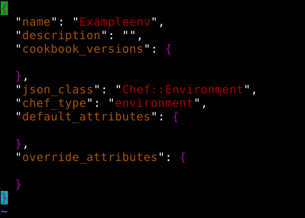

* Save and exit using **[esc][shift]+: wq**
* You can see that the Exampleenv is created



* You can also create the chef environment through Chef Manage console at <https://localhost/chef>
* Under **Policy** click on **Environments** and then click on **Create** as shown below

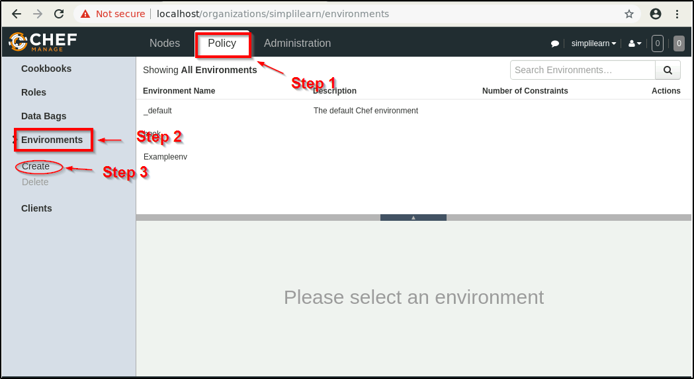

* Enter the name and description and click on Create Environment button

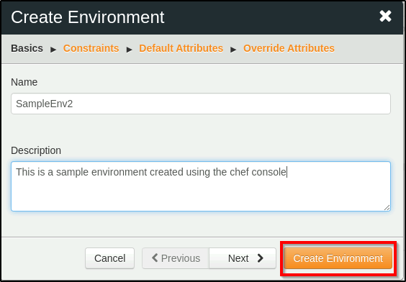

* Once you create, you can see something like this:

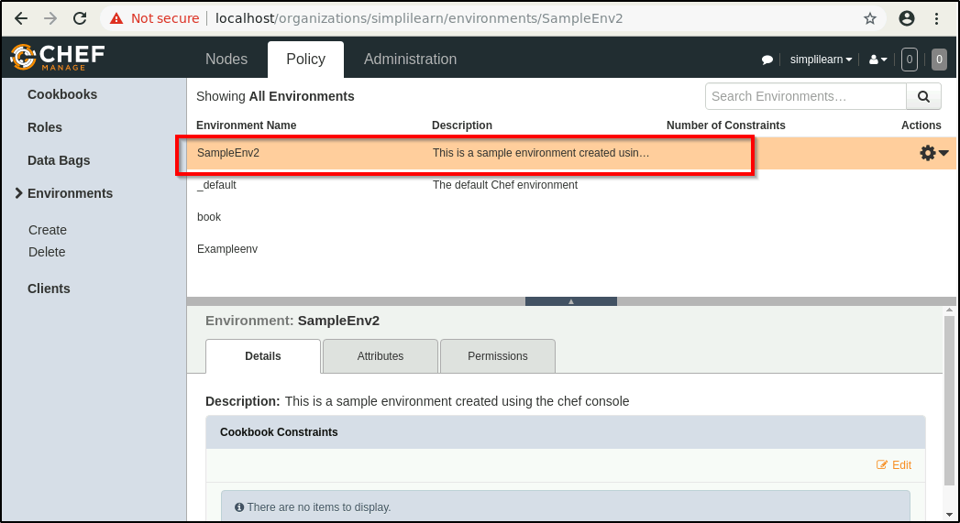

**Step 2: Testing a Chef environment**

* Execute the below code to test a Chef environment:

**knife environment list**

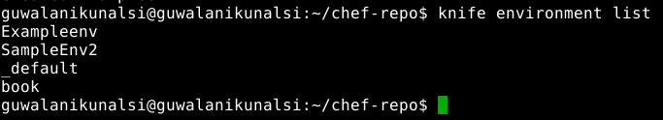

* List all the nodes in the environment using the below command:

**knife node list**



***Note****: As we have not created any nodes yet, the above command doesn’t return anything.*