Lesson 4 Demo 4: Execute Chef Shell

This section will guide you to:

* Execute Chef shell in a Standalone mode

This lab has five sub sections, namely:

1. Executing Chef shell in a standalone mode
2. Switching to attribute mode in the Chef shell
3. Switching to recipe mode
4. Creating a file resource
5. Commencing Chef run

***Note:*** *The demos are incremental. Please ensure you have successfully completed the previous demos before proceeding with this demo.*

**Step 1: Executing Chef shell**

* Execute Chef shell in the chef repo using the below command:

**cd ~/chef-repo**

**chef-shell**

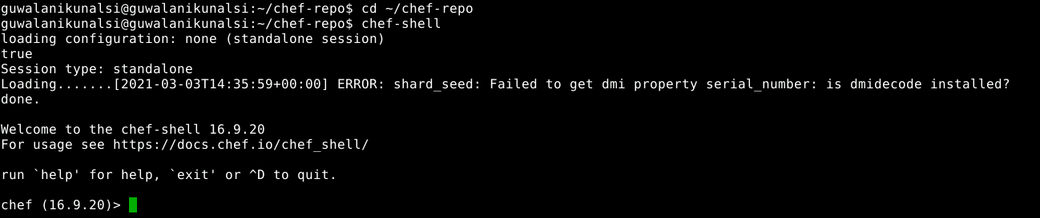

**Step 2: Switching to attribute mode in the Chef shell**

* Execute the below command in the chef shell prompt to switch to attribute mode:

**attributes_mode**



* To quit the attributes mode use the below command in the chef shell prompt:

**quit**

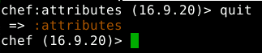

**Step 3: Switching to recipe mode**

* Execute the below command in the chef shell prompt to switch to recipe mode:

**recipe_mode**



**Step 4: Creating a file resource**

* In the recipe mode execute the below command to create a file resource in the recipe:

**file "/tmp/book.txt" do**

**end**



**Step 5: Commencing Chef run**

* Commence the Chef run to create the file with the given content using the below command:

**run_chef**

