Lesson 6 Demo 1: Installing and Setting up Puppet on Ubuntu

This section will guide you to:

* Download and install Puppet

This lab has two subsections, namely:

1. Installing the relevant puppet packages
2. Installing Puppet master and puppet agent

**Note:** You can use Ubuntu 18.04 EC2 instances for setting up puppet master and agent node.

**Step 1:** Installing the relevant puppet packages

* Run the following command on both puppet master and agent node to get the relevant puppet packages:

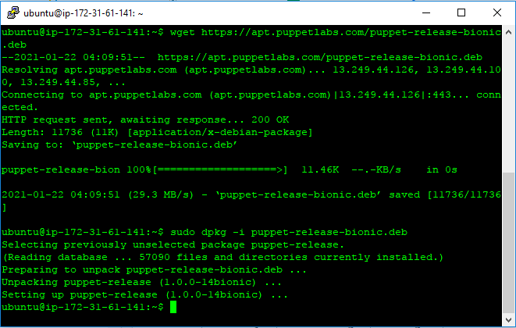

* Run the following command on the terminal to update the VM:

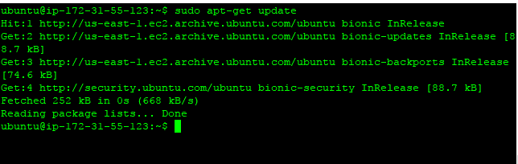

**Step 2:** Installing Puppet master and puppet agent

* Run the following command to install puppet on the master server:
* When prompted, enter y to continue

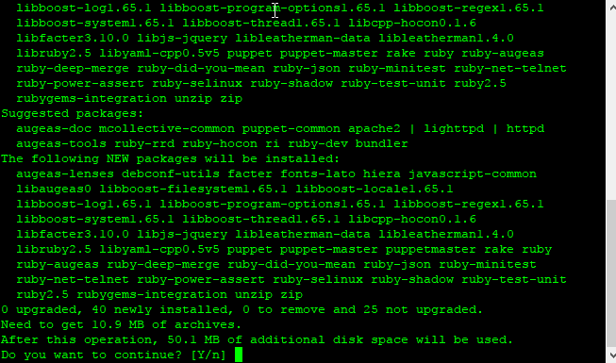

* Run the following command on puppet master to start the puppet service:

**sudo systemctl restart puppetmaster.service**

* Run the following command to install puppet on the agent node:
* When prompted, enter y to continue
* Run the following command on the agent node to start the puppet service:

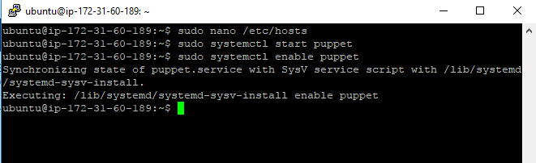

* Run the following command to verify the installation on both puppet master and agent node:

