Lesson 7 Demo 1: View Pre-Defined Puppet Resources

This section will guide you to:

* View pre-defined Puppet resources using the command line terminal

This lab has four subsections, namely:

1. Viewing the types of resources using command line
2. Viewing the resource description of a certain resource type
3. Listing the resources with the same resource type
4. Viewing a user resource

**Step 1:** Viewing the types of resources using command line

* Open the command line terminal of the system where Puppet has been installed
* Type in the following command:
* The above command will display a list of all available Puppet resource types as shown in the screenshot below:

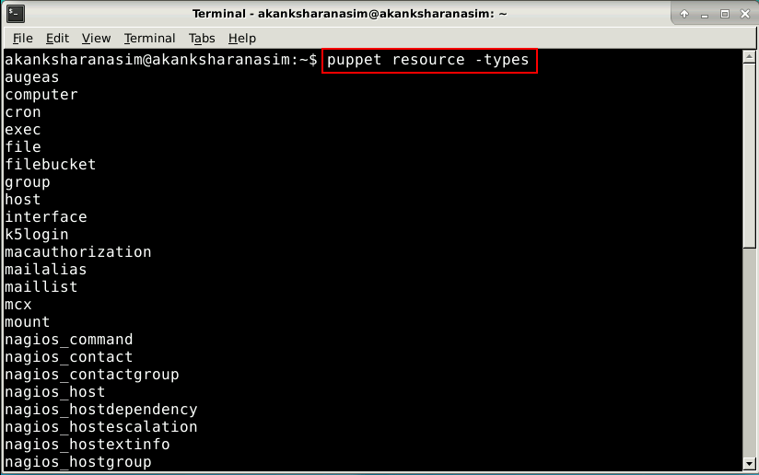

**Step 2:** Viewing the resource description of a certain resource type

* Open the command line terminal on the system where Puppet is installed
* Type in the following command:

**puppet describe <resource type>**

* Replace the <resource type> keyword in the command with the name of any resource type for which you want to view the description
* The above modified command will display a detailed description for the mentioned resource type including the parameters and attributes of that resource type as shown in the screenshot below:

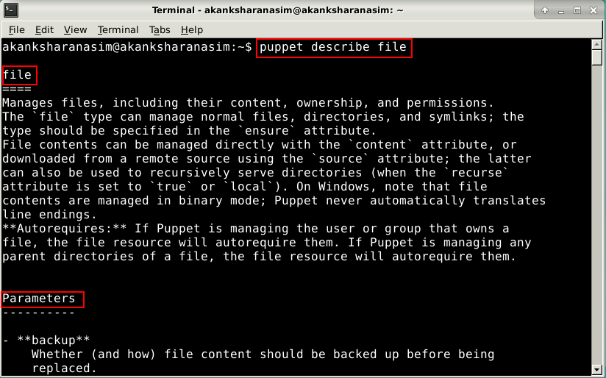

**Step 3:** Listing the resources with the same resource type

* Open the command line terminal on the system where Puppet is installed
* Type in the following command:



* Replace the <resource type> keyword in the command with the name of a resource type
* The above modified command will display a list of all the resources with the mentioned resource types
* The following screenshot displays a list of all the **user resources** available on the system:

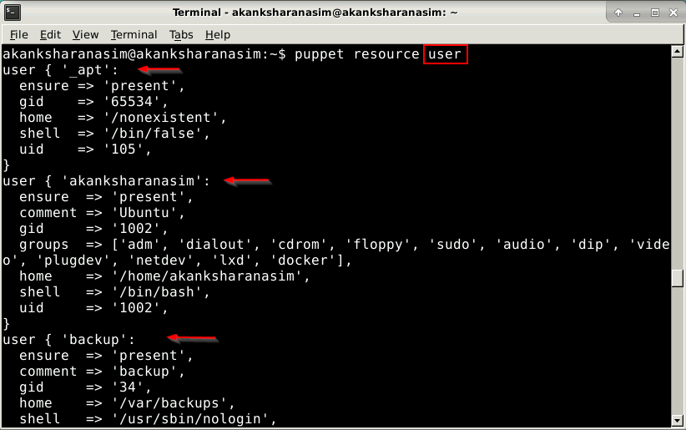

**Step 4:** Viewing a user resource

* Open the command line terminal on the system where Puppet is installed
* Type in the following command:



* Replace the <user name> keyword in the command with the name of the user
* The above modified command displays the mentioned resource as shown in the screenshot below:

