Lesson 7 Demo 2: Create and Remove the Puppet Resources

This section will guide you to:

* Create and remove Puppet resources using the command line terminal

This lab has three subsections, namely:

1. Creating a Puppet resource using a command line terminal
2. Adding an attribute and its value
3. Removing a Puppet resource using command line

**Step 1:** Creating a Puppet resource using a command line terminal

* Open the command line terminal of the system where Puppet has been installed
* Type in the following command:
* The above command will initiate the creation of a user named **Shikha**

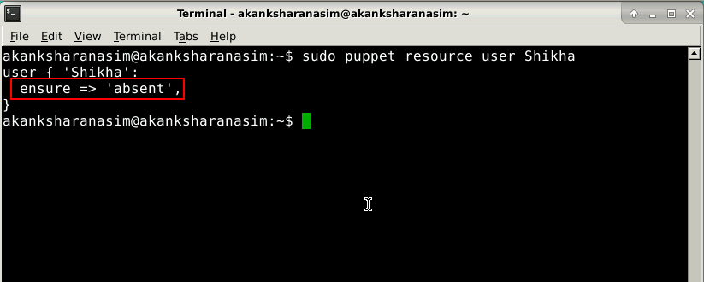

* Use the following command to change the value of **ensure** attribute from **absent** to **present** to complete the creation of the user



* A message saying *the user named Shikha has been created* will be displayed and the attribute value for **ensure** attribute will be changed to present as shown in the screenshot below:

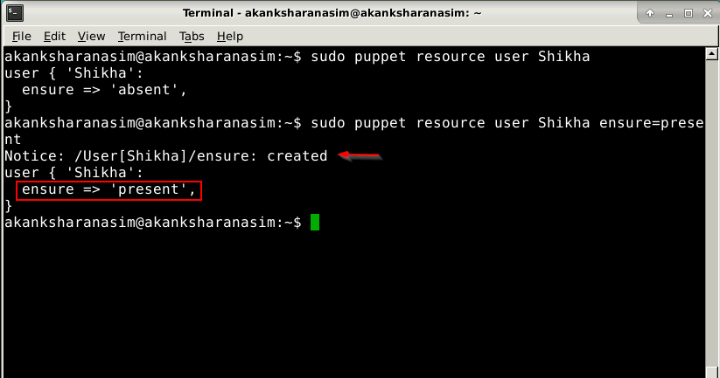

* Use the following command to verify the creation of the user:



* The new user will be listed along with the predefined users as shown in the screenshot below:

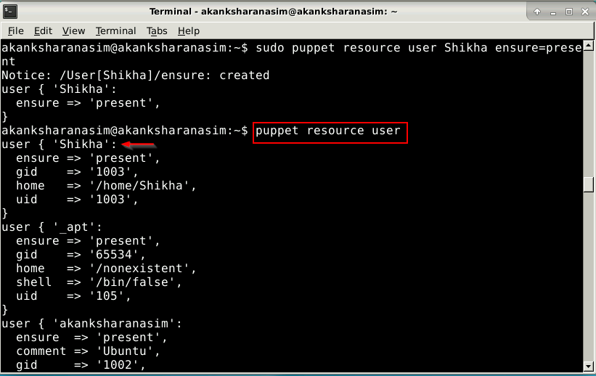

**Step 2:** Adding an attribute and its value

* Open the command line terminal of the system where Puppet has been installed
* Type in the following command to add a **comment** attribute to the user created in the previous step:
* Comment attribute in the Puppet resource contains some description about the resource, and its value is passed or saved as a string

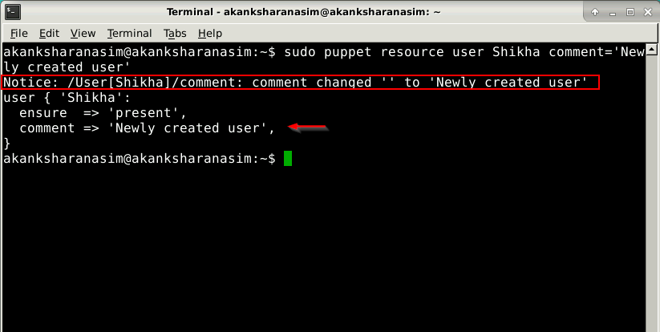

**Step 3:** Removing a Puppet resource using command line

* Open the command line terminal of the system where Puppet has been installed
* Type in the following command to remove the user named Shikha



* A message saying *the user named Shikha has been removed* will be displayed
* Use the following command to verify that the user has been removed:
* A message saying *no such user* will be displayed as shown in the screenshot below:

