Lesson 7 Demo 4: Create a Puppet Module

This section will guide you to:

* Create a custom Puppet module

This lab has three subsections, namely:

1. Creating the module structure
2. Generating metadata
3. Exploring module directory

**Step 1:** Creating the module structure

* Open the command line terminal on the system where Puppet has been installed
* Type in the following command to create the module structure:
* Replace <module-name> in the above command with **new-module**
* Choose a dash-separated name for the module as shown in the following screenshot:

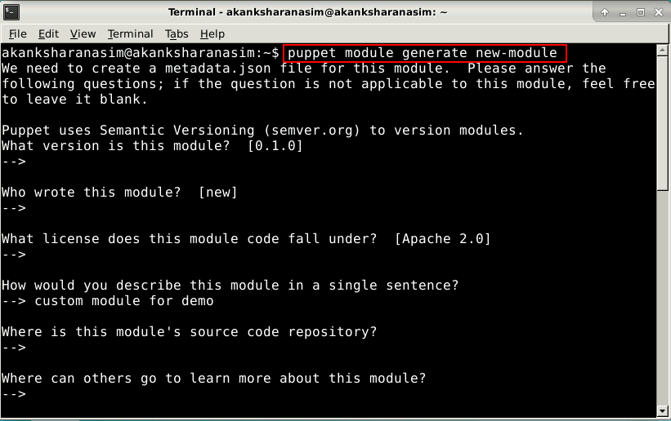

* The above modified command will prompt a series of questions that will be used to create the metadta.json file for the module
* Press **enter** to use the default answers for the questions
* Once the json file is created it will be displayed on the terminal as shown in the screenshot below:

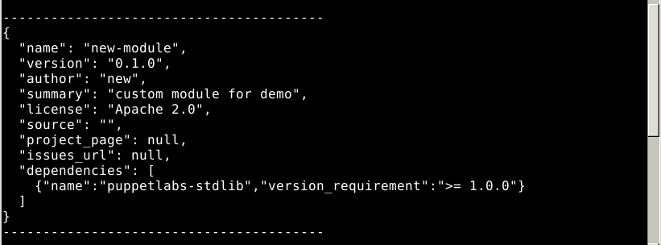

**Step 2:** Generating metadata

* Type y when prompted with the question: about to generate metadata; continue?

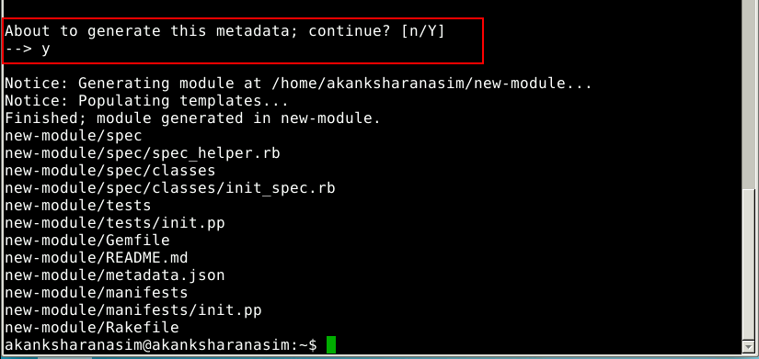

* The basic module structure will be created at /home/rootuser/modulename path
* The default files and templates will be populated inside the module’s respective directories

**Step 3:** Exploring module directory

* From the home directory, type in the following command in the command line:



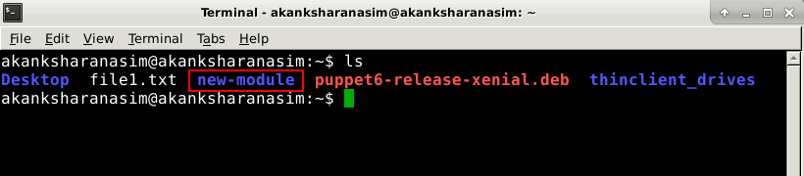

* The module created in the previous step will be listed as a result, among other contents of the home directory
* Type in the following command to enter the module and list the contents of the module:

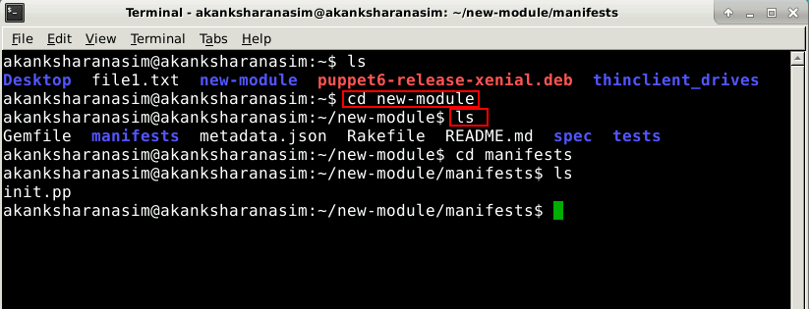

* The above command will display the default files and modules prepared by Puppet while creating the module structure