Lesson 7 Demo 5: Installing Module from Command Line

This section will guide you to:

* Install, upgrade, and uninstall Puppet modules

This lab has three subsections, namely:

1. Installing a Puppet module from Puppet Labs
2. Upgrading Puppet modules
3. Uninstalling Puppet modules

**Step 1:** Installing a Puppet module from Puppet Labs

* Open the command line terminal on the system where Puppet has been installed
* Type in the following command to check if you already have any installed modules:

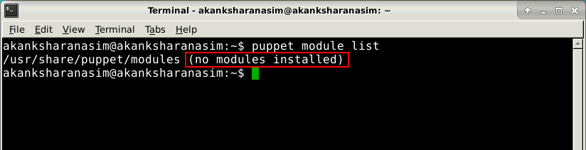

* If there are no pre-existing modules in the system, a message saying **no modules installed** will be displayed
* Type in the following command to install apache module from Puppet labs:

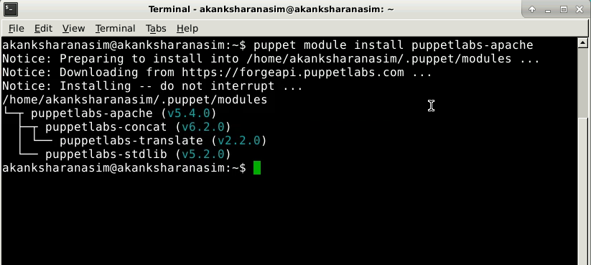

**Step 2:** Upgrading Puppet modules

* Type in the following command to upgrade any Puppet module to its latest version: 
* Replace the <module name> keyword in the above command with the name of the module that you want to upgrade
* To upgrade puppetlabs-apache module use the following command in the terminal:

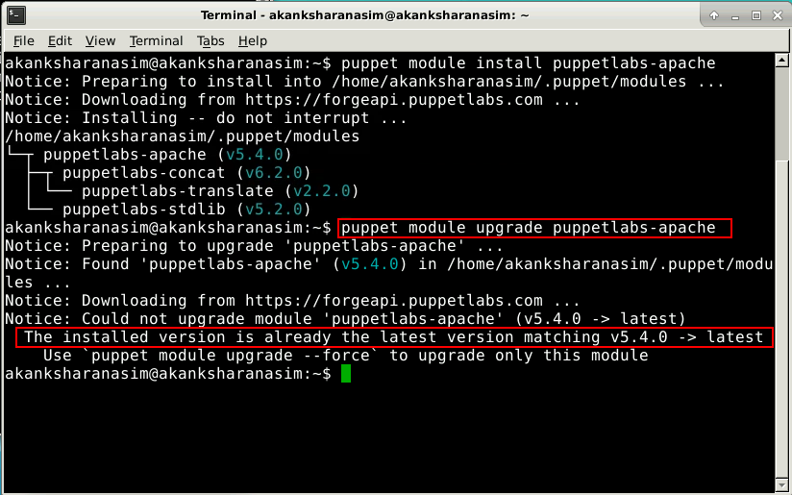

**Step 3:** Uninstalling Puppet modules

* Type in the following command to uninstall a Puppet module:
* Replace the <module name> keyword in the above command with the name of the module that you want to uninstall as shown in the screenshot below:

