Lesson 7 Demo 6: Manage Modules from Command Line

This section will guide you to:

* Perform tasks such as list, search, and install modules from another repository

This lab has three subsections, namely:

1. Listing the modules installed in the specified module path
2. Searching the Puppet labs module repositories for a module
3. Installing module from another repository

**Step 1:** Listing the modules installed in the specified module path

* Open the command line terminal on the system where Puppet has been installed
* Type in the following command to check the list of all installed modules and sub modules:

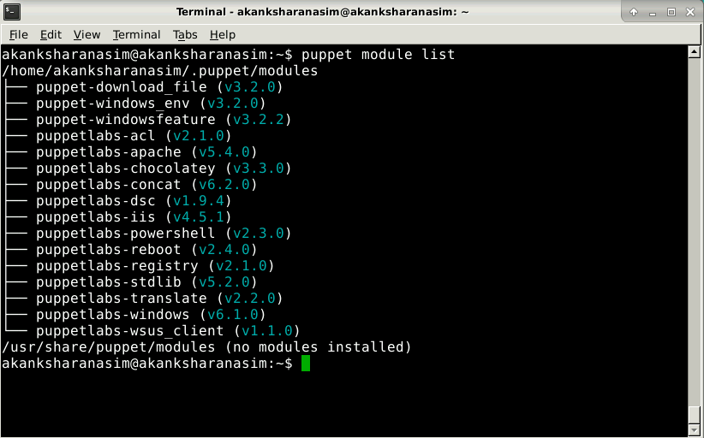

* The following command will list the installed modules in a specified module: path:
* Replace the path keyword in the above command with the directory path where you want to display the list of installed modules as shown below:
* The above modified command displays the list of installed modules in a tree structure that defines the modules and their sub modules distinctly as shown in the screenshot below:

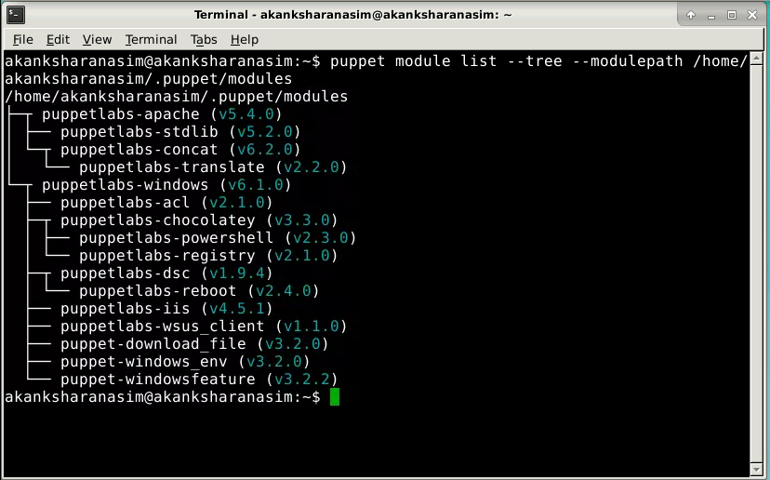

**Step 2:** Searching the Puppet labs module repositories for a module

* Type in the following command to search for a module in Puppet labs module repositories:
* Replace the module name keyword in the above command with the name of the module that you want to search as shown below:

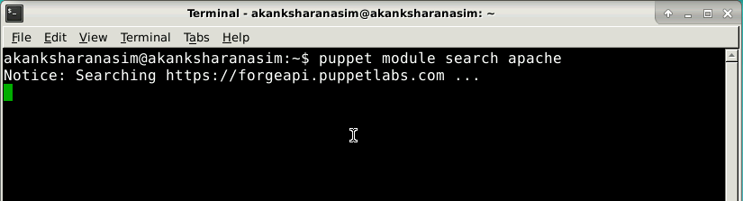

* The above modified command will display all the modules present in the Puppet labs module repositories that have **apache** keyword in them as shown in the screenshot below:

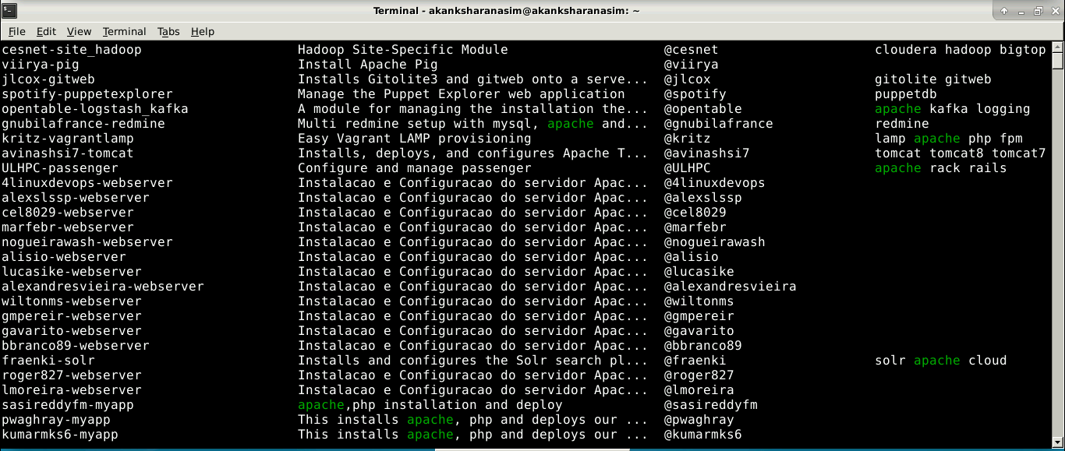

**Step 3:** Installing module from external repository

* The following command will install a Puppet module using a URL of an external repository:

**puppet module install --module_repository <repository URL here> <module name>**

* Replace the <repository URL here> keyword in the above command with the URL of the external repository from where the module has to be installed. One such external repository is **https://forgeapi.puppetlabs.com**
* Replace <module name> keyword in the above command with **puppetlabs-apache** as shown in the screenshot below:

