Lesson 7 Demo 7: Install PHP in Agent Node

This section will guide you to:

* Install PHP from Puppet master to Puppet agent using a manifest

This lab has six subsections, namely:

1. Launching AWS instances
2. Setting up the puppet master server
3. Setting up the puppet agent node
4. Establishing the connection between puppet master and agent node
5. Writing the puppet manifest
6. Pulling configuration in the agent node from puppet master

**Step 1:** Launching AWS instances

* Launch the AWS lab
* Navigate to the EC2 dashboard and click on the launch instance button
* For the AMI, choose Ubuntu Server 18.04

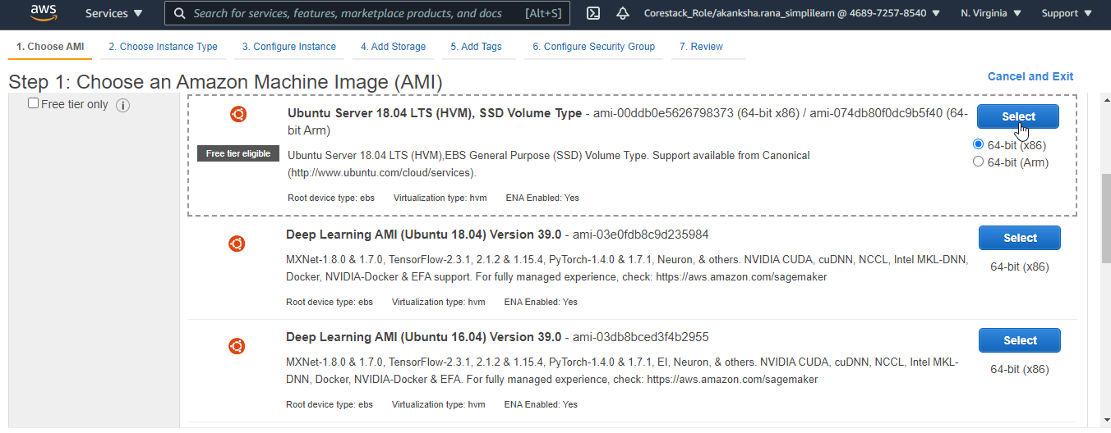

* For instance type, choose **t2.micro** and click on the **Next: Configuration Instance Details** button
* Enter 2 in the number of instances field
* Go with the default settings for storage and tags
* On the Configure security group page, click on the **Add rule** button
* Add the **All tcp** rule and select the source as **anywhere**
* Click on the **Review and Launch** button

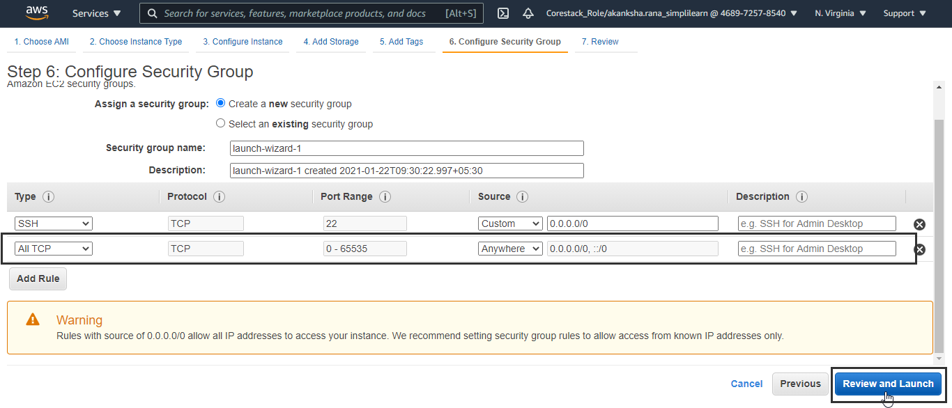

* Click on the **Launch** button on the Review Instance Launch page
* Create a new key pair, download it, and click on the **Launch Instance** button

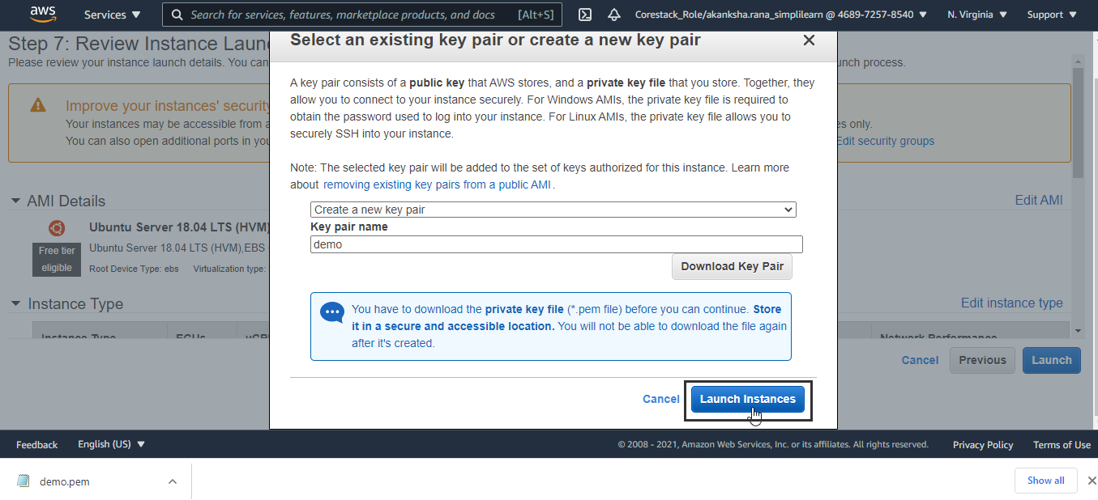

* Name the instances as master and node

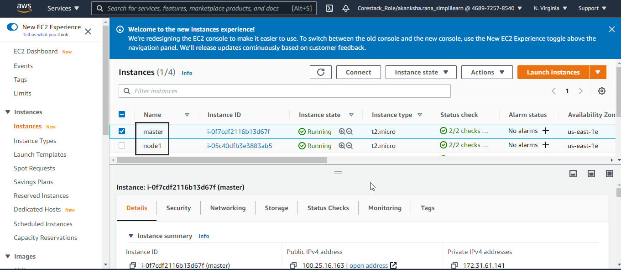

* SSH into both the instances from lab VM.

**Note:** Please make sure that your instance key pair is present in the lab VM, else make sure to transfer it to the lab VM if downloaded in your local system.

**Step 2:** Setting up the puppet master server

* Type in the following command in the master instance to update the already existing modules and packages:
* Type in the following commands to install puppet master:

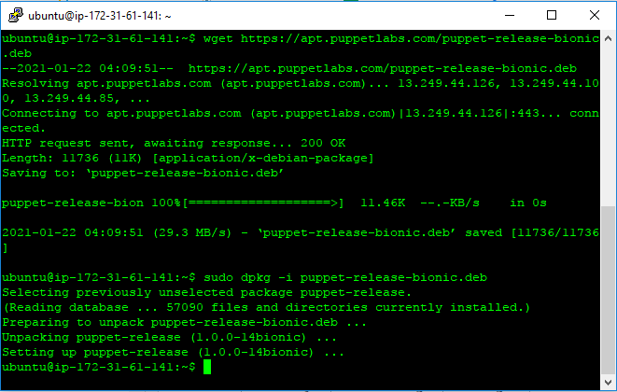

* Run the following command to verify the installation of puppet master:

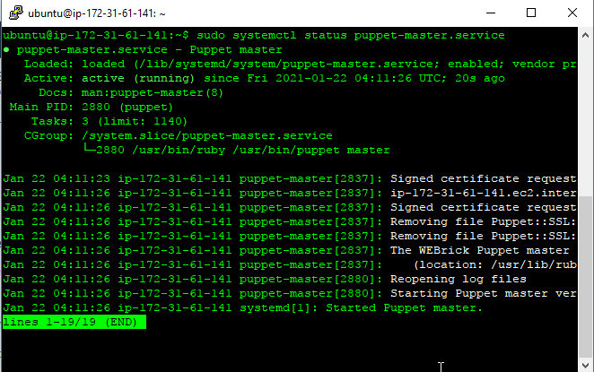

* Puppet master will be active and running as shown in the above screenshot
* Press **ctrl+z** and **Enter** to exit the status reading
* Type in the following command:

* Add the following code snippet in the file, as shown in the screenshot:

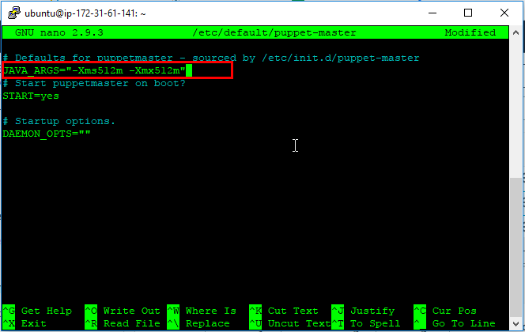

* Use the following command to start the puppet master
* Use the following command to open the port for tcp connection

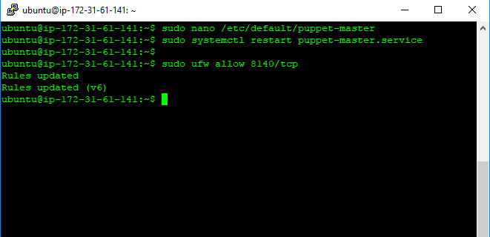

* Enter the following command to edit the host’s file
* Add the public IP address of puppet master in the file as shown in the following screenshot:

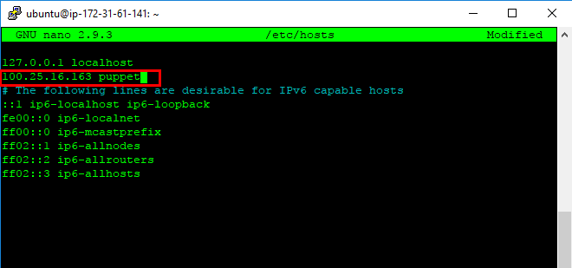

* Save and exit the file

**Step 3:** Setting up the puppet agent node

* Type in the following command in the agent node instance to update the already existing modules and packages:
* Type in the following commands to install puppet agent:
* Enter the following command to edit the hosts file:
* Add the public IP address of puppet master in the file as shown in the following screenshot:

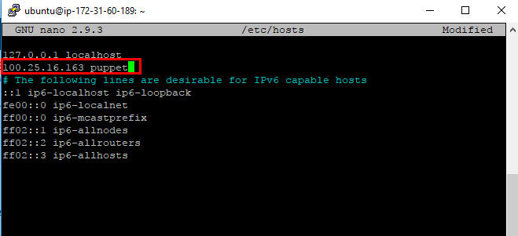

* Save and exit the file

**Step 4:** Establishing the connection between puppet master and agent node

* Run the following command on the agent node to start and enable the puppet agent:

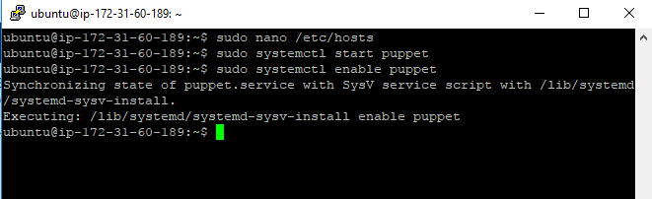

* Use the following command on the puppet master to accept and sign the certificate sent by the puppet agent:

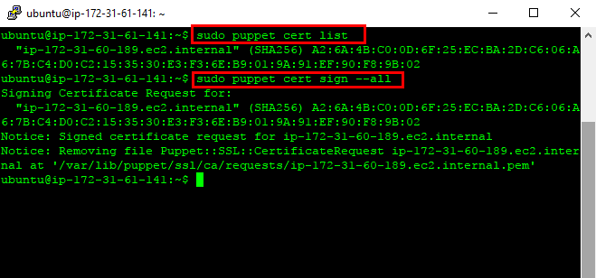

**Step 5:** Writing the puppet manifest

* Use the following command to create a directory for a manifest:
* Use the following command to create a the manifest:
* Add the following content in the file:

**# execute 'apt-get update'**

**exec { 'apt-update': # exec resource named 'apt-update'**

**command => '/usr/bin/apt-get update' # command this resource will run**

**}**

**# install apache2 package**

**package { 'apache2':**

**require => Exec['apt-update'], # require 'apt-update' before installing**

**ensure => installed,**

**}**

**# ensure apache2 service is running**

**service { 'apache2':**

**ensure => running,**

**}**

**# install mysql-server package**

**package { 'mysql-server':**

**require => Exec['apt-update'], # require 'apt-update' before installing**

**ensure => installed,**

**}**

**# ensure mysql service is running**

**service { 'mysql':**

**ensure => running,**

**}**

**# install php package**

**package { 'php':**

**require => Exec['apt-update'], # require 'apt-update' before installing**

**ensure => installed,**

**}**

**# ensure info.php file exists**

**file { '/var/www/html/info.php':**

**ensure => file,**

**content => '<?php phpinfo(); ?>', # phpinfo code**

**require => Package['apache2'], # require 'apache2' package before creating**

**}**

* Save and exit the file

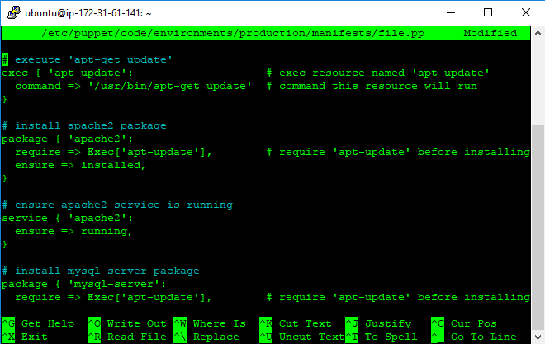

**Step 6:** Pulling configuration in the agent node from puppet master

* Run the following command on the agent node to pull the configurations from puppet master:

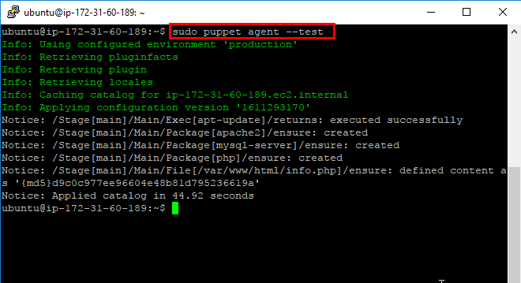

* Run the following command on the agent node to verify the installation of php on the agent node:

