Lesson 8 Demo 1: Installing Puppet Modules from Puppet Forge

This section will guide you to:

* Install Puppet modules manually and by using command line from Puppet Forge

This lab has two subsections, namely:

1. Installing Puppet modules manually from Puppet Forge
2. Searching for and installing Puppet modules from Puppet Forge using the command line

**Step 1:** Installing Puppet modules manually from Puppet Forge

* In Puppet master, open the browser and enter the URL forge.puppet.com as shown in the below screenshot:

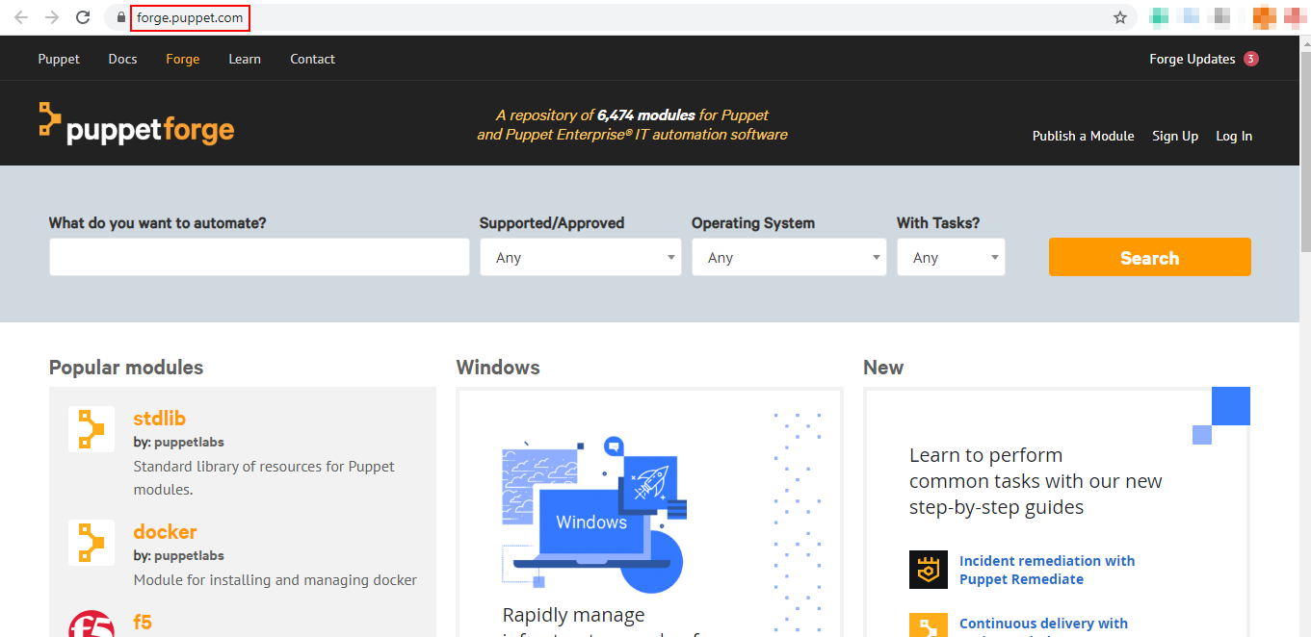

* Enter the name of the module that you want to search for in Puppet Forge. For this assisted practice, we will search for and install a module named vim. Click on the search button.

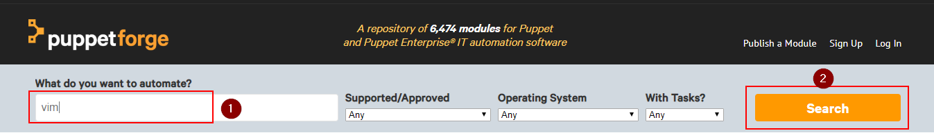

* Once you get the relevant matches for your search, choose the preferred module.

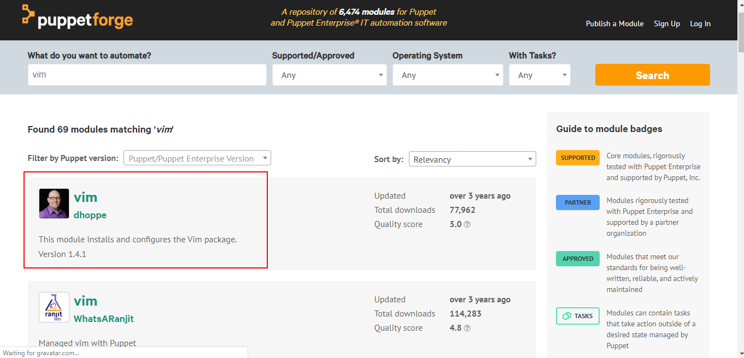

* Click on the download option as shown in the below screenshot:

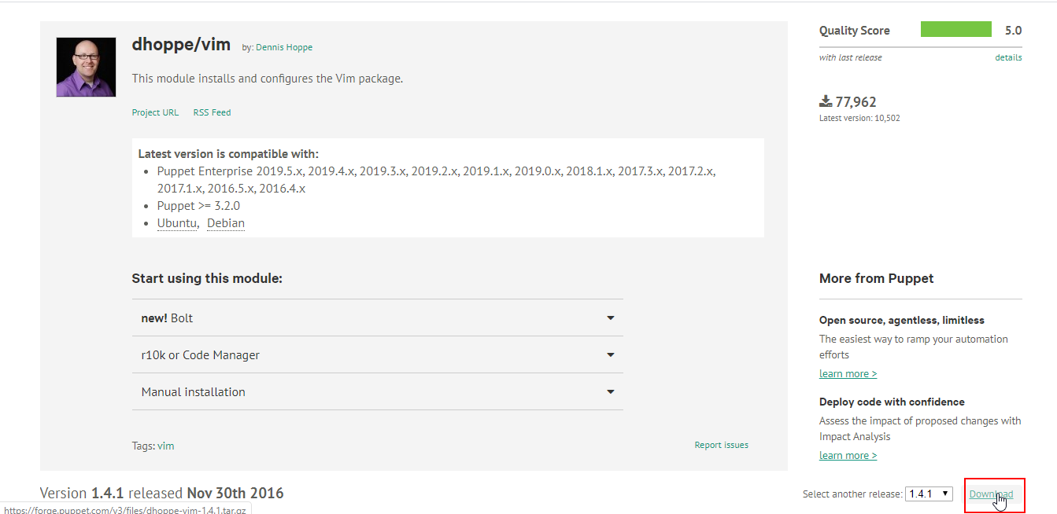

* Once the tarball is downloaded, run the following command in the terminal to extract the tar.gz file:

cd Downloads

tar -xf dhoppe-vim-1.4.1.tar.gz

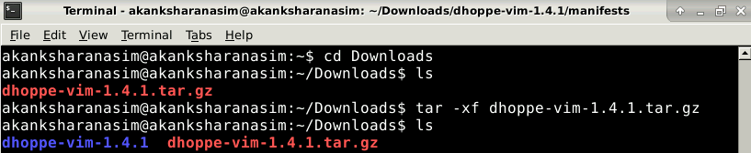

* All the manifests of this modules will be extracted in thedhoppe-vim-1.4.1 directory
* Run the following command to navigate to the manifests directory:

**sudo su -**

**cd**

**cd /etc/puppet/manifests/**

* Run the following command:



* Add the following code snippet in the site.pp manifest file:

**node default {**

**class { 'vim': }**

**}**

* Save and exit the file

**Step 2:** Searching for and installing Puppet modules from Puppet Forge using the command line

* Open command line terminal in Puppet master and run the following command to search for a module:

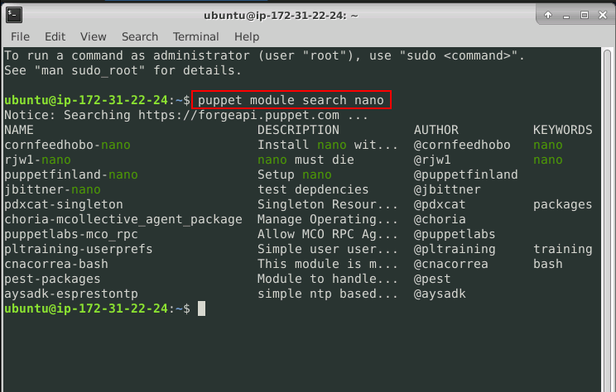

* Run the following command to install cornfeedhobo-nano module:

