Lesson 8 Demo 2: Publish to Puppet Forge

This section will guide you to:

* Upload and publish a custom module to Puppet Forge

This lab has five subsections, namely:

1. Creating a Forge account
2. Preparing the custom module
3. Adding metadata.json file in the module
4. Building a module package
5. Uploading the module package to Puppet Forge

**Step 1:** Creating a Forge account

* Go to forge.puppet.com and click on **Sign Up** as shown in the following screenshot:

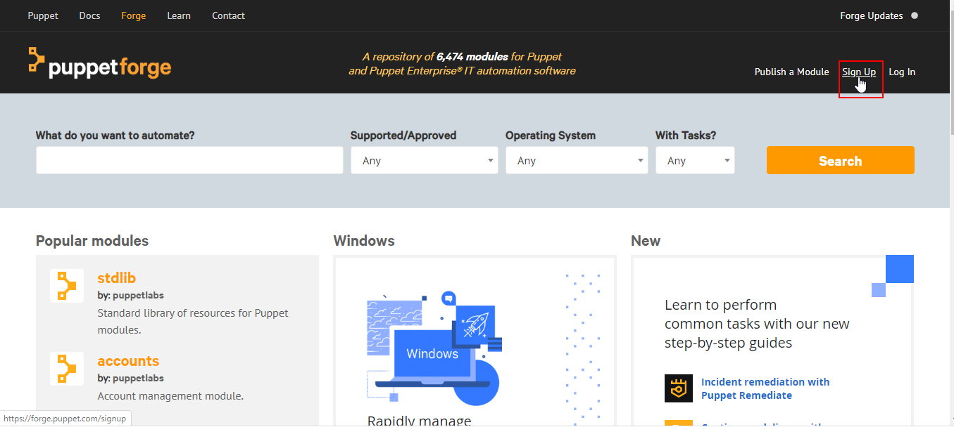

* Fill in the information on the sign-up page.
* Note: The username you choose will become a part of your module long name

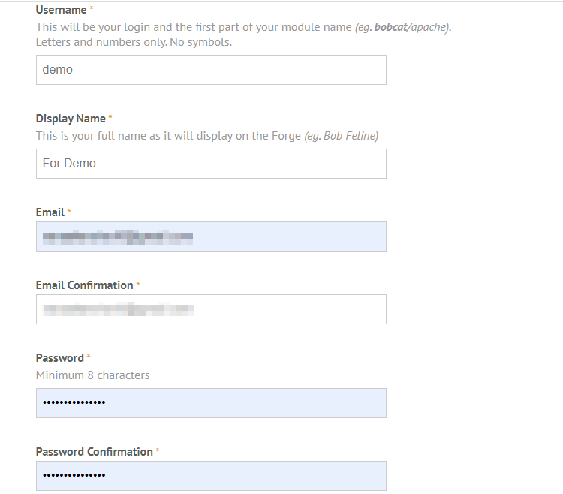

* Follow the email verification steps sent to the email you provided in the previous step
* Go to forge.puppet.com and log in to your account

**Step 2:** Preparing the custom module

* Open the command line terminal on the system where Puppet has been installed
* Type in the following command to create the module structure:



* The above modified command will prompt a series of questions that will be used to create the metadata.json file for the module
* Press **Enter** to use the default answers for the questions

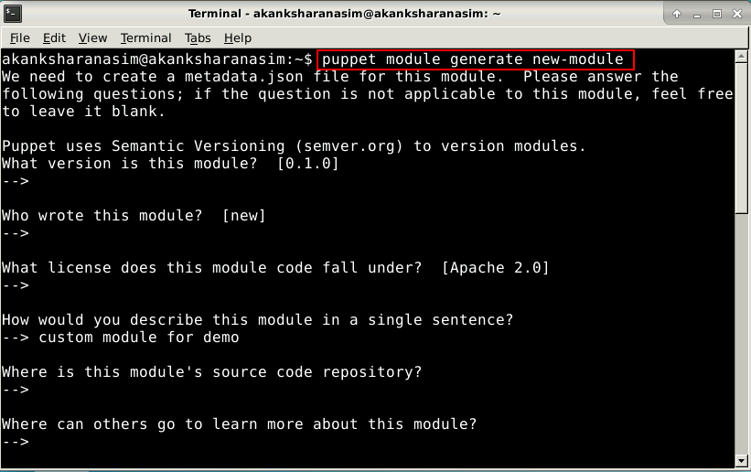

* Once the json file is created it will be displayed on the terminal as shown in the screenshot below:

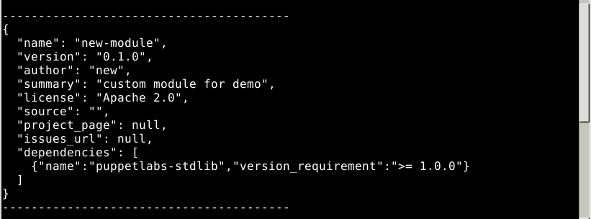

**Step 3:** Adding metadata.json file in the module

* To generate a metadata.json file, type y when prompted with the question: about to generate metadata; continue?

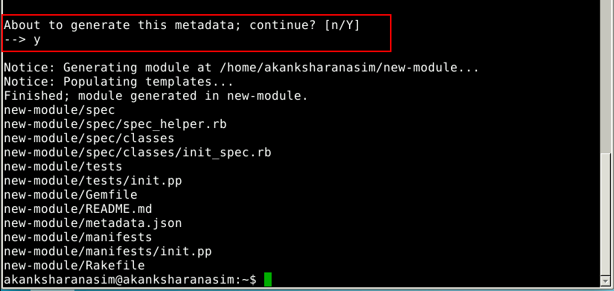

* The basic module structure will be created at /home/rootuser/modulename path
* The default files and templates will be populated inside the module’s respective directories

**Step 4:** Building a module package

* Use the following command to navigate to the module directory:
* Build a package using the following command:
* Use the default answers for the questions prompted by pressing **Enter**
* At the confirmation prompt, confirm the package creation

**Step 5:** Uploading the module package to Puppet Forge

* At the confirmation prompt, confirm the package creation
* Click on **Publish** button
* On the upload page, click **Choose File**
* Locate and select the tarball built in previous steps, then click **Upload Release**