Lesson 8 Demo 3: Deleting Module from Forge

This section will guide you to:

* Delete a module release from the Puppet Forge using the Forge web interface

This lab has the following subsection:

1. Deleting a module release from the Puppet Forge

**Note:** In case you want your module users to know that you are not maintaining and updating the module anymore but want to keep the current release in use, you can opt for deprecating the module instead of deleting it.

**Step 1:** Deleting a module release from the Puppet Forge

* Open your web browser and navigate to the official Puppet Forge website
* Log in to Forge using your credentials

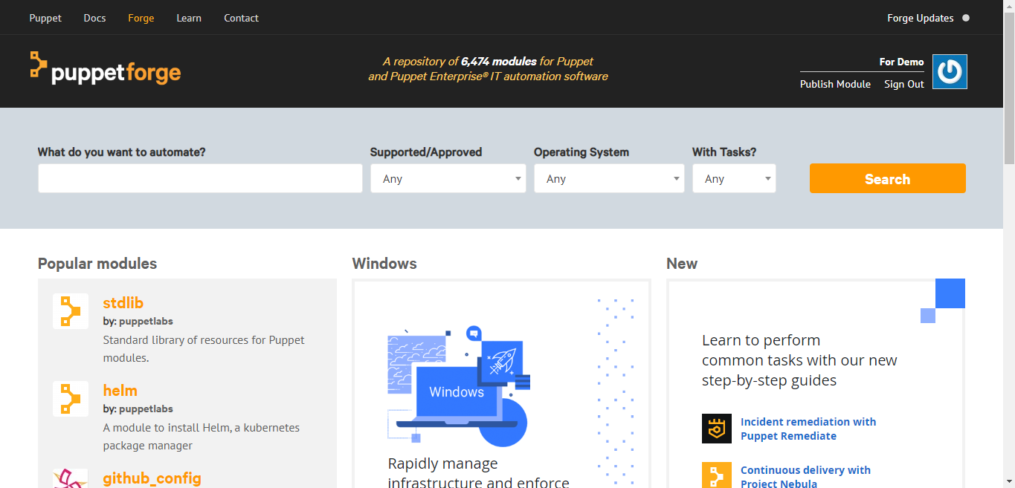

* Go to **Your Modules**
* Navigate to the page of your module release you want to delete
* Click on **Select another release** and choose the release from the drop-down list
* Click on Delete
* Provide a reason for deletion on the confirmation page and click on **Submit**
* Click on **Yes** and delete it