Lesson 8 Demo 4: Testing Hiera

This section will guide you to:

* Test Hiera using Puppet agent server

This lab has two subsections, namely:

1. Adding Hiera data in Puppet agent manifest file
2. Verifying the returned Hiera data in Puppet master from Puppet agent

**Step 1:** Adding Hiera data in Puppet agent manifest file

* Set up the puppet agent as shown in earlier demos
* Open the command line on Puppet agent
* Navigate to the manifests directory using the following command:

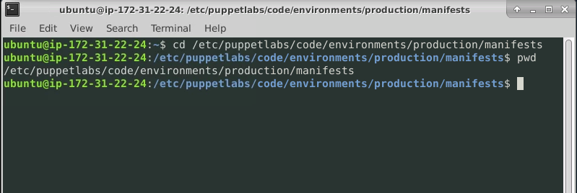

* Use the following command to navigate to the directory containing hiera.yaml: file
* Paste the following code snippet in the site.pp file:

**## site.pp ##**

**node default {**

**notify {hiera(motd::message): }**

**# This is where all classes for nodes are declared**

**# Example:**

**# class {'my_class':}**

**}**

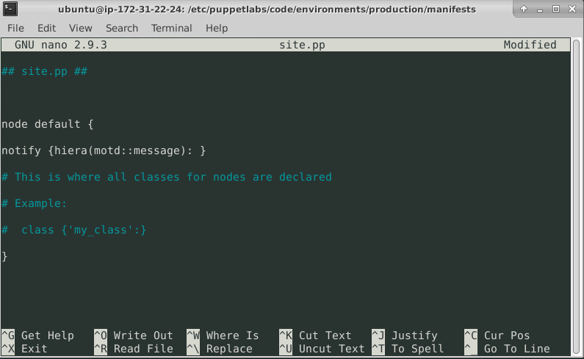

* Save and exit the file

**Step 2:** Verifying the returned Hiera data in Puppet master from Puppet agent

* Open command line on the Puppet master server
* Use the following command to get the OS family details of the puppet master:

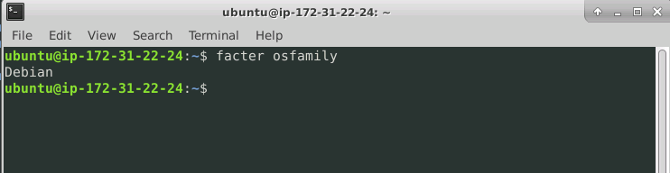

* Use the following command to pick up the Hiera data added in the Puppet agent in the previous step:



