Lesson 9 Demo 1: Set up Apache Web Server Using Ansible

This section will guide you to:

* Set up apache web server using Ansible

This lab has four sub-sections:

1. Install Ansible on Ubuntu
2. Establish connectivity between ansible controller and node machine
3. Write Ansible YAML script to install ansible software
4. Run Ansible YAML script

**Step 1:** Install Ansible on Ubuntu

* Use the below commands on Ubuntu system to install ansible software:

**sudo apt-get install -f**

**sudo apt-get install software-properties-common**

**sudo apt-add-repository ppa:ansible/ansible**

**sudo apt-get update**

**sudo apt-get install ansible**

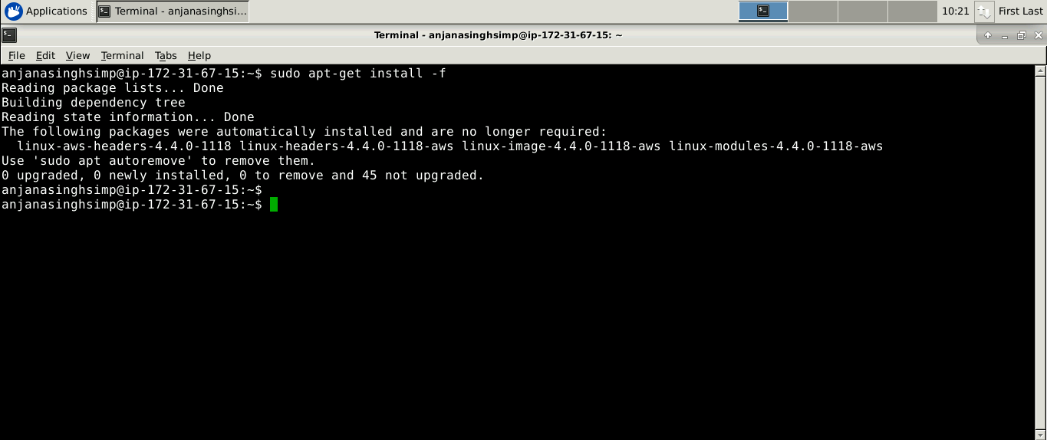

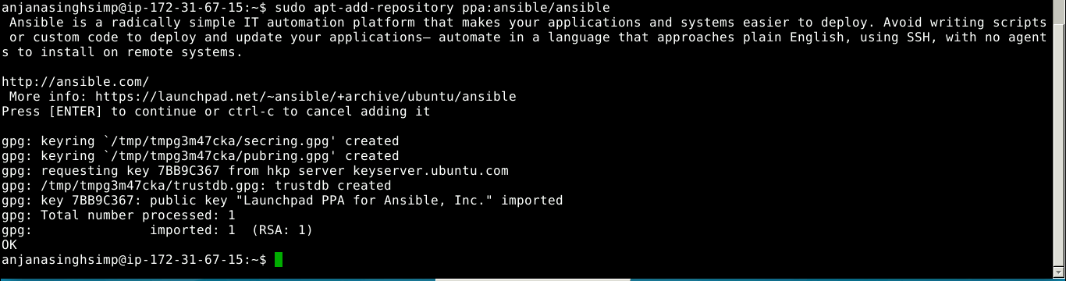

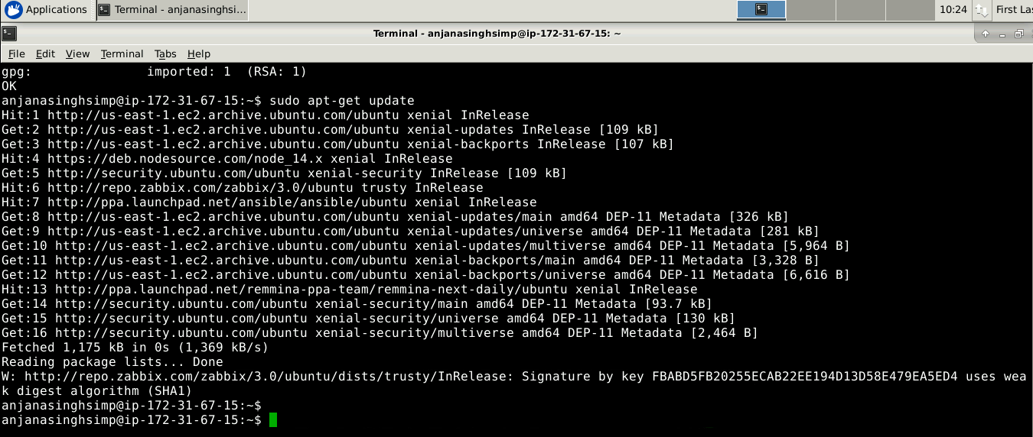

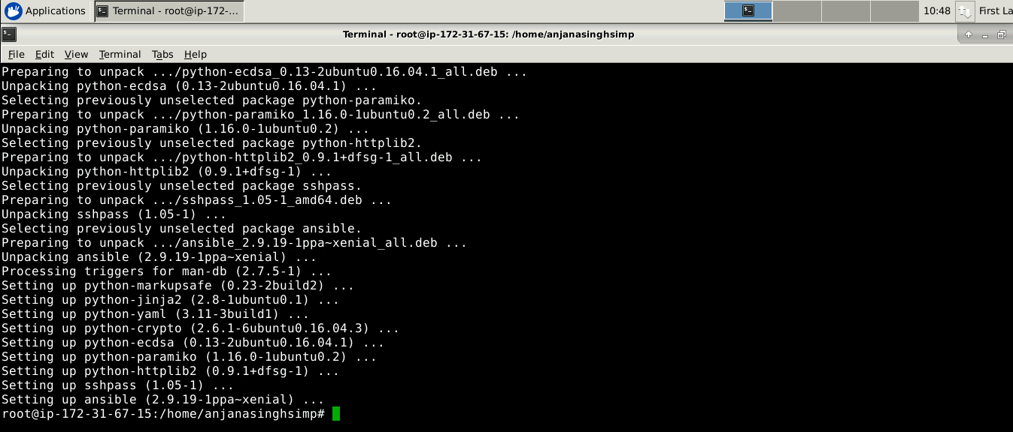

* Establish SSH key pair in linux system to have SSH connectivity with localhost using the following commands:

**ssh-keygen -t rsa**

**cat .ssh/id_rsa.pub >> .ssh/authorized_keys**

**ssh localhost -p 42006**

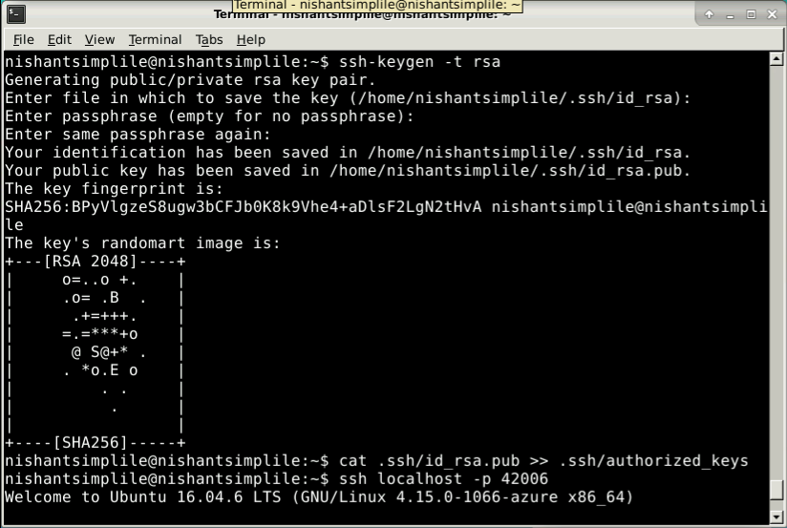

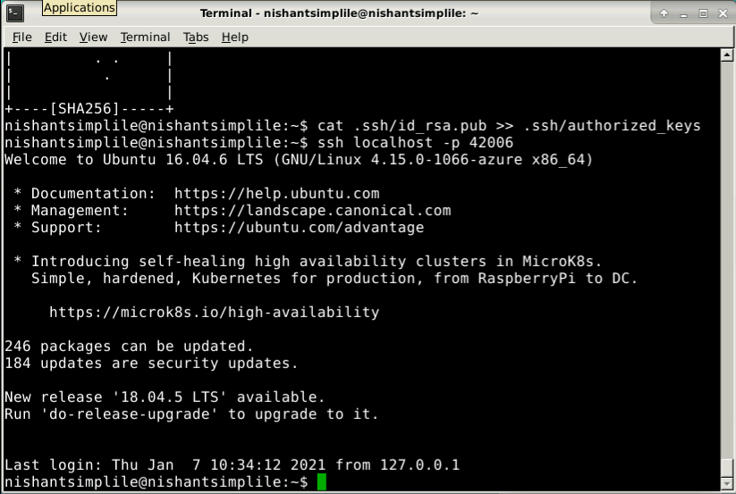

* Now, add the host localhost in ansible host file /etc/ansible/hosts.

**sudo vi /etc/ansible/hosts**

* When the file opens, add the below two lines of the code at the end of the file:

**[webservers]**

**localhost:42006**

**Step 2:** Establish connectivity between Ansible controller and node machine

* Execute the below command to validate host inventory file:

**ansible -m ping webservers**



**Step 3:** Write Ansible YAML script to install Ansible software

* Once connectivity is established, add the following code in the apache.yaml file and proceed with execution

**sudo vi apache2.yaml**

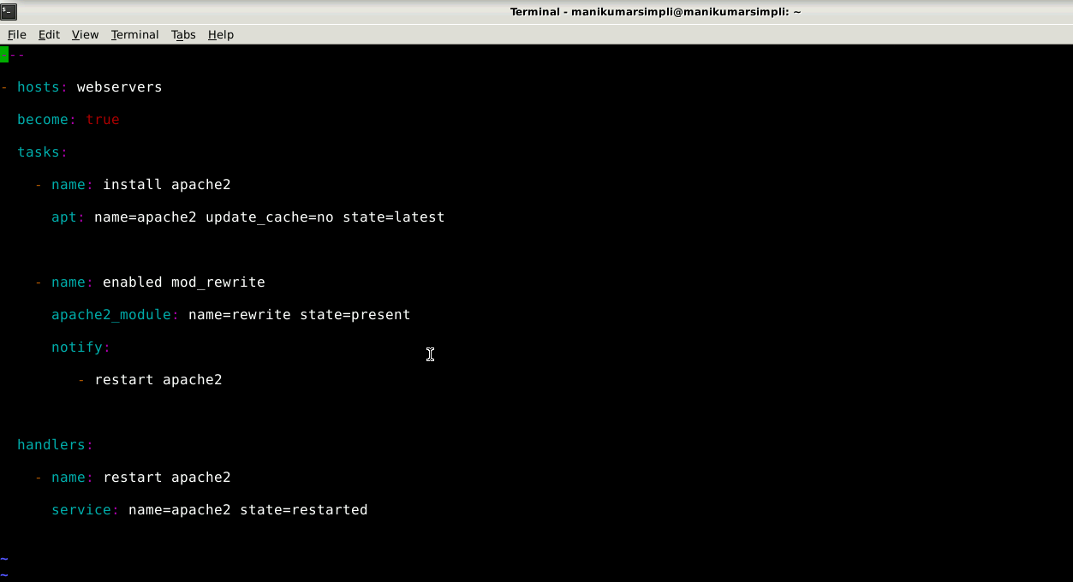

**---**

**- hosts: webservers**

**become: true**

**tasks:**

**- name: install apache2**

**apt: name=apache2 update_cache=no state=latest**

**- name: enabled mod_rewrite**

**apache2_module: name=rewrite state=present**

**notify:**

**- restart apache2**

**handlers:**

**- name: restart apache2**

**service: name=apache2 state=restarted**

**Step 4:** Run Ansible YAML script

* Run apache.yaml file using below command:

**ansible-playbook apache2.yaml**