Lesson 11 Demo 2: Set Up Terraform

This section will guide you to:

* Install Terraform in Linux

This lab has two subsections, namely:

1. Downloading the appropriate package
2. Adding the binary file into the **bin** directory

***Note:*** *Ansible 2.2.3 is already installed in your lab.*

**Step 1:** Downloading the appropriate package

* Click on the URL given below and install the package suitable for your OS:

<https://www.terraform.io/downloads.html>

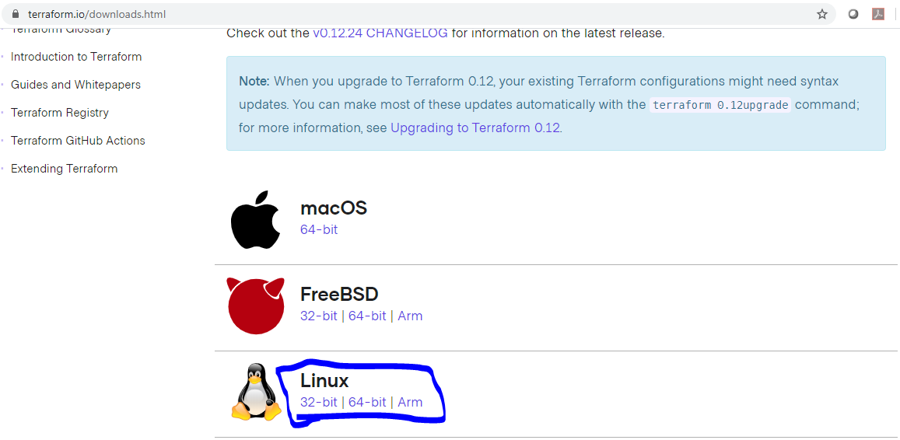

**Step 2:** Adding the binary file into the **bin** directory

* Run the below set of commands to unzip and move the Terraform binary file to the **bin** directory:

**cd Downloads**

**unzip <YourTerraformFileName>.zip**

**mv Terraform /usr/local/bin**

**cd ..**

**terraform -version**

