Lesson 11 Demo 5: Terraform with Jenkins

This section will guide you to:

* Integrate Terraform with Jenkins

This lab has four subsections, namely:

1. Setting up GitHub repository
2. Setting up Jenkins
3. Installing and configuring Terraform plugin
4. Creating and running Terraform project

***Note:*** *Ansible 2.2.3 is already installed in your lab.*

**Step 1:** Setting up GitHub repository

* Create a GitHub repository (such as **“DevOpsTesting01”**) with the below folder structure:

**DevOpsTesting01**

├── terraform-scripts

│ ├── creds.tf

│ ├── main.tf

├── sample.txt

* **Note:** For this demo we are considering a hypothetical repository having files from **“Assisted Practice: First Terraform Deployment”** with the URL as mentioned below for the above repository:

*https://github.com/anujdevopslearn/DevOpsTesting01*

**Step 2:** Setting up Jenkins

* Run the commands given below in your command prompt to install Jenkins:

**sudo apt update**

**sudo apt install openjdk-8-jdk**

**wget -q -O - https://pkg.jenkins.io/debian-stable/jenkins.io.key | sudo apt-key add -**

**sudo sh -c 'echo deb https://pkg.jenkins.io/debian-stable binary/ > \**

**/etc/apt/sources.list.d/jenkins.list'**

**sudo apt-get update**

**sudo apt-get install jenkins**

* Run the command given below to get admin password:

**sudo cat /var/lib/jenkins/secrets/initialAdminPassword**

* Copy the admin password
* Open **localhost:8080** to open Jenkins

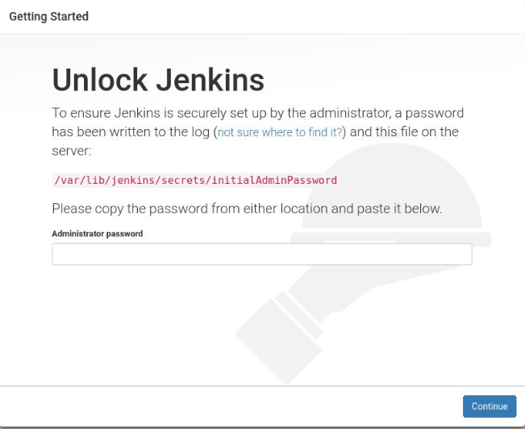

* Paste the admin password and click on Continue
* Install recommended plugins
* Create admin user
* Log in to Jenkins if it doesn’t log in automatically

**Step 3:** Installing and configuring Terraform plugin

* Go to **Manage Jenkins,** click on **Manage Plugins,** click on **Available**, and search **Terraform**

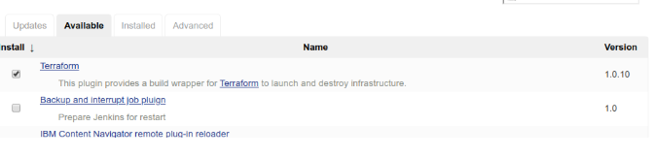

* Go to **Manage Jenkins** and click on **Global Tool Configuration**. It will display Terraform on the list. Click on the **“Add Terraform”** button and select the **right version** for the OS installed in your Lab (for example **Terraform 0.14.4 linux 368**).

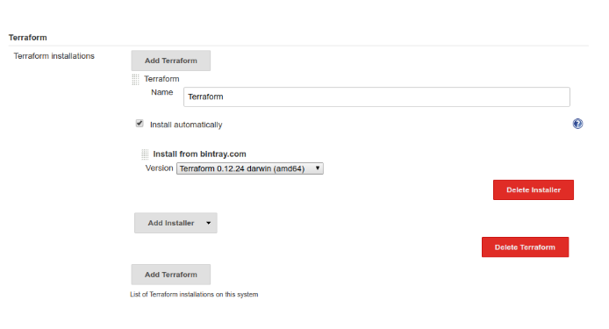

**Step 4:** Creating and running Terraform project

* Open Jenkins, click on **New Item**, enter any job name, choose **Pipeline**, and click **OK**

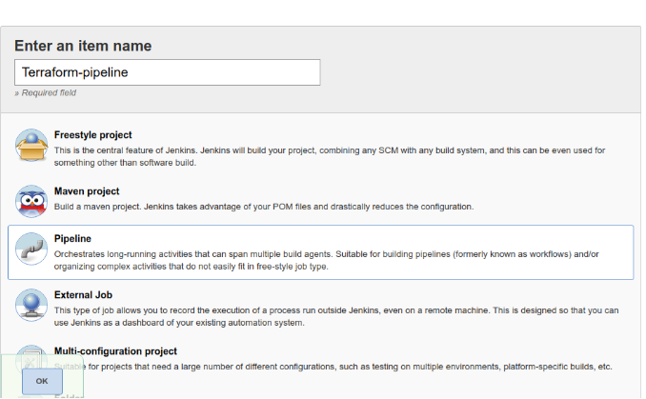

* Enter the pipeline script as given below and add your details wherever required:

**pipeline {**

**agent any**

**stages {**

**stage('checkout') {**

**steps {**

**git branch: 'master', url: 'https://github.com/anujdevopslearn/DevOpsTesting01'**

**}**

**}**

**stage('Set Terraform path') {**

**steps {**

**script {**

**def tfHome = tool name: 'c'**

**env.PATH = "${tfHome}:${env.PATH}"**

**}**

**sh 'terraform version'**

**}**

**}**

**stage('Provision infrastructure') {**

**steps {**

**dir('terraform-scripts')**

**{**

**sh 'terraform init'**

**sh 'terraform plan -out=plan'**

**// sh 'terraform destroy -auto-approve'**

**sh 'terraform apply plan'**

**}}}}}**

* Save and build the job

