Lesson 11 Demo 6: Provisioning EC2

This section will guide you to:

* Implement modules through command line

This lab has three subsections, namely:

1. Preparing the machine
2. Preparing Ansible playbook
3. Running the playbook

***Note:*** *Ansible 2.2.3 is already installed in your lab.*

**Prerequisite:**

* Establish an SSH connection between master and slave node. Your master node is your VM Lab and slave node is an EC2 instance created in AWS Lab.
* Use the AWS access credentials provided in the AWS API Access tab in your LMS as shown in the screenshot below:

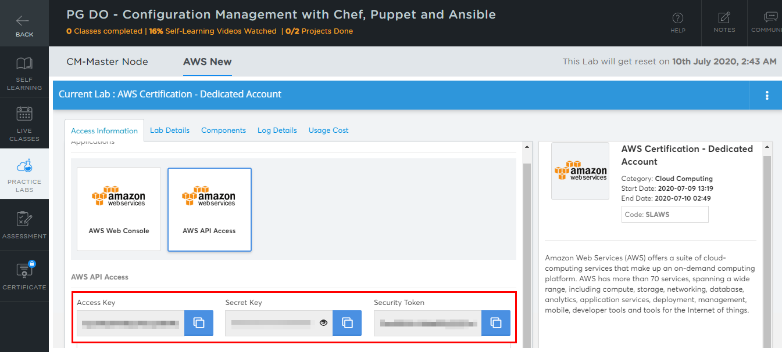

**Note:** AWS access credentials will change when the AWS Lab session expires after every four hours.

### **Step 1:** Preparing the machine

* Execute the following commands to set up your AWS credentials as environment variables:

**export AWS_ACCESS_KEY_ID=<enter your access key>**

**export AWS_SECRET_ACCESS_KEY= <enter your secret key>**

**export SECURITY_TOKEN = <enter your security token>**

* Use the AWS access credentials provided in the AWS API Access tab in your LMS as shown in the screenshot below:



**Note:** AWS access credentials will change when the AWS Lab session expires after every four hours.

* Install Ansible based on the OS of the machine from which you plan to execute the script

### **Step 2:** Prepare Ansible playbook

* Ansible uses the folder structure shown below:

├── ansible.cfg

├── inventory

│ ├── base

│ ├── ec2.ini

│ ├── ec2.py

│ ├── static_hosts

├── variables.yml

├── ec2_prov_playbook.yml

├── ec2_term_playbook.yml

* Enter the code given below in **ansible.cfg:**

**[defaults]**

**# update, as needed, for your scenario**

**host_key_checking=false**

**inventory = inventory/**

**# replace with your private key file or other auth method**

**private_key_file=${AWS_EC2_PEM_KEYPATH}**

**control_path=%(directory)s**

* Enter the code given below in **variables.yml:**

**STATE_RES_NAME: "${STATE_RES_NAME}"**

**ec2_region: "${ec2_region}"**

**ec2_instance_type: "${ec2_tag_Type}"**

**ec2_image: "${ec2_image}"**

**ec2_keypair: "${ec2_keypair}"**

**ec2_volume_size: ${ec2_volume_size}**

**ec2_count: ${ec2_count}**

**ec2_security_group_id: "${security_group_id}"**

**ec2_subnet_id: "${public_subnet_id}"**

**ec2_tag_Type: "${ec2_tag_Type}"**

**ec2_tag_Role: "${ec2_tag_Role}"**

* Enter the code given below in **ec2_prov_playbook.yml:**

**---**

**### provision AWS EC2 instance**

**- hosts: localhost**

**connection: local**

**gather_facts: false**

**user: root**

**pre_tasks:**

**- include_vars: variables.yml**

**tasks:**

**- name: Provision {{ ec2_count }} instances with tag {{ ec2_tag_Role }}**

**local_action:**

**module: ec2**

**key_name: "{{ ec2_keypair }}"**

**group_id: "{{ ec2_security_group_id }}"**

**instance_type: "{{ ec2_instance_type }}"**

**image: "{{ ec2_image }}"**

**vpc_subnet_id: "{{ ec2_subnet_id }}"**

**region: "{{ ec2_region }}"**

**instance_tags: '{"Type":"{{ec2_instance_type}}", "Role":"{{ec2_tag_Role}}"}'**

**assign_public_ip: yes**

**wait: true**

**exact_count: "{{ ec2_count }}"**

**count_tag:**

**Role: "{{ ec2_tag_Role }}"**

**volumes:**

**- device_name: /dev/xvda**

**volume_type: gp2**

**volume_size: "{{ ec2_volume_size }}"**

**delete_on_termination: true**

**register: ec2**

**- add_host:**

**name: "{{ item.public_ip }}"**

**groups: tag_Type_{{ec2_tag_Type}}**

**ec2_region: "{{ ec2_region }}"**

**ec2_tag_Type: "{{ ec2_tag_Type}}"**

**ec2_tag_Role: "{{ ec2_tag_Role }}"**

**ec2_ip_address: "{{ item.public_ip }}"**

**with_items: "{{ ec2.instances }}"**

**- name: Wait for the instances to boot by checking the ssh port**

**wait_for: host={{item.public_ip}} port=22 delay=15 timeout=300 state=started**

**with_items: "{{ ec2.instances }}"**

**# update shippable resource state**

**- name: run cmd**

**shell: |**

**shipctl put_resource_state "{{ STATE_RES_NAME }}" "INST_{{ item.ami_launch_index }}_PUBLIC_IP" "{{ item.public_ip }}"**

**shipctl put_resource_state "{{ STATE_RES_NAME }}" "INST_{{ item.ami_launch_index }}_ID" "{{ item.id }}"**

**shipctl put_resource_state_multi "{{ STATE_RES_NAME }}" "ec2_tag_Type={{ ec2_tag_Type }}" "ec2_tag_Role={{ ec2_tag_Role }}" "ec2_region={{ ec2_region }}"**

**with_items: "{{ ec2.instances }}"**

**post_tasks:**

**- name: refresh hosts inventory list**

**meta: refresh_inventory**

* Enter the code given below in **ec2_term_playbook.yml:**

**---**

**### terminate AWS EC/2 instances**

**- hosts: localhost**

**connection: local**

**gather_facts: false**

**user: root**

**pre_tasks:**

**- include_vars: variables.yml**

**tasks:**

**- name: Get EC2 instance IDs**

**run_once: true**

**ec2_remote_facts:**

**filters:**

**"tag:Type": "{{ ec2_tag_Type }}"**

**"tag:Role": "{{ ec2_tag_Role }}"**

**region: "{{ ec2_region }}"**

**register: instances**

**- name: display instances**

**run_once: true**

**debug:**

**var: instances**

**- name: Remove registered instances**

**run_once: true**

**ec2:**

**state: absent**

**wait: true**

**instance_ids: "{{instances|json_query('instances[*].id')}}"**

**region: "{{ ec2_region }}"**

**when: instances**

### **Step 3:** Running the playbook

* Execute the following command to run the Ansible playbook from the directory that contains the playbook:

**ansible-playbook –v ec2_prov_plaubook.yml**

* Verify on AWS if the EC2 machine was provisioned
* You can terminate the instance by running the command given below:

**ansible-playbook –v ec2_term_playbook.yml**