Lesson 11 Demo 7: Ansible with Jenkins

This section will guide you to:

* Run Jenkins job using Ansible playbook

This lab has three subsections, namely:

1. Logging into Jenkins and getting the API key
2. Creating and building a test job in Jenkins
3. Creating and running an Ansible playbook

***Note:*** *Ansible 2.2.3 is already installed in your lab.*

**Step 1:** Logging into Jenkins and getting the API key

* Once Jenkins is installed and set up, go to **localhost:8080** and provide your username and password and click on **Login**
* Click on the username on the top right of the screen as shown below:



* Click on Configure option on the left panel as shown below:

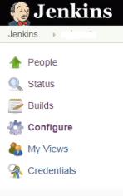

* Copy the API token as shown below:

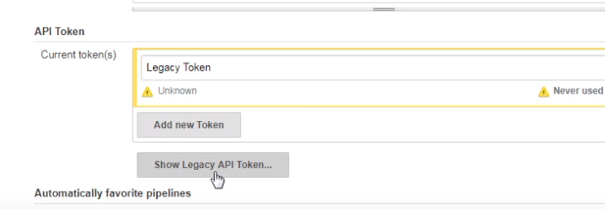

**Note:** If there are no tokens then click on **Add new Token** and then provide a name for the token and click on **Generate** to create a new token.

**Step 2:** Creating and building a test job in Jenkins

* Click on **Dashboard** in the top left corner of the screen
* Click on **New Item**, enter any job name, choose **Freestyle project**, and click **OK**

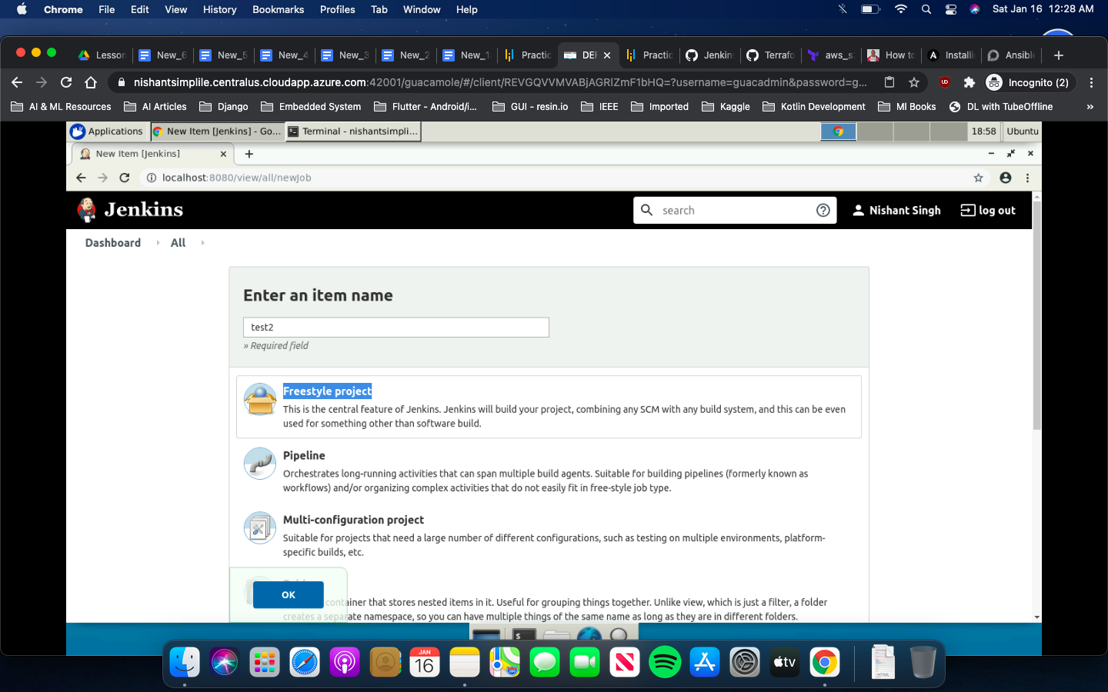

* Scroll down to the **Build** section, click on the **Add build step** drop-down, and select the **Execute shell** option
* In the **Command** section enter the below command:

**echo “Hello Testing”**

* Click on the **Save** button

**Step 3:** Creating and running an Ansible playbook

* Run the below program to create a playbook and add the code given below:

**vim jenkins.yml**

**- name: trigger**

**hosts: localhost**

**vars:**

**Uname: "<<jenkins username>>"**

**Pass: "<<jenkins password>>"**

**HostName: "<<yourip:port>>"**

**TokenName: "<<jenkins API token>>"**

**tasks:**

**- name: Queue build**

**uri:**

**url: "http://{{ HostName }}/job/{{ JobName }}/build?token={{ TokenName }}"**

**method: POST**

**user: "{{ Uname }}"**

**password: "{{ Pass }}"**

**force_basic_auth: yes**

**status_code: 201**

* Run the command given below to execute the playbook:

**ansible-playbook jenkins.yml –extra-vars “JobName=test”**

