Lesson 3 Demo 2: Test Kitchen Setup

This section will guide you to:

* Set up the test kitchen for Chef

This lab has one sub-section, namely:

1. Setting up test kitchen

**Step 1:** **Setting up test kitchen**

* Execute the following commands to set up test kitchen:

**sudo -i**

**gem install kitchen**

**gem install kitchen-vagrant**

* Once the kitchen is installed, run the following command to add vagrant drivers:

**kitchen init**

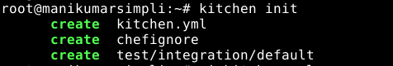

* Create a **kitchen.yml** in the home directory to set up test kitchen using the below commands:

**vi kitchen.yml**

On entering this, you will get a file as shown below. 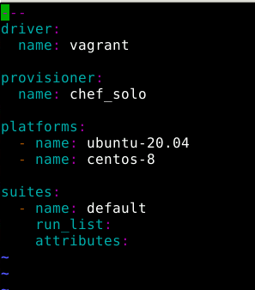

**---**

**driver:**

**name: vagrant**

**provisioner:**

**name: chef_solo**

**platforms:**

**- name: ubuntu-20.04**

**- name: centos-8**

**suites:**

**- name: default**

**run_list:**

**attributes:**

Save and exit using **[esc][shift]+:wq**

This file uses Vagrant as the driver, which requires no additional configuration because it’s the default driver used by Test Kitchen, chef-solo as the provisioner, and a single (default) test suite that runs on Ubuntu 16.04.

Type the following command to see what will be created:

**kitchen list**

● If you get an error concerning vagrant as shown below:

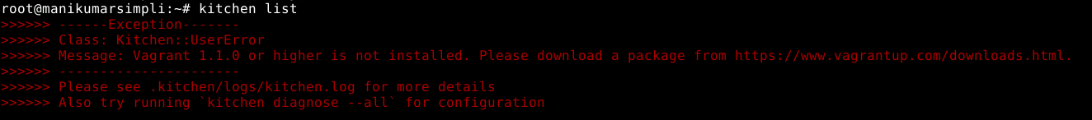

then typically you will need to install vagrant and virtualbox (a virtualization tool for linux)

**sudo apt update  
sudo apt install virtualbox**  
**curl -O** [**https://releases.hashicorp.com/vagrant/2.2.9/vagrant_2.2.9_x86_64.deb**](https://releases.hashicorp.com/vagrant/2.2.9/vagrant_2.2.9_x86_64.deb) **sudo apt install ./vagrant_2.2.9_x86_64.deb**

● Check the version by typing:

**vagrant --version**



Then type the following command to see what will be created:

**kitchen list**



To start Test Kitchen and to spin up some vagrant virtual machines type:

**kitchen create**

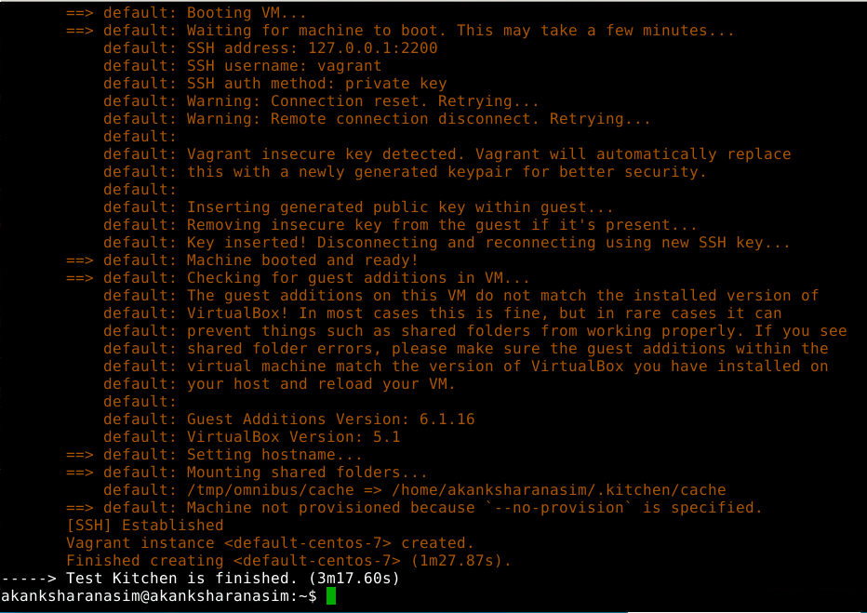

● You can list the virtual machines using the command:

**kitchen list**

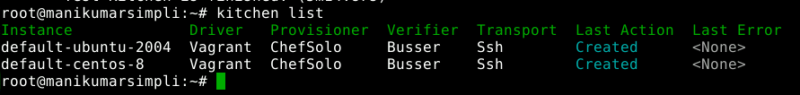

● You can connect to a running instance by entering the command:

*kitchen login <instance_name>*

For instance you can connect to centos-7 using the following command:

**kitchen login default-centos-8**

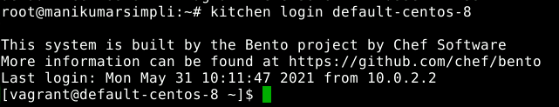

* You can type **exit** toreturn