Lesson 3 Demo 3: Configure Chef Knife

This section will guide you to:

* Configure Knife for Chef

This lab has six sub-sections, namely:

1. Generating Chef repository directory
2. Adding the RSA Private Keys for Password-less Authentication
3. Configuring Knife.rb file
4. Configuring SSL Certificate
5. Validation
6. Configuring Git for your Chef repository (Optional Best Practice)

***NOTE:*** *Please ensure you have completed demo 1 of lesson 3 before proceeding with this demo.*

**Step 1: Generating Chef repository directory**

* Execute the below command in the terminal to generate a chef repository on the machine:

**Note:** If you are logged in as the root user, run the command **exit** to exit the root user.

**chef generate repo chef-repo**   
  
(chef-repo is the name of the repo. You can give any name of your choice)

**Note:** *You might have to accept the chef license by typing* ***yes*** *when prompted*

* To check the repo components use the below command:

**cd chef-repo**

* On executing the command **ls -1** you can see the chef-repo looks like as shown below:

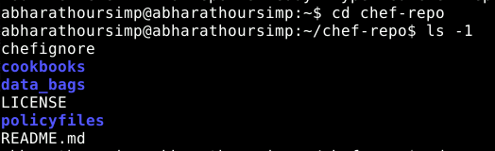

**Step 2: Adding the RSA Private Keys for Password-less Authentication**

* If you do not already have an RSA key-pair on your workstation, generate one. This key-pair will be used to gain access to the Chef server and then transfer their .pem files:

**cd   
ssh-keygen -b 4096**

* Press Enter to use the default names id_rsa and id_rsa.pub in /home/<your_username>/.ssh. You will be prompted as Enter Passphrase. Do not enter anything. Just press enter both the times.

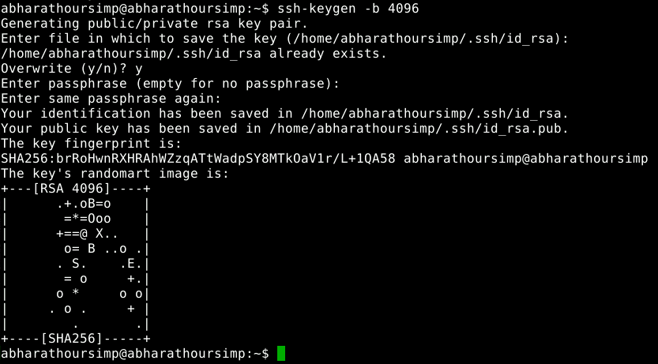

* Upload your workstation’s public key to host the Chef server  
    
  **Note:** Ensure you replace *<your_username>* with the Chef server’s user account the you had created in the demo 1 of lesson 3

**sudo ssh-copy-id -p 42006 <your_username>@localhost**

**Note:** You might have to enter your lab username’s password when prompted.

* Copy the *user.pem* and *org.pem* files from your Chef server to your workstation using the scp command

**Note**: These are the files which were created in demo 1 of lesson 3 and should be present in ~/.chef/ directory

**cd chef-repo  
mkdir .chef  
scp ~/.chef/*.pem ~/chef-repo/.chef/**

* Confirm that the files have been copied successfully by listing the contents of the .chef directory:

**ls ~/chef-repo/.chef**

* Your .pem files should be listed as shown below:

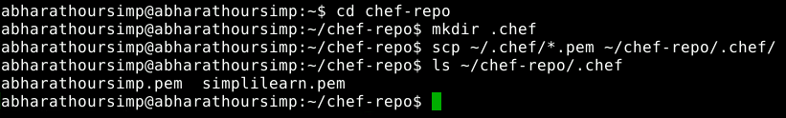

**Step 3:** **Configuring Knife.rb file**

* While configuring knife, the names of the key and the url depend on what you have created when creating the chef user in the chef manage console using: <https://localhost/chef> (Demo 1 of Lesson 3)

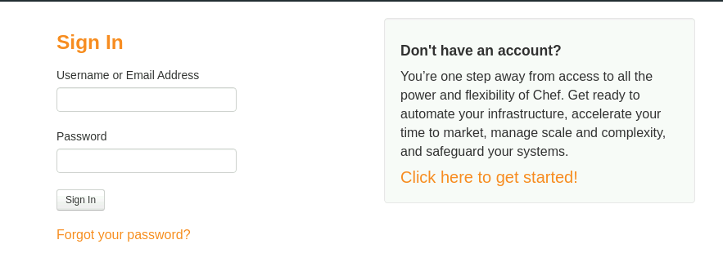

* Provide your credentials which you have created in demo 1 lesson 3 and log in to your chef server
* Once logged in, generate knife configuration file as follows:
* Go to **Administration Tab** -> Select your **Organization** -> Click on **Generate Knife Config** -> Save the file (filename 🡪 config.rb)

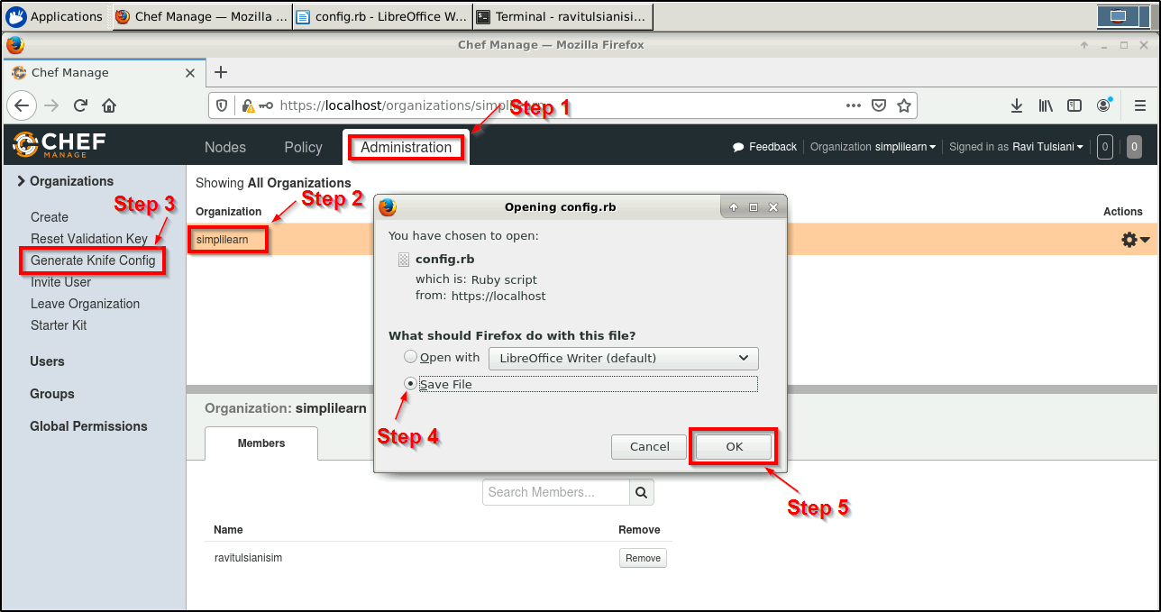

* ***config.rb*** file should be downloaded in the home folder of your lab and should have the content similar to the following:

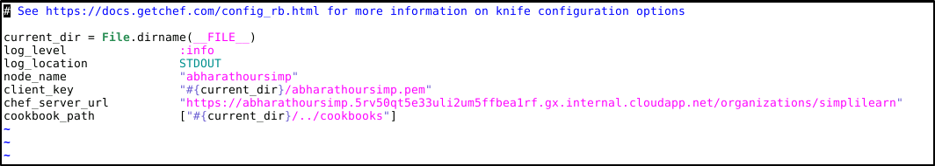

* Rename the file to knife.rb and mv it to ~/chef-repo/.chef using the following commands:

**cd ~/Downloads/  
mv config.rb knife.rb**

**mv knife.rb ~/chef-repo/.chef/**

* Now you should have the following files in your *~/chef-repo/.chef* directory on running the command:

**cd *~/chef-repo/.chef***

**ls**



**Step 4: Configuring SSL Certificate**

* Fetch the SSL certificate from your Chef server by executing the commands shown below:

**cd ~/chef-repo**

**knife ssl fetch**

* Validate the downloaded SSL certificate using the below command:

**knife ssl check**

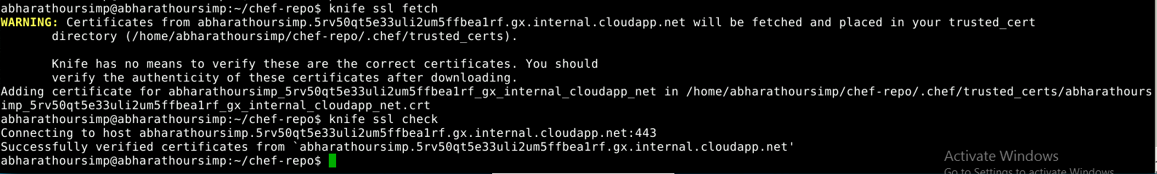

**Step 5: Validation**

* Run the following commands to verify that Chef knife utility has been configured correctly:

**knife client list**

**knife node list**

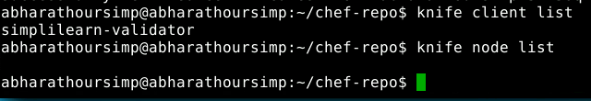

* This command will output the validator name. No output for *Knife node list* is expected as we have not configured/bootstrapped any nodes yet to our chef server.

**Step 6:** **Configuring Git for your Chef repository (Optional Best Practice)**

* The ChefDK adds the Git component to your workstation and initializes a Git repository in the directory used to generate the Chef repo.

**git config --global user.name <Your Git Username>**

**git config --global user.email <Your Email ID>**

***Note****: Provide a valid Git username and email address of your git repository*

* Add the .chef directory to the .gitignore file using the below command:

**echo ".chef" > ~/chef-repo/.gitignore**

* Move into the ~/chef-repo directory if you are not already there, and add and commit all existing files:

**cd ~/chef-repo**

**git add .**

**git commit -m "initial commit"**

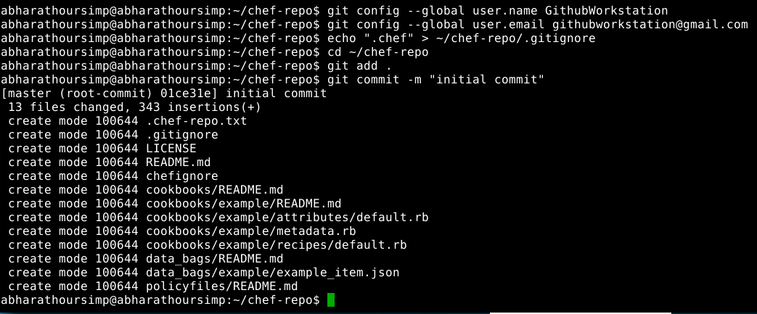

* Make sure the directory is clean by running the below command:

**git status**

