Lesson 4 Lesson End Project: Configure Gmail Notification with Jenkins

This section will guide you to configure Gmail in Jenkins

This lab has 4 subsections:

1. Install **Email Extension plugin** in Jenkins.
2. Configure Gmail in Jenkins.
3. Receive an email when the Build fails.
4. Receive an email when the Build is successful.

**Step 1 :** Install **Email Extension plugin** in Jenkins

* Go to Jenkins landing page ➔ Manage Jenkins ➔ Manage plugins ➔ Available
* Search for the **Email Extension plugin** and install it. Once done, you will be able to see it in the list of installed plugins.

**Step 2 :** Configure Gmail in Jenkins

* Go to Jenkins **landing page** ➔ **Configure system** ➔ **Extended Email notification**
* Fill it up as follows:  
    
  SMTP server – ‘**smtp.gmail.com**’  
  Username – **(Your email id)**Password – **(Your password)**SMTP port – **465**Reply To List - **(Your email id)**

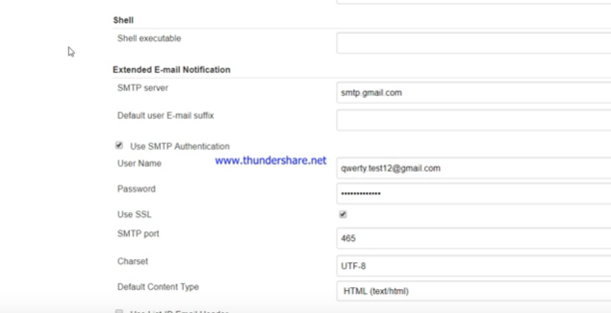

* If you realize that you are not receiving emails to your Gmail account, login to your email account and enable **Allow less secure apps**.

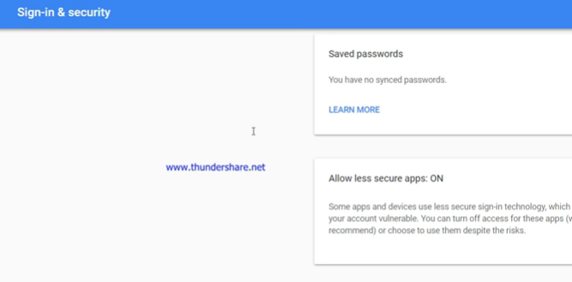

* Now, set the following:

Default Subject: $PROJECT_NAME – Build # $BUILD_NUMBER - $BUILD_STATUS!

Default Content: $PROJECT_NAME – Build # $BUILD_NUMBER - $BUILD_STATUS

* Check console output at $BUILD_URL to view the results.

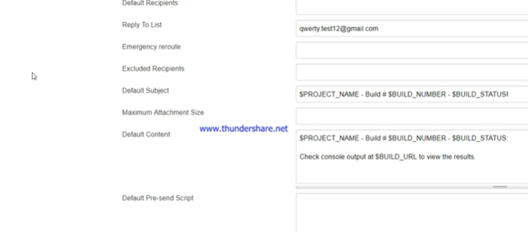

* You can click on **Test Notification** and check if you have received an email or not.
* Then click on **Save**.
* Create a new job named **TestJob**. Then go to **Configure**.
* You need to configure so that when the job build fails, you will receive an email.
* Go to **Add post-build action** ➔ **Email Notification**
* Fill in your email id in **Recipients**.
* You can put multiple email ids by providing a space between consecutive ones.

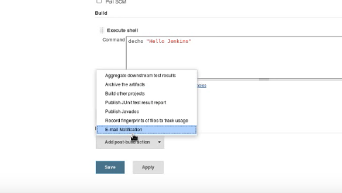

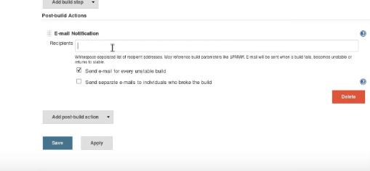

* Click on **Save**.

**Step 3:** Receive an email when the Build fails.

* Build the project to receive an email
* Make some changes to your code so that the Build is not successful.
* Go to **Build Now** ➔ Check the output in the **console**, and make sure that your Build has **failed**
* Now, go to your email id to make sure that you have received an email stating that the Build has failed.

**Step 4:** Receive an email when the Build is successful.

* Rectify your mistake, and Build the project to receive an email again
* Go to your project, and rectify your mistake in the code so that the Build is successful.
* Once done, Build it again, and check if you have received an email stating that the Build was successful.