Lesson 4 Demo 1: Install and Configure Jenkins

This section will guide you to install and run Jenkins

This lab has 4 sub-sections:

* Add a key to use Debian repository
* Make changes to /etc/opt/sources.list
* Update local package index
* Run Jenkins in the browser

**Note:** Go to <https://pkg.jenkins.io/debian-stable/> to understand how to install Jenkins on a Ubuntu/Debian machine.

**Step 1:** Add a key to use Debian repository

* To use the Debian repository of Jenkins to automate installation and upgrade, first add the key to your system using the following command:

**wget -q -O –** [**https://pkg.jenkins.io/debian-stable/jenkins.io.key**](https://pkg.jenkins.io/debian-stable/jenkins.io.key) **| sudo apt-key add –**

**Step 2:** Make changes to /etc/opt/sources.list

* Then, add the following entry in your **/etc/apt/sources.list**:

**sudo vi /etc/apt/sources.list**

Now add the following command:

**deb** [**https://pkg.jenkins.io/debian-stable binary/**](https://pkg.jenkins.io/debian-stable%20binary/)

Save and exit using [esc] [shift]+: wq

**Step 3:** Update your local package index

* Run the command

**sudo apt-get update**

* Make sure you have JDK installed. If not, install it using the following command:

**sudo apt-get install openjdk-8-jdk**

**Note:** If you get **dpkg** **frontend lock** error, please follow the below set of commands to free the process and install JDK again:

**lsof /var/lib/dpkg/lock-frontend  
sudo kill -9**

**sudo rm /var/lib/dpkg/lock-frontend**

**sudo dpkg --configure -a**

* Then install Jenkins

**sudo apt-get install jenkins**

**Step 4 :** Run Jenkins in the browser

* Once Jenkins is installed, open a browser in the lab and enter the URL given below:

URL: **localhost:8080**

* You will need to enter the admin password.
* To find the password, type the following command:

**sudo cat /var/lib/jenkins/secrets/initialAdminPassword**

* Use the string of numbers as a password. Once you are logged in, you will be redirected to the page below:

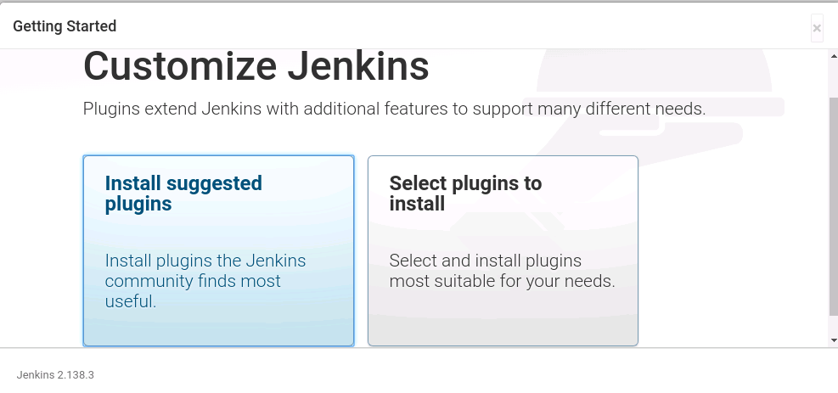

* Select **Install suggested plugins**.You will be redirected to the page below:

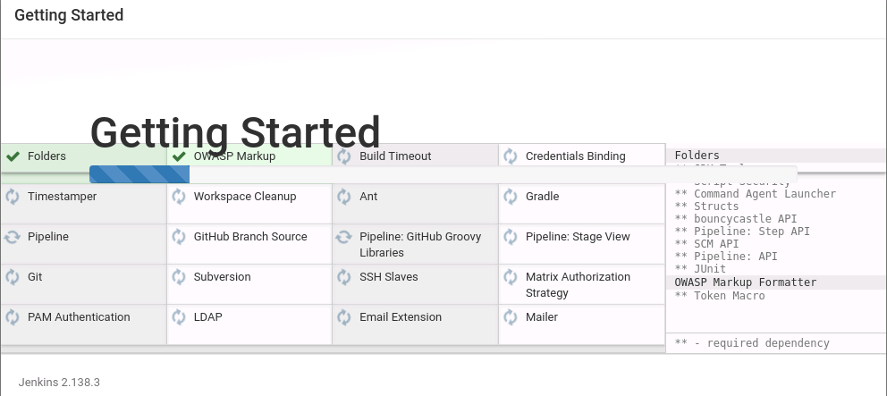

* After installing recommended plugins, you can create a First **Admin User** or continue as an admin by filling the required details as shown in the screenshot.

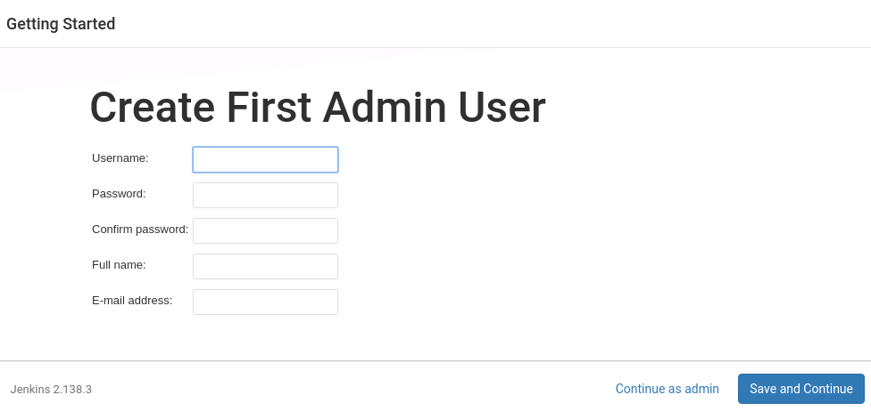

* Once that is done, start using Jenkins.