Lesson 5 Lesson End Project: Cucumber with Java

This section will guide you to:

* Use cucumber and write the scenario with Gherkin language
* Write the first step definition in Java
* Confirm the output of cucumber with the positive result

**Step 1:** Create a project directory with cucumber-archetype Maven plugin. Open the terminal, navigate to the project directory, and execute the following command:

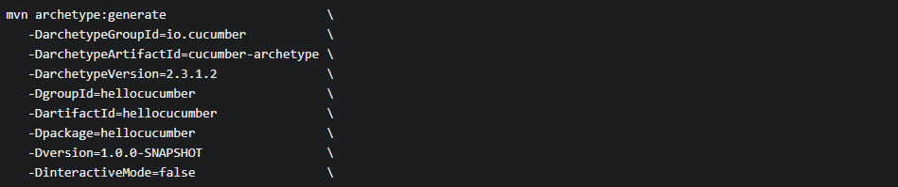

If you haven’t encountered any errors, you will get the following result:



**Step 2:** Create a directory **hellocucumber** inside the project directory, and navigate inside the **hellocucumber** folder.

* Choose any IDE and select the **Open as Project** option, then choose the **pom.xml** file**.**
* Verify cucumber installation by executing **mvn test.**
* If you haven’t encountered any errors, then you should see the following output:

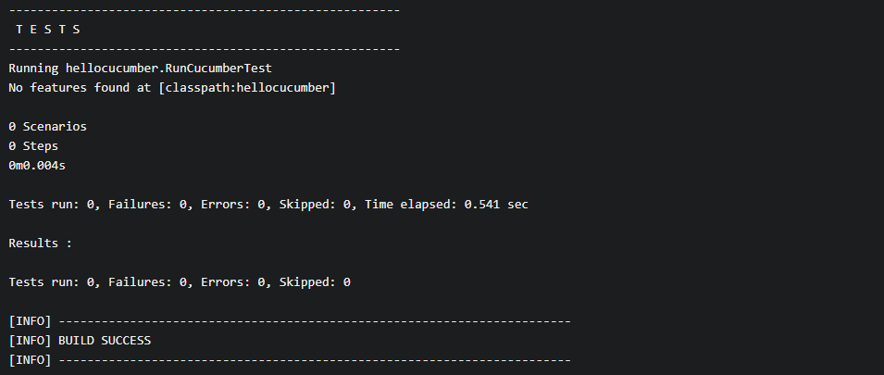

* Create an empty file called **is_it_Friday_yet.feature** in the directory path **src/test/resources/hellocucumber/is_it_Friday_yet.feature** with the following code:

Feature: Is it Friday yet?

Everybody wants to know when it's Friday

Scenario: Sunday isn't Friday

Given today is Sunday

When I ask whether it's Friday yet

Then I should be told "Nope"

**Step 3:** See scenario reported as undefined

Execute the following command from the terminal:



You should confirm the following output.

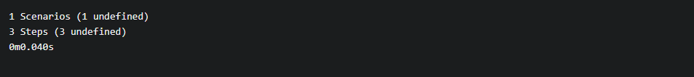

**Step 4:** See scenario reported as failing

* Create a **stepdefs.java** at the location **src/test/java/hellocucumber/stepdefs.java** if it is not already created.
* Add the below mentioned step definition code:

package hellocucumber;

import cucumber.api.java.en.Given;

import cucumber.api.java.en.When;

import cucumber.api.java.en.Then;

import static org.junit.Assert.*;

class IsItFriday {

static String isItFriday(String today) {

return null;

}

}

public class Stepdefs {

private String today;

private String actualAnswer;

@Given("^today is Sunday$")

public void today_is_Sunday() {

this.today = "Sunday";

}

@When("^I ask whether it's Friday yet$")

public void i_ask_whether_is_s_Friday_yet() {

this.actualAnswer = IsItFriday.isItFriday(today);

}

@Then("^I should be told \"([^\"]*)\"$")

public void i_should_be_told(String expectedAnswer) {

assertEquals(expectedAnswer, actualAnswer);

}

}

* Run the cucumber so that you would be able to confirm that two steps will pass, and the last step will fail.

3

**Step 5:** See scenario as passing

* Add **return ‘Nope’;** to the code available in the step definitionfile.

static String isItFriday(String today) {

return "Nope";

}

* Run the cucumber and confirm the following output:

