Lesson 5 Demo 1: TDD with JUnit 5

This section will guide you to:

* Use Java and Eclipse throughout the demonstration
* Download the Eclipse from the official site
* Use JUnit to demonstrate test-driven development

**Note:** You do not have to install Java and Eclipse. They are already installed in your labs, and you can check the Java version from the terminal by executing **java -version**.

**Step 1:** Clone the repository from Git

* Execute the following command from the terminal. Create a new directory named **DevOps-Lesson-04** and clone the repository from Git.

**mkdir devops-lesson-04**

**cd devops-lesson-04**

**git clone** [**https://github.com/SimplilearnDevOpsOfficial/Lesson-04-JUnitTDD.git**](https://github.com/SimplilearnDevOpsOfficial/Lesson-04-JUnitTDD.git)

* Check the path where you have created the folder and downloaded the source codes using **pwd from** the terminal

**Step 2:** Import the project in Eclipse

* Open Eclipse in your lab (/opt/Eclipse) and select the workspace where you would like to place your work. Click on **File** → **Open Projects from File System…** → navigate to the folder **Lesson-04-JUnitTDD** you just downloaded from git

**Step 3:** Manipulation of codes

* You may find JUnit 4 already available with your project. You need to remove JUnit 4 from the build path. Right click on **JUnit 4** and select **Build Path** -> **Remove from Build Path** as shown below:

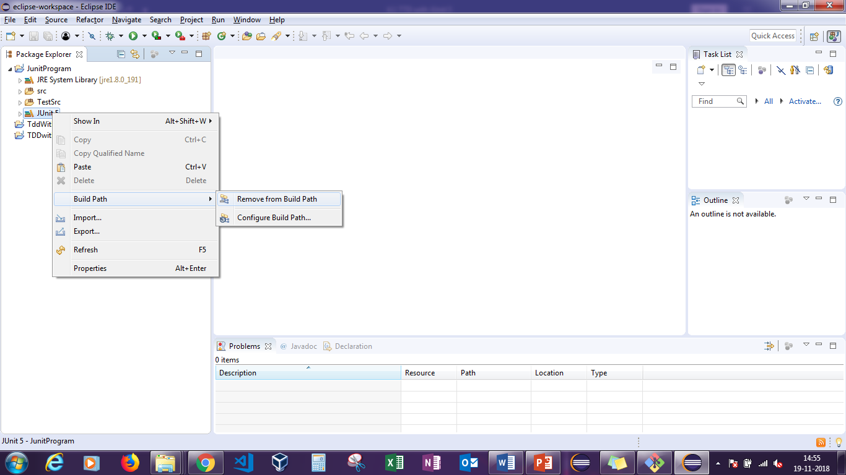

* Navigate to **TestSrc** -> **com.tddjunit.java** -> **MathsTest.java**, copy the entire code, and paste it in any document temporarily. After this delete the **com.tdd.junit.java package**

**Note:** The required Java code for development is already written, and you will find the source codes in the **src** folder. Do not change the codes available in the **src**.

* Now, navigate to the **src** directory and right click on **Maths.java**. Select **New->Junit Test Case**

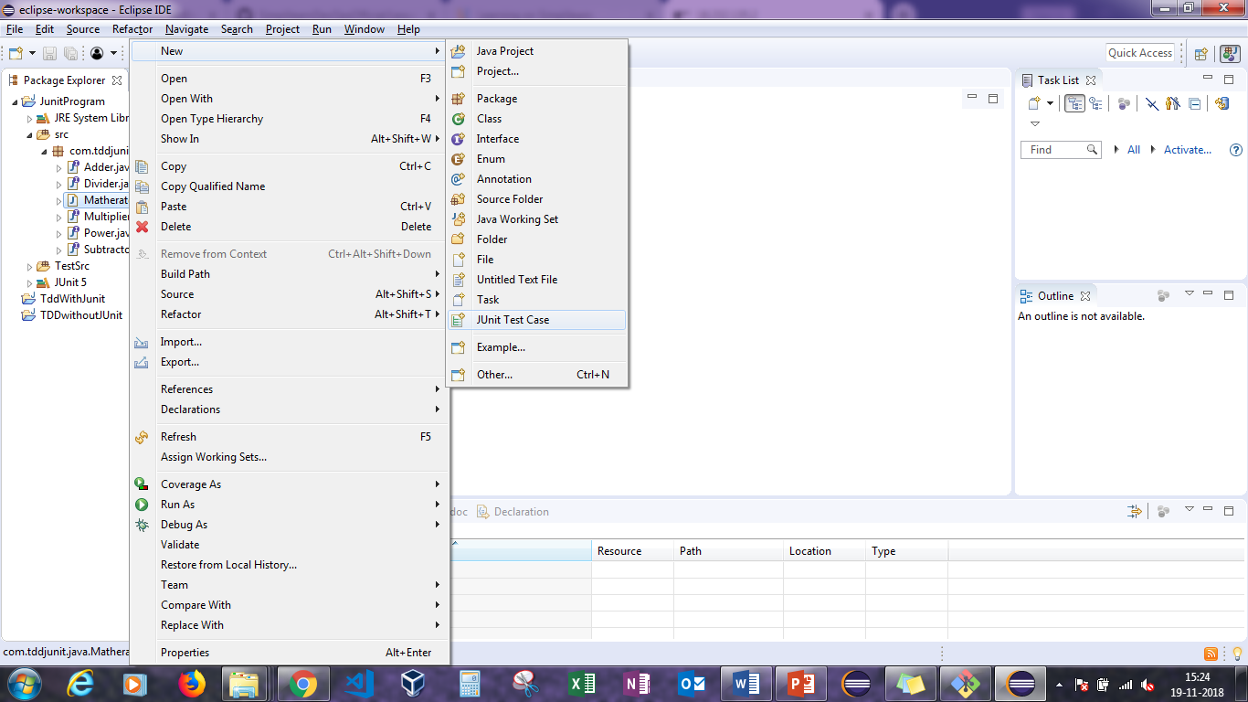

* Click on **Browse** to change the directory from **src** to **TestSrc** and click on **Finish**

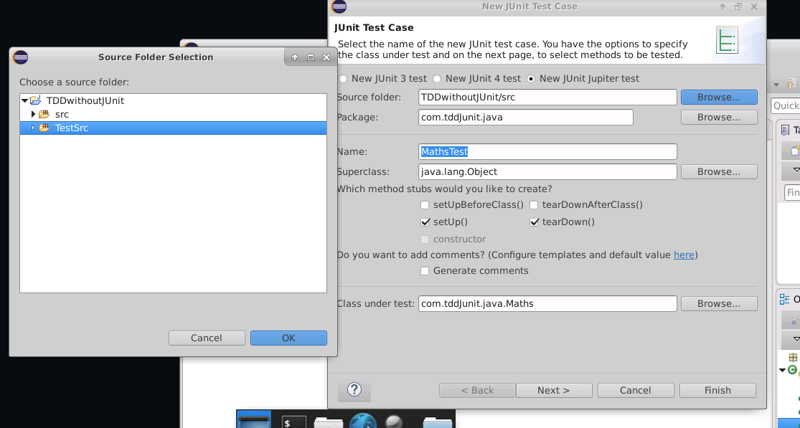

* It will generate a test file in the **TestSrc** directory and JUnit 5 libraries in the project. Do not change any files in the JUnit 5 libraries
* Run the **MathsTest.java** file, and confirm that the test cases will fail. Now, replace the existing code with the codes saved in the temporary file (**MathsTest.java** file), and perform the following changes:
  + Comment out: Comments 1, 2, 4, and 6
  + Delete comments: Comments 3 and 5
* Rerun the test cases, and confirm that the test cases will pass without any errors or warnings 