Lesson 7 Demo 3: Docker Registry with Centos

This section will show you how to work with a Docker registry and run a Docker registry from an official registry image.

This lab has 3 sub-sections:

* Pull a Centos Linux container
* Push the image to the local repository
* Run a new image

**Step 1:** Pull a Centos Linux container

* Pull a recent version of the Centos Linux container

**docker pull registry:2**

* Run the registry in a new Docker container with port 5000 exposed

**docker run -d -p 5000:5000 \**

**--restart=always --name registry registry:2**

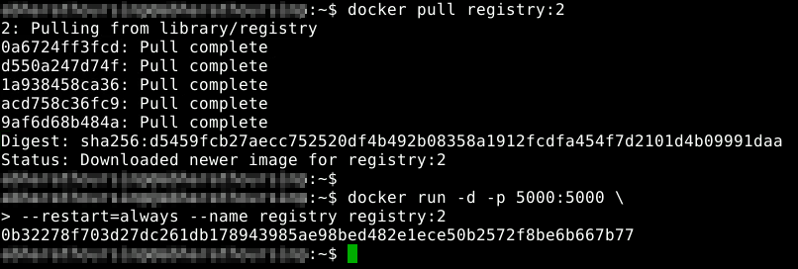

* Pull another image from Docker Hub and store it in the local registry

**docker pull ubuntu**

* Tag the image for the local registry

**docker tag ubuntu localhost:5000/ubuntu**

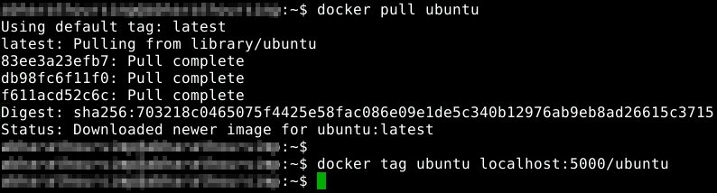

**Step 2:** Push the image to the local registry

* Use the following command to push the image to a local registry:

**docker push localhost:5000/ubuntu**

* Remove the image from the local cache

**docker rmi ubuntu**

* Confirm that it has been removed

**docker images**

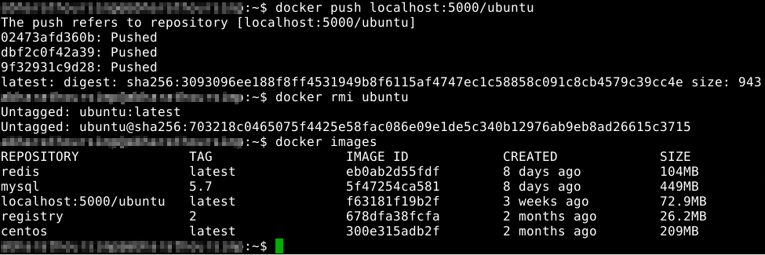

**Step 3:** Run the new image

* Pull the image from the local registry

**docker pull localhost:5000/ubuntu**

* Confirm it is in the local cache

**docker images**

* Run the new image

**docker run -it --rm localhost:5000/ubuntu /bin/bash**

* Exit the container

**exit**

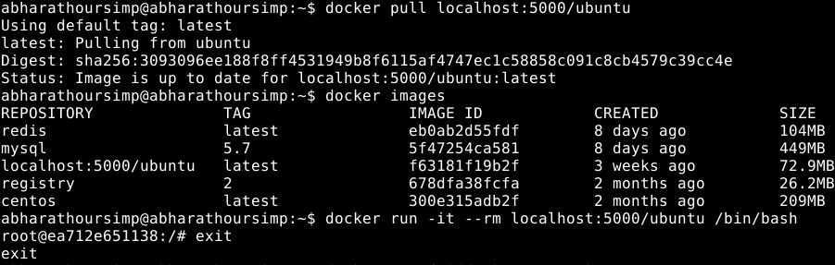

* Clean up the images and containers

**docker rm -f $(docker ps -aq)**

**docker rmi $(docker images -q)**

