Lesson 7 Demo 4: Docker Networking with 2 SSHs

This section will show you how to use Docker network and its configuration in a container.

This lab has 3 sub-sections:

* Create a Centos container and commit it
* Create a bridge network and find its IP address
* Connect the network from another SSH server

**Step 1:** Create a Centos container and commit it

* Create a Centos Docker container and install net tools

**docker run -it --name centos centos /bin/bash**

**yum install -y net-tools**

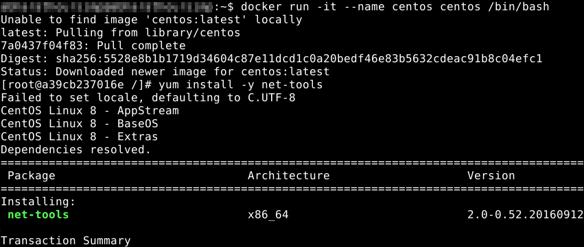

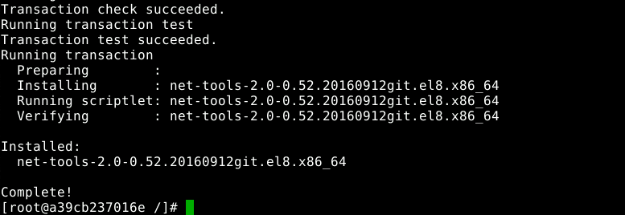

* Check the IP address and hostname

**ifconfig**

**cat /etc/hosts**

**hostname**

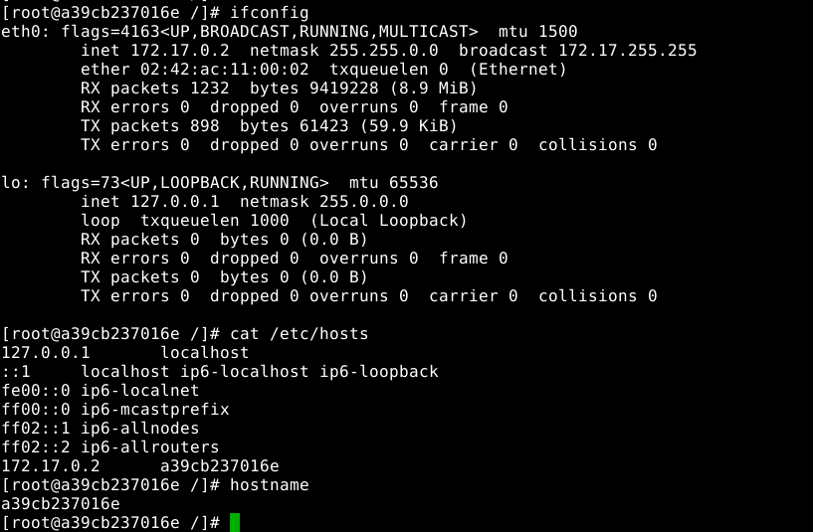

* Exit the container using **CTRL+D**
* Commit the container to an image (Please refer to the screenshot)

**docker commit centos centos-net**

**docker images**

**docker rm centos**

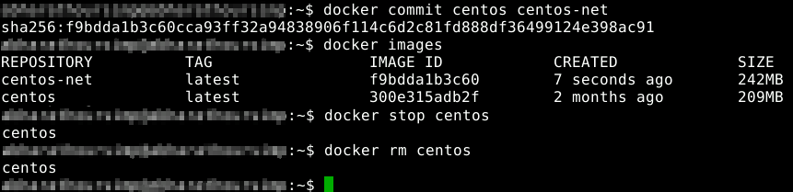

**Step 2:** Create a bridge network and find its IP address

* Create a bridge network and find its IP range

**docker network create exnet**

**docker network ls**

**docker network inspect exnet**

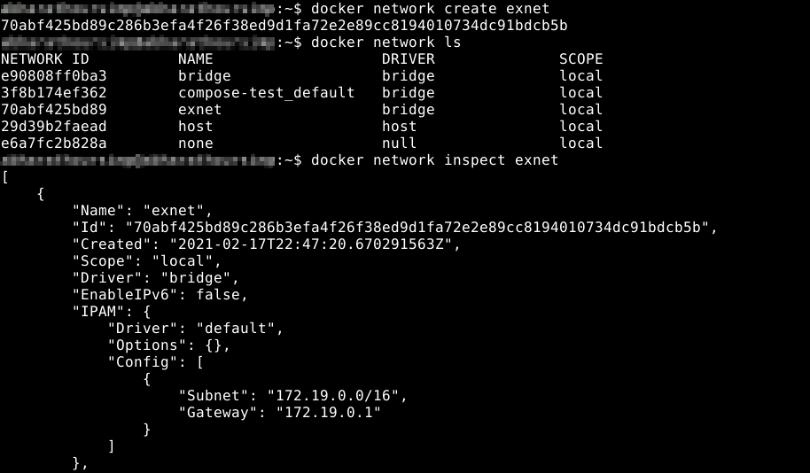

* Run the centos container using the new network

**docker run -it --rm --network exnet centos-net /bin/bash**

* Check the IP address and hostname

**ifconfig**

**cat /etc/hosts**

**hostname**

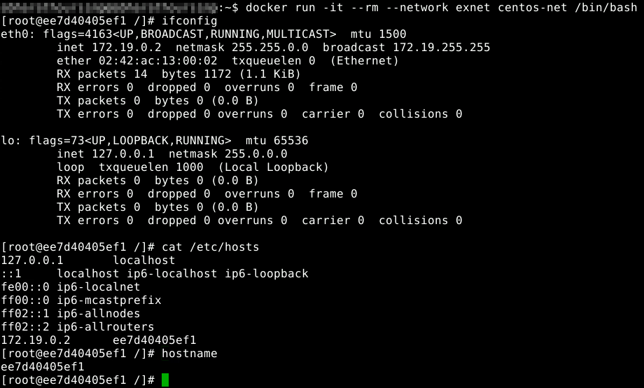

* Exit the container using **CTRL+D**
* Start a new container using the default network

**docker run -it --rm --name centos centos-net /bin/bash**

* Check the IP address and hostname

**ifconfig**

**cat /etc/hosts**

**hostname**

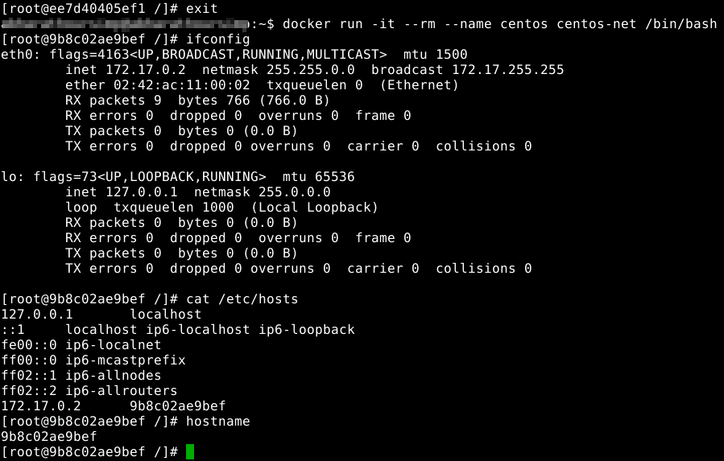

**Step 3:** Connect the network from another SSH server

* Click on **File** to open another Terminal window
* From the second SSH window, connect the network to the container

**docker network connect exnet centos**

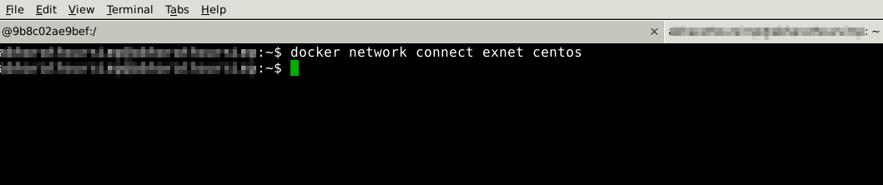

* Go back to the running container. You will see that it now has two IP addresses (Please refer to the screenshot)

**ifconfig**

**cat /etc/hosts**

**hostname**

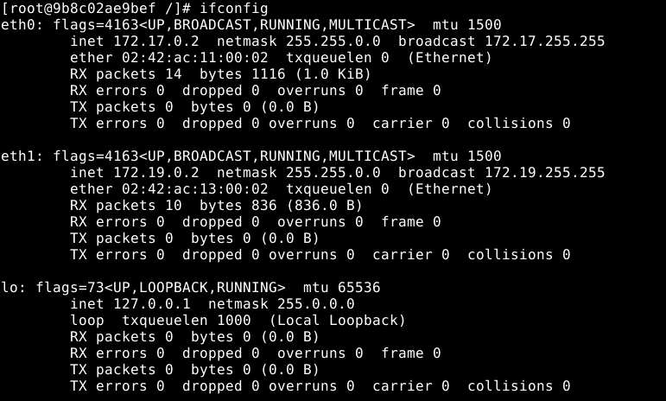

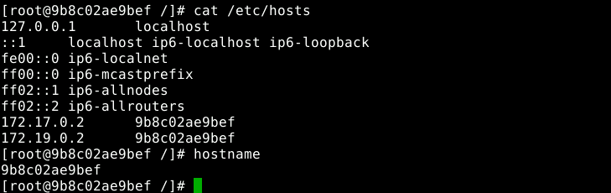

* Go to the second SSH window and disconnect the network

**docker network disconnect exnet centos**

* Go back to the running container and see that it now has one IP address

**ifconfig**

**cat /etc/hosts**

**hostname**

* Exit the container using CTRL+D

