Lesson 7 Demo 1: Run MySQL Database in Docker Container

This section will show you how to run MySQL database in Docker Container.

This lab has 3 sub-sections:

* Clone the repository from Git
* Inspect the IP address
* Run MySQL database instance in Docker

**Step 1:** Clone the repository from Git

* Clone the git repository:

**git clone** [**https://github.com/SimplilearnDevOpsOfficial/DockerWithMySQL.git**](https://github.com/SimplilearnDevOpsOfficial/DockerWithMySQL.git)

* Change to the lab directory

**cd DockerWithMySQL**

* Create a Docker data volume to hold the database

**docker volume create --name monitoring_data**

* Confirm that the data volume has been created

**docker volume ls**

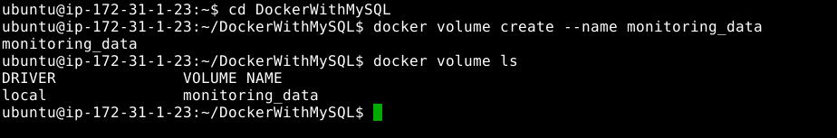

* Provide access to perform action on the file

**chmod u+x runserver_first**

* Examine the script that will run and create the case study database structure

**cat runserver_first**

* Run the server

**./runserver_first**

**Note:** You should be able to see that the connection is up and running at the specific port number.

* Run the script to create a container with MySQL running and create the database

**docker images**

* You will need to monitor the logs to see when MySQL has completed creating the student database and is waiting for connections.

**docker logs mysql**

**Note:** When you see the following in the logs, you may continue.

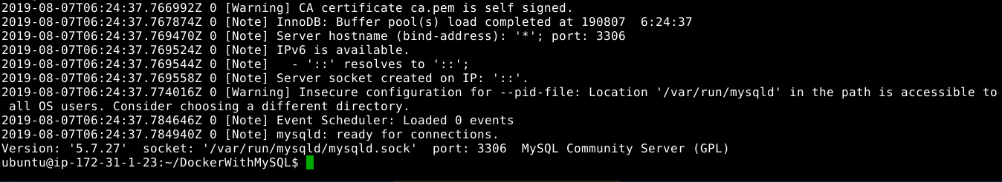

**Step 2:** Inspect the IP address

* Find the IP address of the server

**docker inspect mysql**

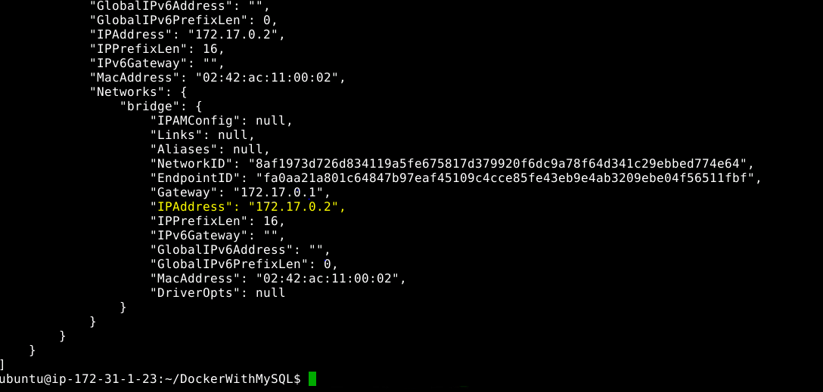

* To run the client and log the data in the database, use the commands given below:

**chmod 777 runclient**

**./runclient**



**Step 3:** Run MySQL database in Docker container

**Note:** You will be working at **root** level. You will be placed inside the client container running the Bash command shell. You can now type commands to use the database. You may need to change the IP address to that of the server.

* Type the following command:

**mysql -h 172.17.0.2 -u student -p**

**Note:** Password is **student**

* When you connect, you will see the MySQL client prompt **mysql>** as shown below:

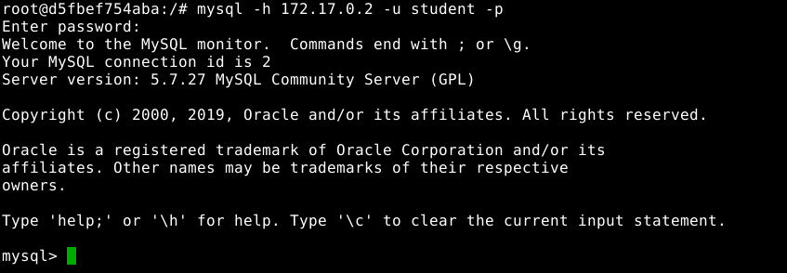

* Examine the database tables

**show databases;**

**use monitoring;**

**show tables;**

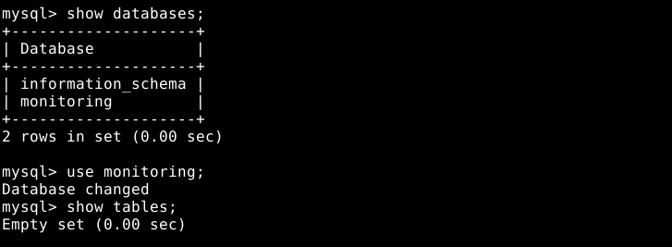

* Create a database table named **docker**

**create table docker(name VARCHAR(20));**

**show tables;**

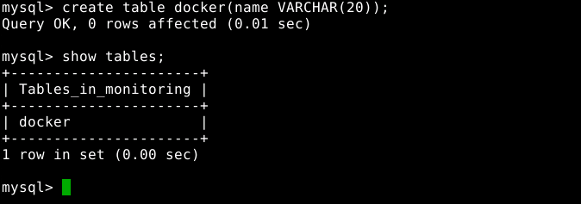

* Exit from the MySQL client

**quit;**

* Exit from the client container (Please refer to the screenshot below)

**exit**

